Snapshot Day 10/12/06 Data
(Salt Front RM 52.5)
RIVER MILE 41
Steamboat Dock Park, Verplanck, Westchester
Latitude N 41°14’.56” Longitude W 73°57’.52"
Bob Connick & Mahopac High School 9th & 10th graders
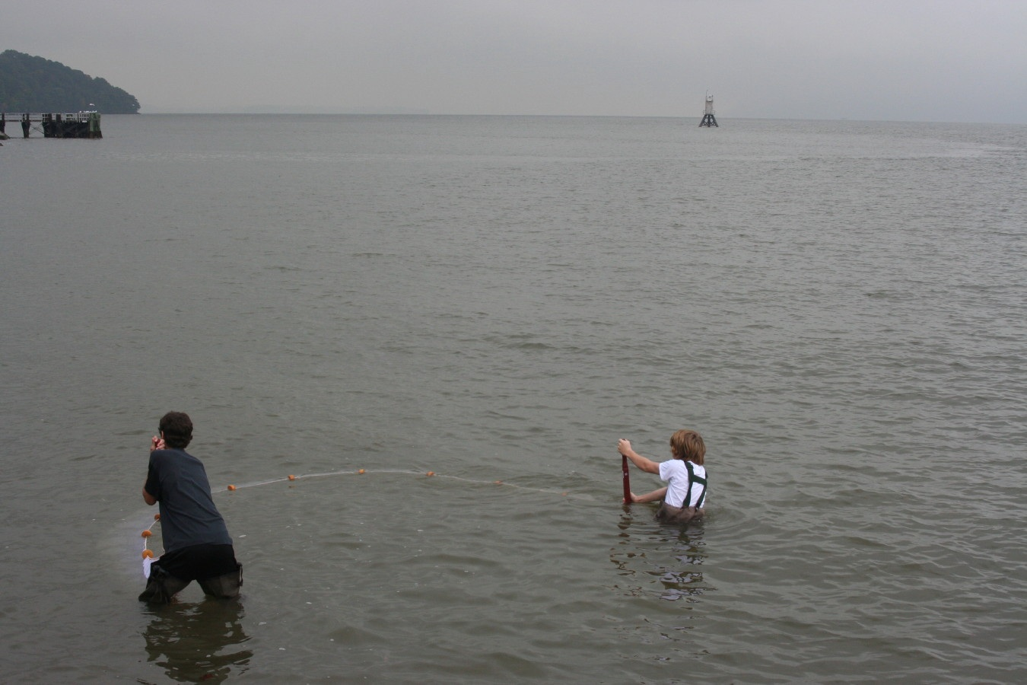
Location: Steamboat Dock Park beach, City of Verplanck in Westchester County
Area: located in a small cove between a point and a bulkhead – sampled approximately 30 ft. from south end of dock/parking lot
Surrounding Land Use: Urban/residential 10% , Forested 10%, beach 10%, Industrial commercial 70%. Some buildings with large parking lots in front to the north. Beach, a street with houses with some trees to the south
Sampling Site: beach, riprap, banks altered
Plants in area: 7% covered with plants in water:
Water Plants include: clasping pondweed 50%
Sago pondweed 50%
Eel weed – 2% (possibly Vallisinaria
Land Plants include: Black locust 65-70%
Virginia Creeper – 15%
Tree of Heaven – 5%
Poison Ivy – 5%
Milkweed – 1%
Wild Grape 4%
Water chestnut seedpods present on the ground
Water depth: 65 cm
River Bottom – sandy bottom with some rocks

ITEM | Time |  | Reading 1 | Reading 2 | Comments
Physical
Air Temperature | 10:52 AM |  | 19°C
 | 11:30 AM |  | 24°C  62 °F
 | 11:50 Am |  | 26°C
Wind Speed | 7-10 knots |  | NE
Cloud Cover | overcast
Weather today | Clearing up
Weather recently | 2 inches of rain last night
Water Temperature | 10:54 AM | 69° F  21°C |  | 11:23 AM | 69° F  21°C
Turbidity | 12:30 | .93 m |  | 93 cm | secchi
Chlorophyll |  | 0.2
Core | 13.5 cm Total | 7.5 cm top layer |  | 6 cm bottom layer
 | Clay rare | Mud rare |  | Sand common | Brick abundant
Chemical
DO  (drop kits) | 10:45 AM | 7.45 mg/L |  | 21°C | 83.4%
 | 11:25 Am | 7.2 mg/L |  | 21°C | 82.5 %
pH  Indicator sol | 11:20 | 7.7 |  | 7.6 | .7.7
Phosphate
Nitrate
Alkalinity | 11:20 | 85 mg/L |  | 68 mg/L | 102 mg/L
Salinity  Drop test | 11:20 AM | 1.6 ppt |  | 1.7 ppt | 1.5 ppt
Fish Catch | Number Caught | Species |  | CPUE | Seine
20 ft net – 3 seines | 17 | Striped bass
 | 3 | white perch
 | Present (not tallied) | Atlantic silversides
 | Possible juvenile | American Shad
Tides
Group A | 10:46 AM | 65 cm
 | 11:16 AM | 78 cm |  | rising
Group B* New stick set | 11:45 AM | 59 cm |  | rising
 | 12 noon | 65 cm |  | rising
Currents  (no times listed but at site 10:30 – 12:30) | 50cm/60 secs | 0.83 cm./sec. |  | 0.017 knots | flood
 | 150 cm/60 secs | 2.5 cm./sec. |  | 0.05 knots | flood
Traffic | No time | Barge |  | Southbound | Loaded with crates
Other Items | Beach Items | Eel grass fragments (probably wild celery) |  | Water chestnut seed pods

