Snapshot Day 10/12/06 Data
(Salt Front RM 52.5)
RIVER MILE 58
Kowawese Unique Area, Plum Point
GPS Latitude 41°46’N Longitude 74°.01’W
Pam Golben, Museum of the Hudson Highlands
Sue Mitchell, Cornwall Central High School (11-12th grade)
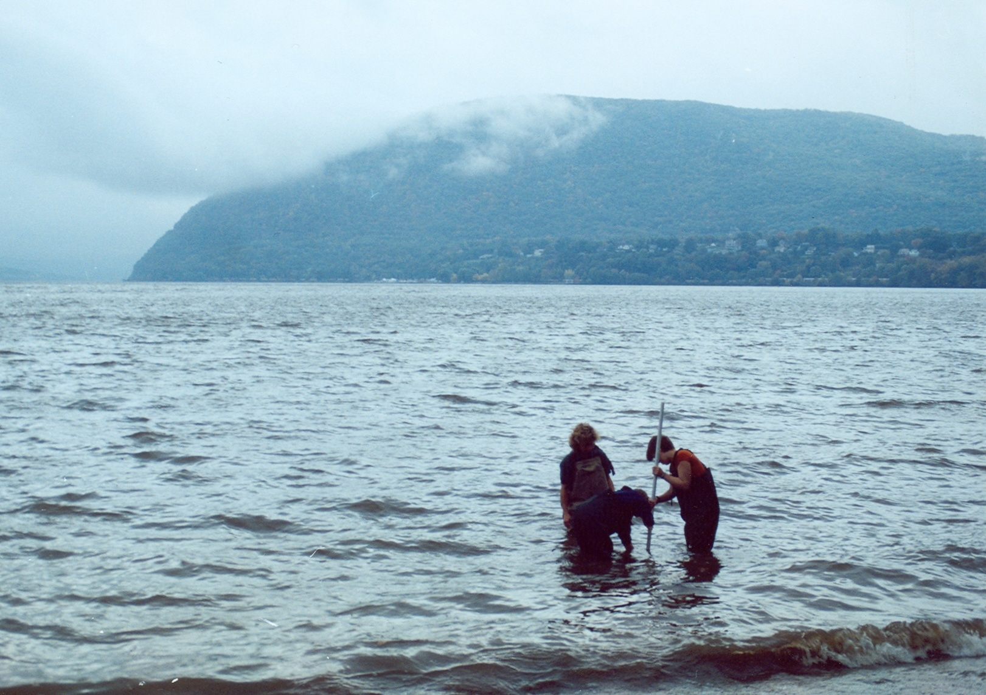
Location: Sandy beach at Kowawese, New Windsor, Orange County
Area: Sandy beach surrounded by grass and trees and picnic area. Parkign above beach area. No swimming. People fish and launch boats here.
Surrounding Land Use: Forested 10%, beach 70%, park 20%
Sampling Site: sandy beach (cove) – Moodna Creek just south of beach. Much wood, plants and trash washed up on beach.
Plants in area: no plants growing in the water at the beach area
Washed up on shore: 85% water chestnut
15% water celery
Water depth: 2 feet
River Bottom – sandy with some rocks – no aquatic plants rooted, only washed up on the beach

ITEM | Time |  | Reading 1 | Reading 2 | Comments
Physical
Air Temperature | 10:22 AM |  | 17.7°C  64°F | 17.7°C  64°F | 17.2°C  63°F
 | 11:18 AM |  | 17.7°C  64°F | 17.7°C  64°F | 17.7°C  64°F
 | 1:15 PM |  | 20°C  68°F | 19.4°C  67°F | 20°C  68°F
Wind Speed | 2 knots |  | South | Water somewhat choppy
Cloud Cover | Overcast to begin then went to partly cloudy
Weather today | Drizzle in AM
Weather recently | Heavy rain overnight, light rain day before, 2-3 days before that warm and sunny
Water Temperature | 10:30 AM | 63° F  17.2°C |  | 11:30 AM | 65° F  18.3°C
Turbidity  sight tube | 10:22 AM | 80 JTU |  | 80 JTU | 80JTU
 | 11:00 AM | 50 JTU |  | 60 JTU | 60 JTU
 | 1:15 PM | 60 JTU |  | 80 JTU | 60 JTU
Chlorophyll | 10:25 | .7 |  | 1:15 PM | 1.0
Chemical
DO  (drop kit) | 10:25 AM | 10.0 mg/L |  | 18°C | 110%
 | 12:45 | 11.0 mg/L |  | 19°C | 115%
 | 1:40 PM | 10.0 mg/L |  | 19°C | 105%
pH (litmus paper) | 10:22 AM | 7.0 |  | 7.6 | 7.0
Phosphate
Nitrate
Alkalinity
Salinity  Quantabs | 11:22 AM | 36 ppm
 | 12:45 PM | 57 ppm
 | 1:40 PM | 57 ppm
Fish Catch | Number Caught | Species |  | CPUE | Seine  25 ft net/ 20 ft pull
11:00 AM low tide | 14 | Unknown baby fish w/forked tail |  |  | Seine #1  (2 pulls each group)  (17 total)
 | 2 | Striped Bass
 | 1 | Blue crab
12:00 noon higher tide | 1 | Herring |  |  | Seine #2  (2 pulls each group)  (12 total)
 | 5 | Unknown baby fish w/forked tail
 | 1 | White perch
 | 2 | Spottail shiner
 | 1 | Striped crab
 | 2 | Blue crab - male
1:00 PM | 6 | Spottail Shiner |  |  | Seine #3  (2 pulls each group)  (9 total)
 | 2 | Striped Bass
 | 1 | Sunfish
Tides | 11:15 AM | 23 cm
 | 11:50 AM | 41 cm |  | Rising
 | 12:50 PM | 74 cm |  | Rising
 | 1:10 PM | 81 cm |  | Rising
 | 1:35 PM | 61 cm |  | Falling
 | 1:45 PM | 58 cm |  | Falling
Currents |  |  |  | Beach is in a cove – no currents recorded
Traffic | 1:15 PM | Canoe with 2 sails |  | Southbound
 | 1:50 PM | Large red barge |  | Southbound
Other Items | 2 | Garter snakes
 | 2 | Monarch butterflies
 | 12 | People: fishing, with dogs, walking, picnicing

