Snapshot Day 10/12/06 Data
(Salt Front RM 52.5)
RIVER MILE 61E
Long Dock, Beacon
Latitude 42°15’.407” Longitude 73°48’.781”
Rebecca Johnson, NYS DEC Hudson River Estuary Program
Susan Hereth, Scenic Hudson
Linda Houlihan, Beacon 5th grade
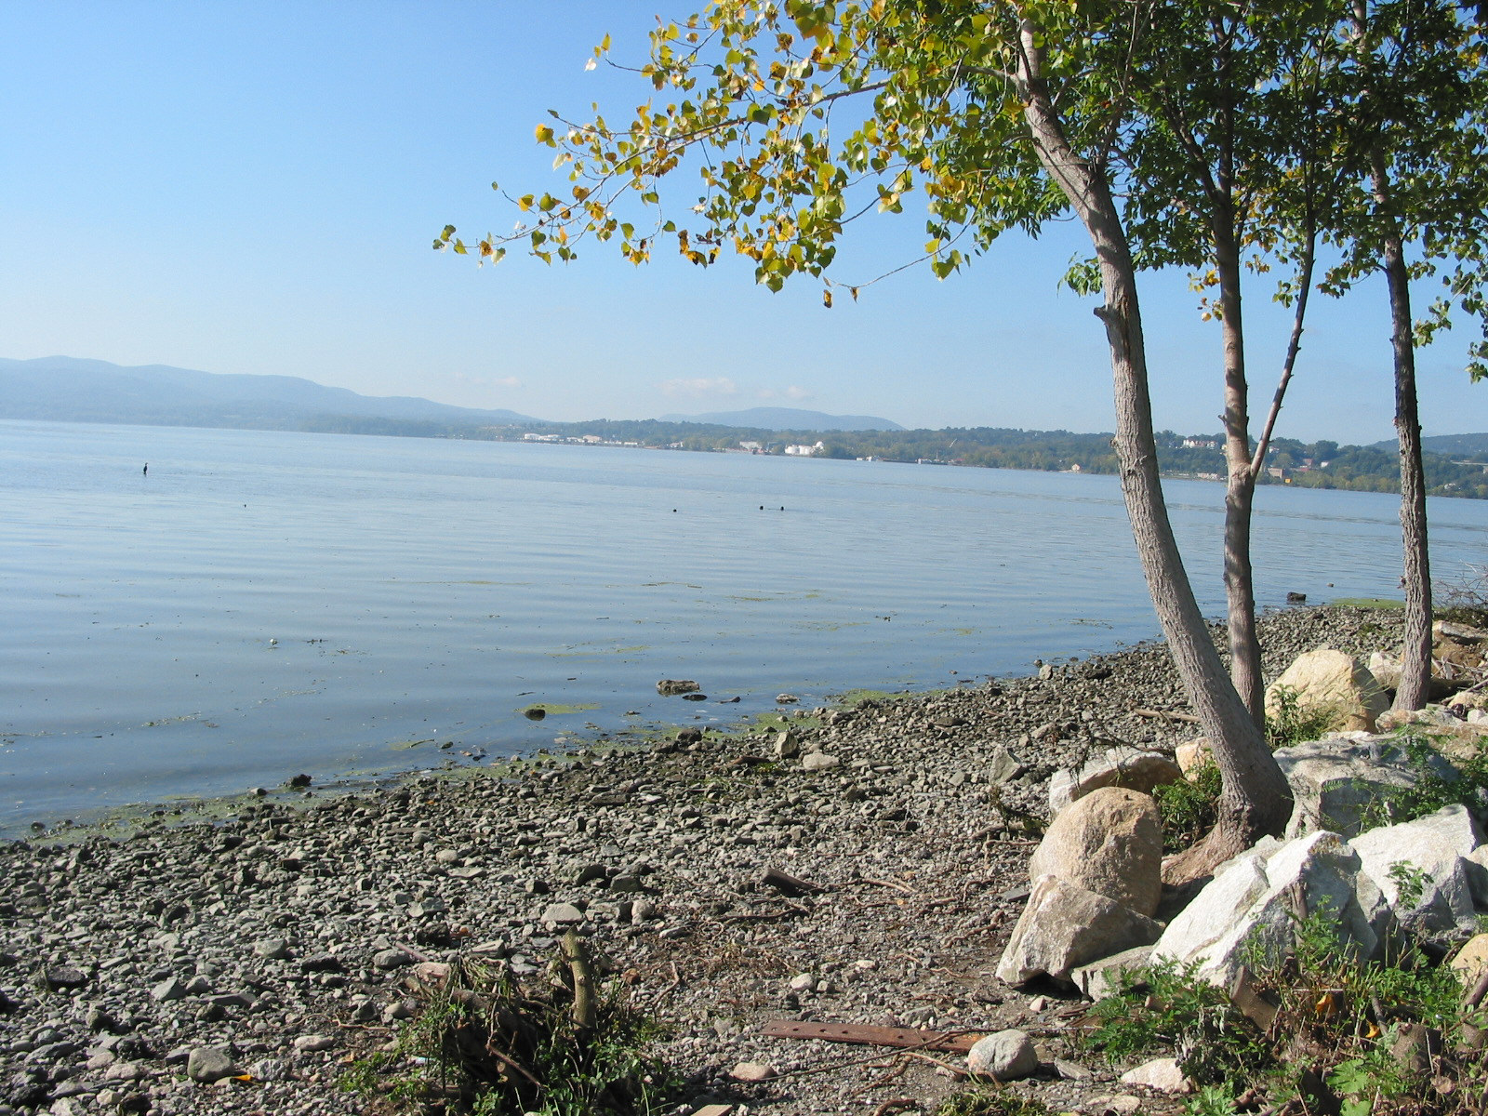 | 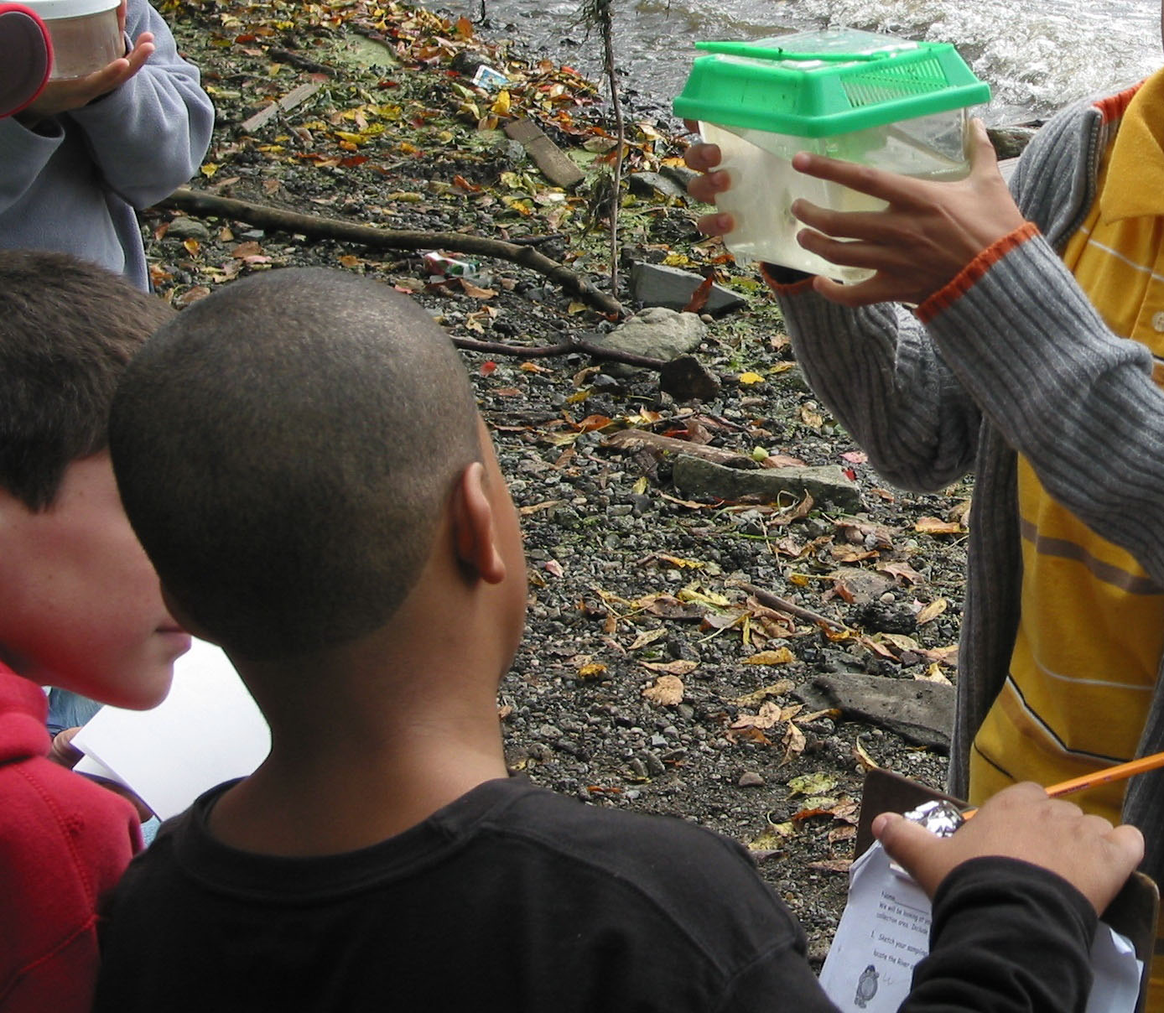 | 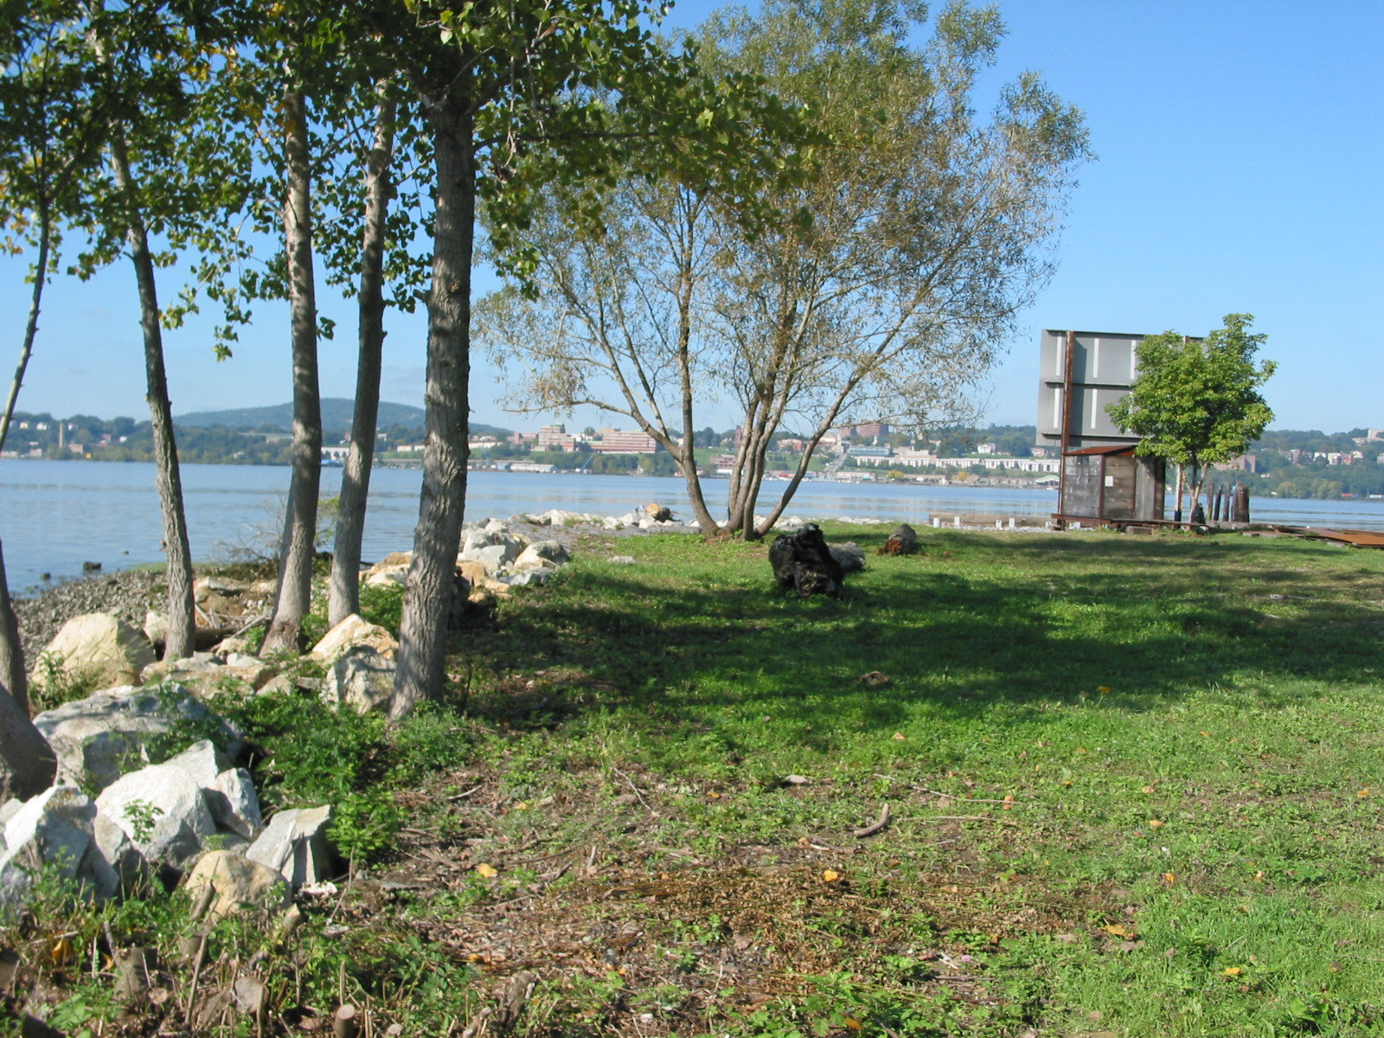
Location: Long Dock in Beacon, Dutchess County NY
Area: Site is forested, open and grassy, includes a parking lot, used for picnics, and fishing
Surrounding Land Use: Forested 25%, beach 35%, urban-residential 2%, open area with grass and cement 38%
Sampling Site: beach, banks altered, shoreline rip rap, bulkhead, collected wood/debris
Plants in area:
Tidal Shallows Plants | water celery 15% | water chestnut 85%

Water depth: 1-5 ft. deep
Bottom Surface: rocky and muddy

ITEM | Time |  | Reading 1 | Reading 2 | Comments
Physical
Air Temperature | 10:20 AM |  | 19°C  62 °F
 | 11:20 AM |  | 21°C  68 °F
 | 1:20 PM |  | 21°C  70 °F
Wind Speed | 10:20 AM |  | 11-16 knots Beaufort | South
 | 11:20 AM |  | 10 knots
Cloud Cover | overcast |  |  |  | Water choppy
Weather today | Mostly cloudy and overcast BUT at 11:30 sun came out
Weather recently | Stormy and showers overnight, windy warm and sunny 2 days ago
Water Temperature | 10:15 AM | 62° F  18°C |  | 62° F  18°C
 | 10:45 AM | 61° F  17°C |  | 61° F  17°C
 | 11:15 AM | 62° F  18°C |  | 62° F  18°C
 | 12:10 PM | 63° F  19°C |  | 60° F  17°C | Second temp. in shady spot
 | 12:51 PM | 62° F  18°C |  | 62° F  18°C
 | 1:25 PM | 62° F  18°C |  | 62° F  18°C
Turbidity | 10:30 Am | 80 JTU |  | 80 JTU | Sight tube
 | 10:45 AM | 80 JTU |  | 80 JTU
 | 11:30 AM | 80 JTU |  | 80 JTU
 | 12:40 PM | 80 JTU |  | 80 JTU
 | 12:50 PM | 80 JTU |  | 80 JTU
 | 1:25 PM | 80 JTU |  | 80 JTU
Chlorophyll | 9:00 | 2.0
Chemical
DO  (drop kit)  9.0 mg/L each test | 10:15-1:25 PM | 9.0 mg/L |  | 17°C  63°F | 95%
pH – Indicator Sol. | 10:15-1:25 | 7.5 |  | 7.5 | 7.5
pH pen | 10:15-1:25 | 8.0 |  | 8.1 | 7.9
Phosphate
Nitrate
Alkalinity | 12:45 PM | 120 ppm
Salinity - %NaCl | 10:15-1:25 | .006 |  | .005 | .006
Fish Catch | Number Caught | Species |  | CPUE | Seine – 1 pull  80 ft.
 | 4 | Blueback Herring
 | 1 | Pumpkinseed
 | 2 | Smallmouth bass
 | 1 | Spottail shiner
 | 6 | Striped bass
 | 5 | White perch
 | 1 | American Shad |  | Y-o-y (young of the year)
Tides | 10:08 AM
 | 10:35 AM |  |  | Falling
 | 10:40 AM |  |  | Falling
 | 11:28 AM |  |  | Rising
 | 12:05 PM |  |  | Rising
 | 12:40 PM |  |  | Rising
 | 1:05 PM |  |  | Rising
 | 1:45 PM |  |  | Rising
Currents | Wind was pushing stick upriver (north) – wind too strong to determine current I believe
Traffic | 12:45 PM | Very large Barge |  | South | loaded – possible fill or dirt
Other Items |  | Immature bald eagle
 |  | Gulls
 |  | cormorant
 | 2 | Monarch  butterflies

