Snapshot Day 10/12/06 Data
(Salt Front RM 52.5)
RIVER MILE 76
Sloop Clearwater, Poughkeepsie, Dutchess County
Jeannine Cahill, Clearwater
Smith Magnet School, 5th grade
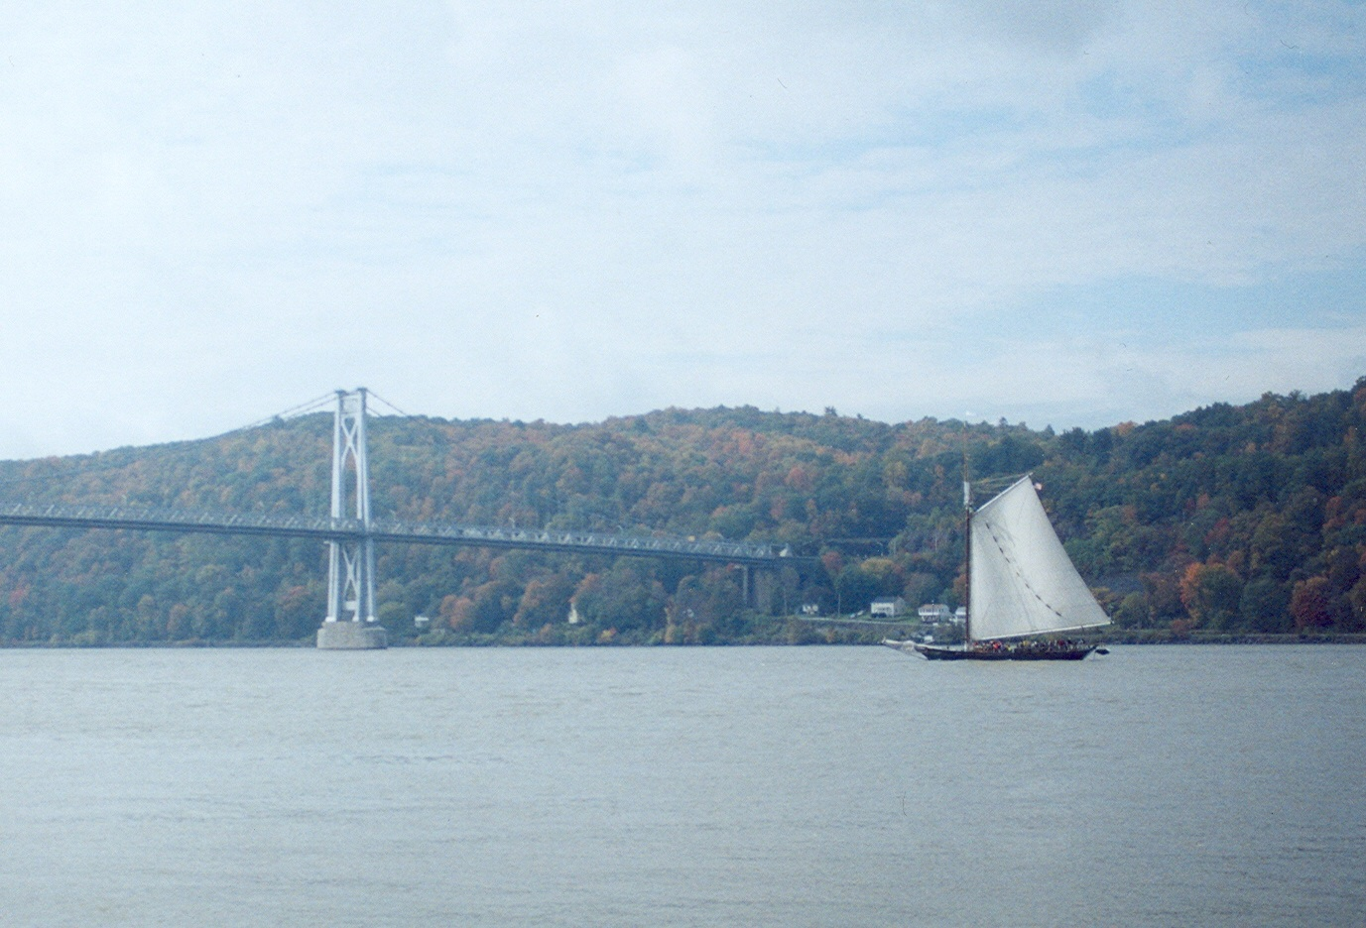
Location: Wayras Park and surrounding river area
Area: public park
Surrounding Land Use: grassy, parking lot adjacent, used for recreation – picnics, boating, fishing, swimming
Sampling Site: shoreline is riprap, and rocky
Plants in area:
Water depth: 30 ft.
River Bottom –rocky, weedy bottom

ITEM |  | Time |  | Reading 1 | Reading 2 | Comments
Physical
Air Temperature
Wind Speed |  | Force 1
Cloud Cover
Weather today |  | Cloudy, sprinkles
Weather recently |  | Heavy rain last night
Water Temperature |  | 11:05 AM | 63° F  17.2°C |  | 65° F  18.3°C | 64° F  17.7°C
Turbidity – sight tube |  | 10:40 AM | 40 cm |  | 35 cm | 35 cm
Chlorophyll
Chemical
DO  (drop count) |  | 11:08 AM | 8.0 mg/L |  | 17.7°C | 84%
pH – test strips |  | 11:14 AM | 8.0 |  | 7.5 | 7.5
Phosphate
Nitrate
Alkalinity
Salinity - refractometer |  | 11:20 AM | 0 ppm |  | 2 ppm | 0 ppm
Fish Catch |  | Number Caught | Species |  | CPUE | trawled
 |  | Nothing caught in trawl
Macroinvertebrates |  | scuds | copepods |  | Segmented worms
Tides |  | 10:56 AM |  |  | Falling
Currents |  | 10:56 AM |  |  | Ebb
Traffic
Other Items |  | Noted cigarette butts, bottles, candy wrappers/paper as pollution

