Snapshot Day 10/12/06 Data
(Salt Front RM 52.5)
RIVER MILE 7 and River Mile 11
79th St. Boat Basin (plankton & minnow traps)
Mid River South of the George Washington Bridge by Edge Water, New Jersey
Sloop Lettie G. Howard, South Street Seaport
Shane Riordan, The Harbor School, 9th grade
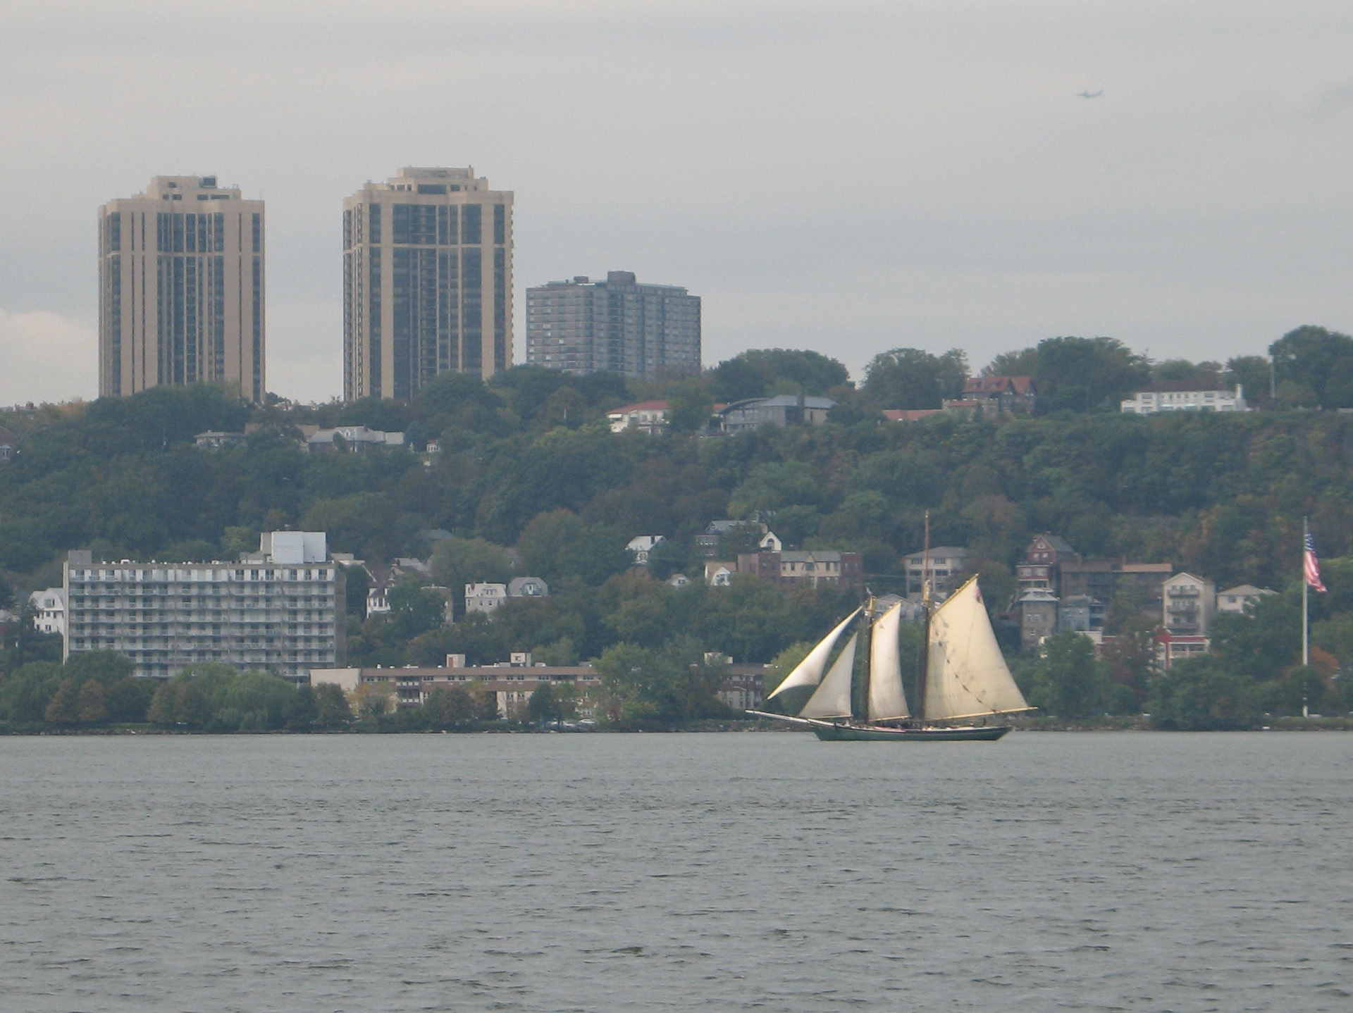

Location: 79th St. Boat Basin for plankton & minnow traps. Chemistry and trawl from Mid River South of the George Washington Bridge by Edge Water, New Jersey
Area: public boat basin and mid river
Surrounding Land Use: marina
Sampling Site: Plants in area:
Water depth:
River Bottom –

ITEM | Time |  |  | Reading 1 | Reading 2 | Comments
Physical
Air Temperature
Wind Speed
Cloud Cover
Weather today | Cloudy
Weather recently | Heavy rain last night
Water Temperature |  |  | 18.5°C
Turbidity –
Chlorophyll
Chemical
DO  (color comparator) | Boat times 11AM-3:45PM |  | 7.2 mg/L |  | 18.5°C | 77% saturated
pH –
Phosphate
Nitrate
Alkalinity
Salinity - hydrometer | Boat times 11AM-3:45PM |  | 13.3 ppt
Fish Catch | Number Caught |  | Species |  | CPUE | trawled
 | 1 (6 inch) |  | Tomcod
 | 22 (1 inch) |  | Glass shrimp
 | 11 (5 inch) |  | Hog chocker
 | 2 (7-8 inch) |  | Oyster toadfish
 | 1 (1 inch_ |  | Striped sea robin
 | 28 (103 inch) |  | Blue crab
 | 15 (3-5 inch) |  | Blue crab
 | 4 (6-7 inch) |  | Blue crab
 | 6 (3-5 inch) |  | Weakfish
 | 1 (3 inch) |  | Mantis shrimp
Minnow Traps  79th street | 1 (1.5 inch) |  | Grubby |  |  |  | Trap #1
 | 2 (2 inch) |  | Glass Shrimp
 | 1 (2 inch) |  | Glass shrimp |  |  |  | Trap #2
 | 1 (1/2 inch) |  | Mud crab |  |  |  | Trap #3
Plankton  79th street | Dinoflagellates |  | Diatoms |  |  |  | Phytoplankton
Plankton  79th street | Copepods |  | Zoea |  | Comb Jelly |  | Zooplankton
 | Sea lice
Tides
Currents
Traffic
Other Items

