Snapshot Day 10/12/06 Data
(Salt Front RM 52.5)
RIVER MILE 84.5
Mills-Norrie Point Environmental Center, Staatsburgh, NY, Dutchess County
Jean Villa McAvoy & Laurie Fila, Hudson River National Estuarine Research Reserve (HRNERR)
Johanna Tomik, Haviland Middle School (116 students 6th graders)
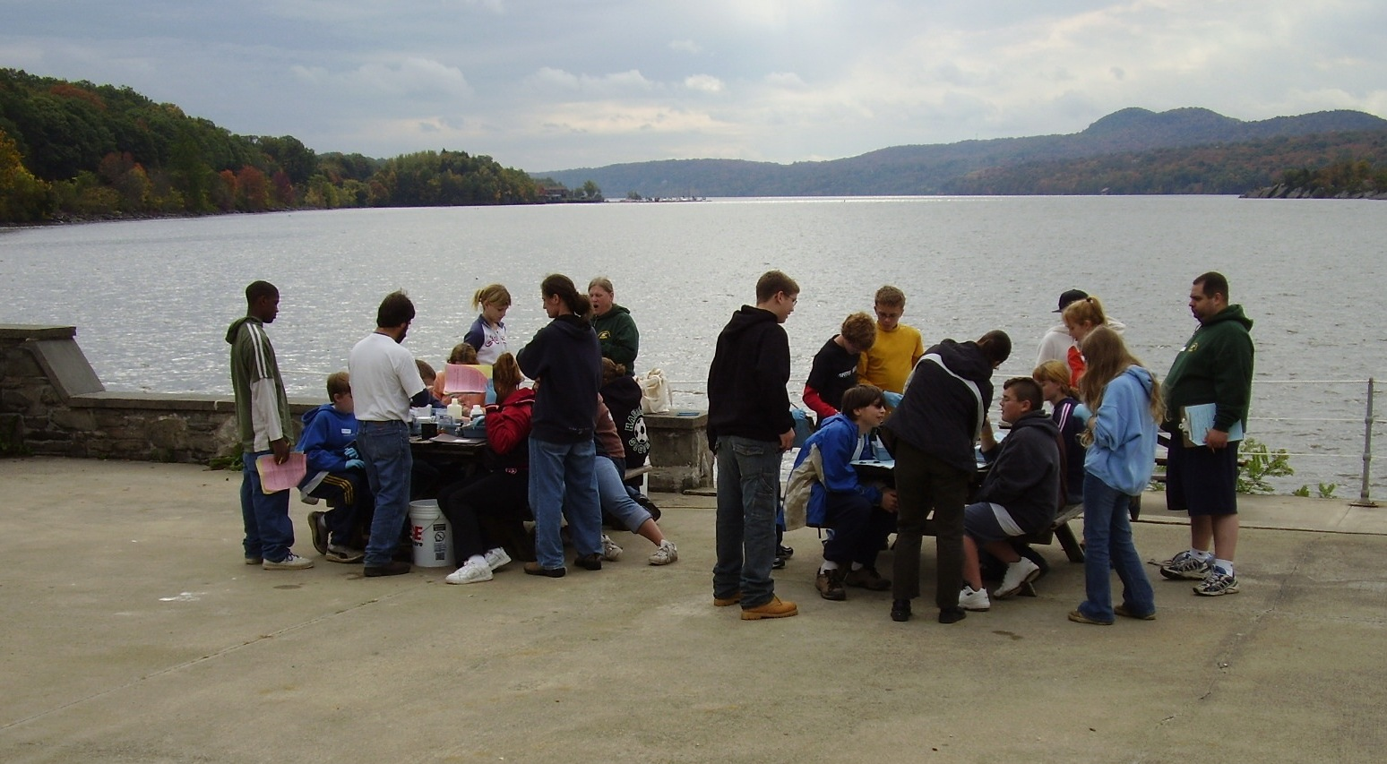
Location: Sampling done on the southern inlet of Norrie Point. East side of Hudson far from the main channel in a protected cove
Area: Substantial paved areas nearby, large environmental center building adjacent to the water.
Surrounding Land Use: forested 60%; Environmental Education Center (EEC) and concrete patio, parking lots and access area 40%
Sampling Site: Seining area – large parking lot adjacent to shallows – fairly protected bay. By water chemistry area: samples collected off concrete patio adjacent to dock and EEC; Wind and weather taken from inside EEC & concrete patio between building and river
Shoreline: covered with vegetation (some duckweed on surface, water celery in the bay- mostly uprooted), banks altered for EEC building, riprap along RR tracks, collected wood and debris in shallow cove
Plants in area: 7% of water in sampling site is covered with plants.
cattail
duckweed
water celery
water chestnut
sedge (unknown variety)
yellow flag (iris)

Water depth: 3-6 feet deep where chemistry water collected
River Bottom – gravel and rock bottom where chemistry done. Rocky and partly muddy where seining/sediment/plankton done.

ITEM | Time |  |  |  | Reading 1 |  |  | Reading 2 |  |  | Comments
Physical
Air Temperature | 9:36am |  |  |  | 18°C |  |  | Average Daily Temp |  |  | 19.2°C
 | 10:17am |  |  |  | 18°C
 | 10:50am |  |  |  | 17°C
 | 12:18pm |  |  |  | 23°C
 | 1:01 AM |  |  |  | 20°C
Wind Speed | 9:36am |  |  |  | south |  |  | 4 to 6 |  |  | Overcast
 | 10:17am |  |  |  | south |  |  | 7 to 10 |  |  | Overcast
 | 10:50am |  |  |  | south |  |  | 4 to 6 |  |  | Mostly cloudy
 | 12:18pm |  |  |  | south |  |  | 4 to 6 |  |  | Overcast
 | 1:01pm |  |  |  | south |  |  | 4 to 6 |  |  | Mostly cloudy
Cloud Cover | Yes all day
Weather today | No rain
Weather recently | Rainy afternoon and evening, windy
Water Temperature | 9:52am |  |  |  | 17°C |  |  | 18°C
 | 10:31am |  |  |  | 17°C |  |  | 17°C
 | 11:04am |  |  |  | 17°C |  |  | 17°C
 | 12:15pm |  |  |  | 17°C |  |  | 17°C
 | 1:03pm |  |  |  | 17°C |  |  | 17°C
Turbidity | Time |  |  |  | Secchi |  |  | Sight tube
Results posted as averages of 3 groups except where noted with (2) | 9:44am |  |  |  | 90cm (2) |  |  | 48 cm
 | 10:26am |  |  |  | 70cm
 | 11:08am |  |  |  | 34cm
 | 12:30pm |  |  |  | 45cm
 | 1:15pm |  |  |  | 45cm |  |  | 54 cm (2)
Chlorophyll | 9:30 AM |  |  |  | 5.0 |  |  | 11:20 AM |  |  | 2.0
Chemical
DO  (drop count) | 9:32am |  |  |  | 8.0 mg/L |  |  | 17.5°C |  |  | 83%
 | 10:28am |  |  |  | 8.0 mg/L |  |  | 17°C |  |  | 82%
 | 11:04am |  |  |  | 9.0 mg/L |  |  | 17°C |  |  | 93%
 | 12:18pm |  |  |  | 9.0 mg/L |  |  | 17°C |  |  | 93%
 | 12:42pm |  |  |  | 9.0 mg/L |  |  | 17°C |  |  | 93%
pH
Phosphate
Nitrate
Alkalinity
Salinity | 9:35am |  |  |  | 40 mg/l |  |  | 35 mg/L |  |  | 37.5 mg/L
-drop count kit | 10:14am |  |  |  | 35 mg/L |  |  | 35 mg/L |  |  | 35 mg/L
 | 10:55 AM |  |  |  | 40 mg/L |  |  | 35 mg/L |  |  | 37.5 mg/L
 | 12:10pm |  |  |  | 45 mg/L |  |  | 40 mg/L |  |  | 42.5 mg/L
 | 12:56pm |  |  |  | 40 mg/L |  |  | 40 mg/L |  |  | 40 mg/L
Fish seined  39X4 ft. X 0.375 mesh | Group1 |  | Group 2 |  |  | Group 3 |  | *Group 4 |  | Group 5 |  |  | TOTAL
American Eel | 5 |  | 4 |  |  | 1 |  | 1 |  | 7 |  |  | 18
Golden Shiner |  |  |  |  |  |  |  |  |  | 1 |  |  | 1
Herring |  |  |  |  |  |  |  |  |  | 6 |  |  | 6
Pumpkinseed | 6 |  | 4 |  |  | 4 |  |  |  | 15 |  |  | 29
Smallmouth Bass |  |  |  |  |  | 1 |  |  |  |  |  |  | 1
Spottail Shiner | 3 |  |  |  |  |  |  | 1 |  | 2 |  |  | 6
Sunfish |  |  |  |  |  |  |  | 6 |  |  |  |  | 6
Tesselated Darter | 1 |  |  |  |  |  |  |  |  |  |  |  | 1
Killifish | 1 |  |  |  |  | 1 |  | 6 |  | 2 |  |  | 10
Blue Crab | 2 |  | 1 |  |  | 1 |  |  |  |  |  |  | 4
TOTALS | 18 |  | 9 |  |  | 7 |  | 14 |  | 33 |  |  | 81
Macros: 2 boatmen, 1 water beetle, 1 damselfly, isopods

* noted that they thought a large or small mouth bass was in this count but it wasn’t recorded on the sheet
30 ft net/60 ft pull | 548.64 m |  |  | 5 total |  |  |  | 0.009 |  |  | Seine #1
30 ft net/60 ft pull | 548.64 m |  |  | 2 total |  |  |  | 0.004 |  |  | Seine #2
30 ft net/60 ft pull | 548.64 m |  |  | 1 total |  |  |  | 0.002 |  |  | Seine #3
30 ft net/60 ft pull | 548.64 m |  |  | 6 total |  |  |  | 0.011 |  |  | Seine #4
30 ft net/60 ft pull | 548.64 m |  |  | 9 total |  |  |  | 0.016 |  |  | Seine
30 ft net/60 ft pull | 548.64 m |  |  | 9 total |  |  |  | 0.016 |  |  | Seine #6
30 ft net/60 ft pull | 548.64 m |  |  | 17 total |  |  |  | 0.031 |  |  | Seine #7
30 ft net/60 ft pull | 548.64 m |  |  | 16 total |  |  |  | 0.029 |  |  | Seine #8
30 ft net/60 ft pull | 548.64 m |  |  | 17 total |  |  |  | 0.031 |  |  | Seine #9
30 ft net/60 ft pull | 548.64 m |  |  | 10 total |  |  |  | 0.018 |  |  | Seine #10
Tides |  |  |  | cm |  |  |  | Ebb or flood
 | 9:30am |  |  | 59 |  |  |  | ebb
 | 10:10am |  |  | 49 |  |  |  | ebb
 | 10:38am |  |  | 41 |  |  |  | ebb
 | 10:45am |  |  | 39 |  |  |  | ebb
 | 11:10am |  |  | 36 |  |  |  | ebb
 | 12:11pm |  |  | 33 |  |  |  | flood
 | 12:36 PM |  |  | 38 |  |  |  | flood
 | 12:55pm |  |  | 46 |  |  |  | flood
 | 1:25pm |  |  | 63 |  |  |  | flood
Currents | Not recorded
* Site is far from main channel – unable to calculate current due to site restrictions
Traffic |  | Time |  |  | Direction
Sailboat under power |  | 10:25 |  |  | South
Freighter (Intermarine) |  | 11:00 |  |  | North
Tanker |  | 12:09 |  |  | North
Pleasure Boat |  | 12:19 |  |  | South
Tugboat |  | 12:21 |  |  | South
Commercial Tour Boat |  | 12:52 |  |  | South
Other Items |  | Bald eagle flew by and landed in a tree just south of the cove near the site.
 |  | We also saw the Pilot boat motor out to exchange boat pilots.
 |  | It was an exciting, informative and fun-filled day; basically it was AWESOME!! A number of Haviland students were heard to say that it was the best field trip they had been on!

