Snapshot Day 10/12/06 Data
(Salt Front RM 52.5)
RIVER MILE 92
Kingston Point Park, Kingston
GPS Latitude 41°55.64 N Longitude 73°57.80 W
Steve & Julie Noble, Forsythe Nature Center
Victor Melendez, Scenic Hudson
Jolene Johnson, Scenic Hudson
John F. Kennedy Middle School 5th grade
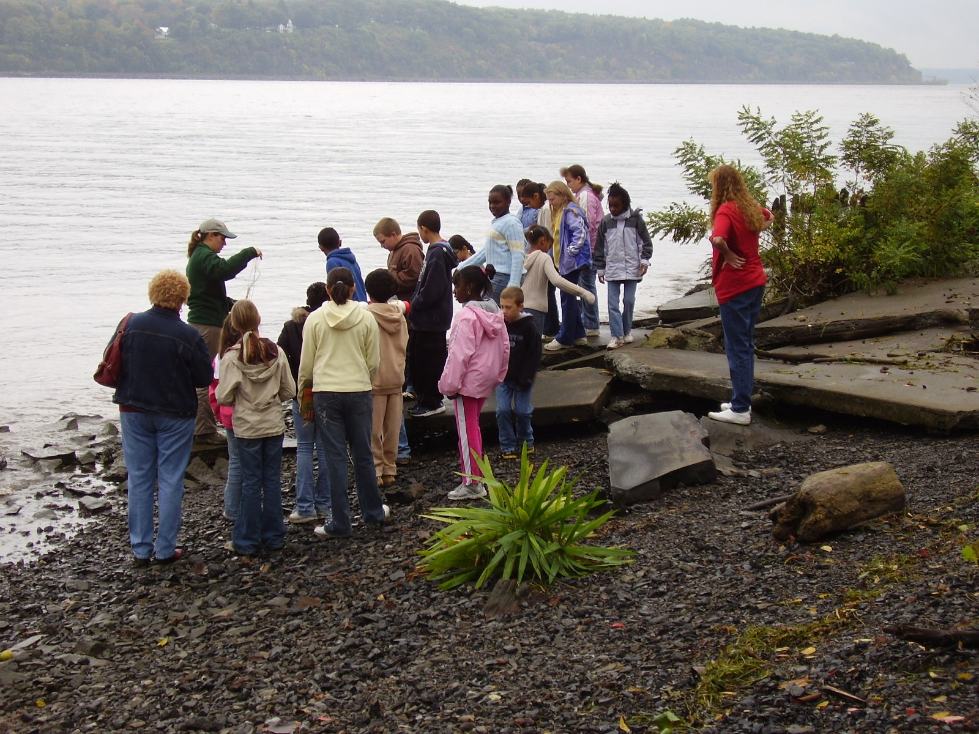
Location: Forested area, park
Area: Used for picnics, boating, fishing
Surrounding Land Use:
Group 1: 25% Forested; 45% picnic area; 30% water
Group 2: 75% grassy; 5% picnics; 5% fishing; 15% beach
Group 3: 30% forested, 70% park
Sampling Site: shoreline is rocky and muddy, banks are altered, riprap and wooden bulkhead; piping entering the river
Plants in area: Spadderdock covering 50% of area
Water depth: 9 inches
River Bottom : rocky bottom
ITEM | Time |  | Reading 1 | Reading 2 | Comments
Physical
Air Temperature | 11:18 AM |  | 23°C  77°F
 | 12:10 AM |  | 25°C  80°F | 25°C
 | 1:08 PM |  | 21°C  78°F
Wind Speed | 3 on beaufort |  | South | Calm water
Cloud Cover | overcast |  | rainy
Weather today | Partly cloudy
Weather recently | Mon. warm and sunny, Tues. cloudy and warm, Wed. cool and rain last night
Water Temperature | 11:50 AM | 20°C  62 °F |  | 1:11 PM | 20°C  62 °F
Turbidity  Site tube | 11:15 AM | 20 JTU
 | 12:10 PM | 20 cm
Chlorophyll | 11:05 AM | 0.3 |  | 0.5
Chemical
DO  (ampules) | 11:16 AM | 8.0 mg/L  10 mg/L |  | 20°C | 86% saturated  108% saturated
 | 12:09 PM | 8.0 mg/L  10 mg/L |  | 20°C | 86% saturated  108% saturated
 | 1:06 PM | 10 mg/L |  | 20°C | 108% saturated
pH | 11:10 AM | 7.2 |  | 7.2 | meter
 | 12:20 PM | 7.1
 | 1:15 PM | 6.8 |  | 7.2
Phosphate | 11:16 AM | 0.1 ppm |  | 0.1 ppm
 | 1:06 PM | 0.1 ppm
chemets | 1:25 PM | 0.2 ppm |  | 0.2 ppm
Nitrate | 11:16 AM | 0.2ppm |  | 0.2ppm
chemets | 1:06 PM | 0.1 ppm
 | 1:25 PM | 0.1 ppm |  | 0.2 ppm
Alkalinity
Salinity
Fish Catch  28’seineX35’ pull | Number Caught | Species |  | CPUE | Seine
 | 2 (6.5 in) | Bluegill Sunfish |  |  | Group 1
 | 2 (3.5 in) | Shiner
 | 2 (5.2 in) | Sunfish |  |  | Group 2
 | 1 | Shiner
 | 1 | Banded killifish |  |  | Group 3
 | 1 | Bluegill Sunfish
 | 1 | sunfish
Tides- Group 1 | 10:41 AM | 5.5 inches
 | 11:07 AM | 3 inches |  | Falling
Group 2 | 11:42 AM | 9 inches
 | 12:15 PM | 6.5 inches |  | Falling
Group 3 | 1:00 PM | 12 inches
 | 1:14 PM | 13 inches |  | Rising
Currents | 10:47 AM | ebb
 | 11:45 AM | ebb
 | 1:03 PM | flood
Traffic | 12:30 PM | Barge |  | Southbound
 | 12:45 PM | Barge |  | Southbound
 | 12:45 PM | Tugboat |  | Southbound
Other Items | Pollution items | Plastic, foil, glass bottles, shoe, glass, lighter, oil from factory, trash, animal waste
 | Three recreational boats | 10:30, 10:37 and 10:40 speedboats on the river
 | Three additional recreational boats | 11:40 AM Sailboat South  11:55 AM Motorboat South  Noon kayak heading north
Core

