Snapshot Day 10/12/06 Data
(Salt Front RM 52.5)
RIVER MILE 96.5
Ulster Landing State Park, Town of Ulster, Ulster Co.
Latitude 42°N, Longitude 73°56’W
Rick Fritschler of Lower Esopus River Watch
Dixon Onderdonk, Kingston High School 11-12th graders
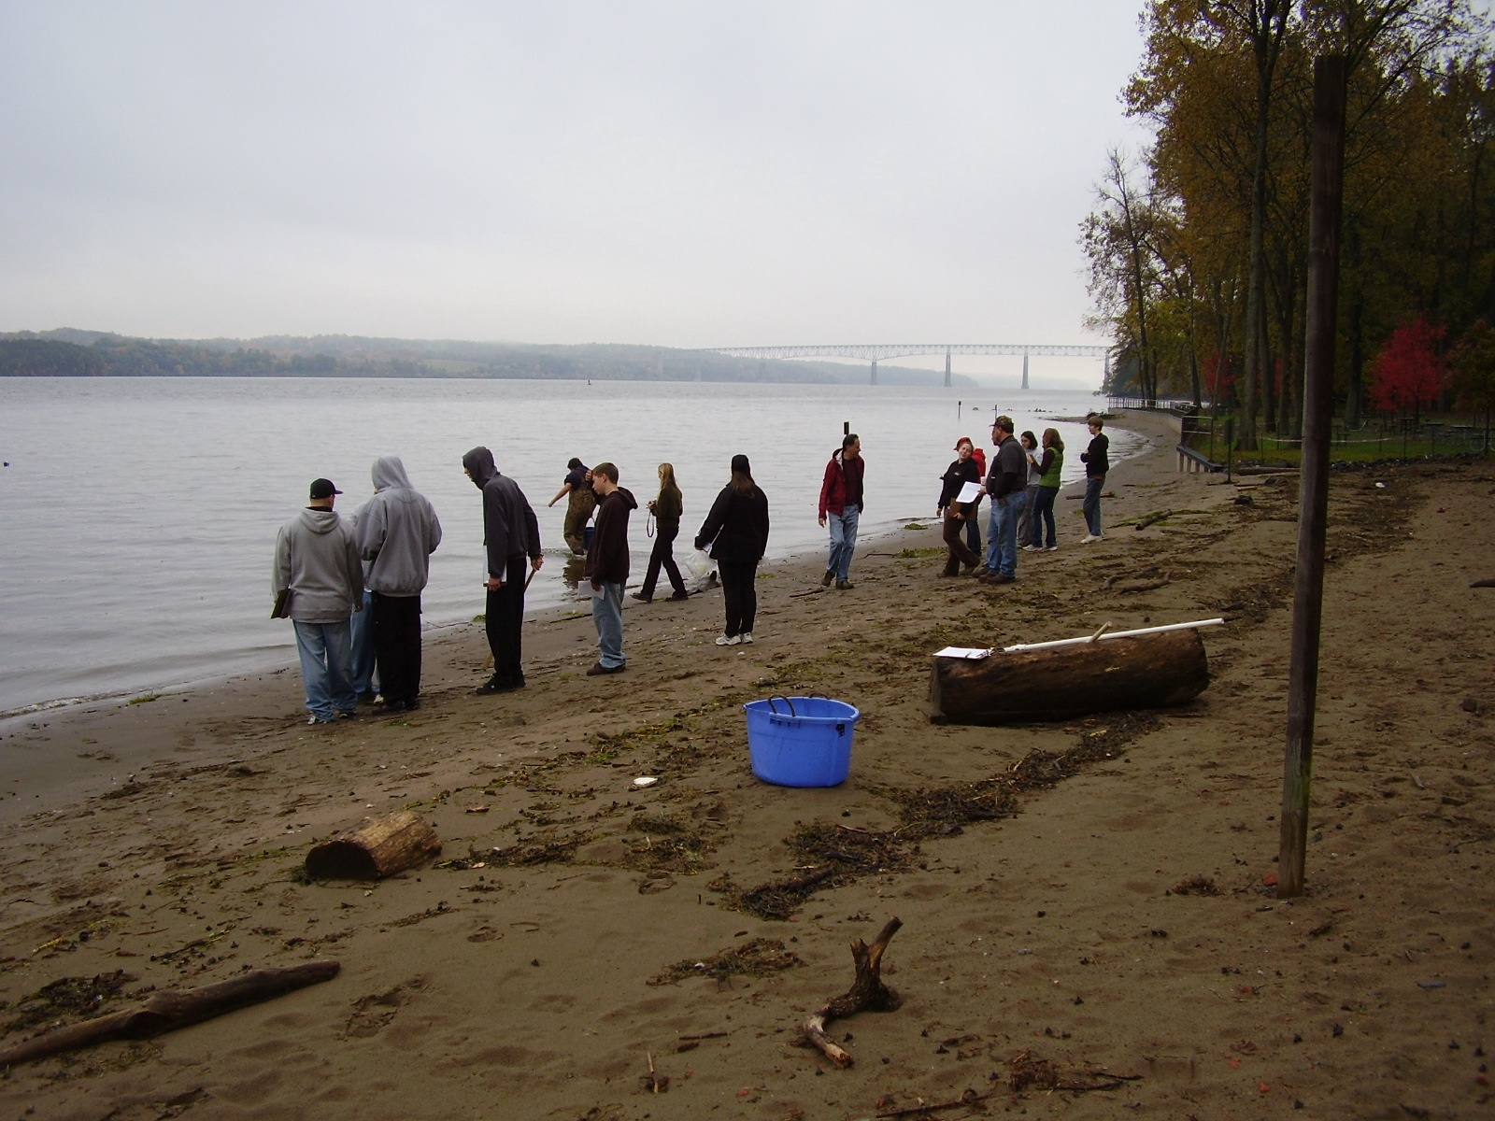
Location: Swimming beach, Ulster Landing Park, Town of Ulster, Ulster County
Area: fishing, swimming beach, has a building with restrooms
Surrounding Land Use: Beach 95%; Wooded lawn picnic area 5%
Sampling Site: beach, sandy, altered bank with bulkhead with metal plates holding shore in place, somw driftwood, Piping entering the river north of site ~ 5-10 ft.
Plants in area: no plants evident

Water depth: 56 cm
River Bottom : sandy bottom

ITEM | Time |  | Reading 1 | Reading 2 | Comments
Physical
Air Temperature | 10:15 AM |  | 17°C  62 °F
Wind Speed | 1-3 on beaufort |  | SW | Water calm
Cloud Cover | overcast |  | No rain
Weather today | Clearing around 11:30 AM
Weather recently | M & T sunny; W (yesterday) rainy overnight
Water Temperature | 9:30 AM | 17°C  62 °F |  | 17°C  62 °F | 17°C  62 °F
 | 10:12 AM | 16°C  60 °F |  | 16°C  60 °F | 16°C  60 °F
Turbidity  turbidimeter | 10:25 AM | 5.61 NTU |  | 5.57 NTU | 5.89 NTU
Chlorophyll | 10:00 | 0.3
Chemical
DO  (Hach DR-890) | 10:25 Am | 11.8 mg/L |  | 17°C | 120% saturated
pH | 10:25 | 8.0 X 3 tests |  |  | Indicator sol.
Phosphate | 10:30 AM | 0.08 mg/L |  | 0.04 mg/L
Nitrate | 10:27 AM | 1.9 mg/L
Alkalinity | 10:30 AM | 50 mg/L |  | 60 mg/L | 60 mg/L
Salinity | 10:23 Am | 64 mg/L X 3 tests |  |  | Lamotte titration kit
Fish Catch  27.5’seine | Number Caught | Species |  | CPUE | Seine
 | 1 | Golden Shiner |  | 11 cm
 | 23 | Spottail Shiner |  | 11 cm
 | 3 | Striped Bass |  | 5.5 cm
 | 1 | Tesselated Darter |  | 5.5 cm
 | 3 | White Perch |  | 15 cm
 | 15 | Blue Crab
 | 6 | Amphipods
Seine #1 | 11:30 AM | 7 fish |  | 0.01 | 75 ft. pull
Seine #2 | 11:45 Am | 1 fish |  | 0.002 | 75 ft. pull
Seine #3 | 12:00 PM | 12 fish |  | 0.014 | 100 ft. pull
Seine #4 | 12:15 PM | 11 fish |  | 0.007 | 200 ft. pull
Tides | 9:00 AM |  |  | Ebb
 | 10:00 AM |  |  | Ebb
 | 11:00 AM |  |  | Ebb
 | 12:00 PM |  |  | Rising
 | 1:00 PM |  |  | Rising
Currents
Traffic | 9:05 AM | Canadian Pleasure Boat |  |  | Southbound
 | 9:43 AM | Sailboat with 2 people |  |  | Southbound
 | 9:52 Am | Sailboat with 3 people - Andren |  |  | Southbound
 | 10:11 AM | Large boat with raft – 3 people |  |  | Southbound
 | 10:12 AM | Small speed boat 2/liferaft |  |  | Southbound
 | 10:12 AM | Medium speedboat with 1 person |  |  | Northbound
 | 11:45 AM | Sailboat 2 people with lifeboat |  |  | Southbound
 | 12:15 PM | Large Barge – red |  |  | Southbound
 | 12:36 PM | Large barge blue |  |  | Northbound
Other Items
Core | Water depth 50 cm  Slightly oxidized top  No H2S smell or oil  Mainly sand with rare bits of mud and clay  Few brick pieces  Mostly dark brown – some light on top layer

