Snapshot Day 10/12/06 Data
(Salt Front RM 52.5)
RIVER MILE -11
Breezy Point, Queens
GPS latitude N40.5733 W 073.93313
Dan Meharg, Geri Kobryn-Blatter, Jen and Liz at Ecology Village,
National Parks Service Rangers
Mrs. Crane’s Class at I.S. 220
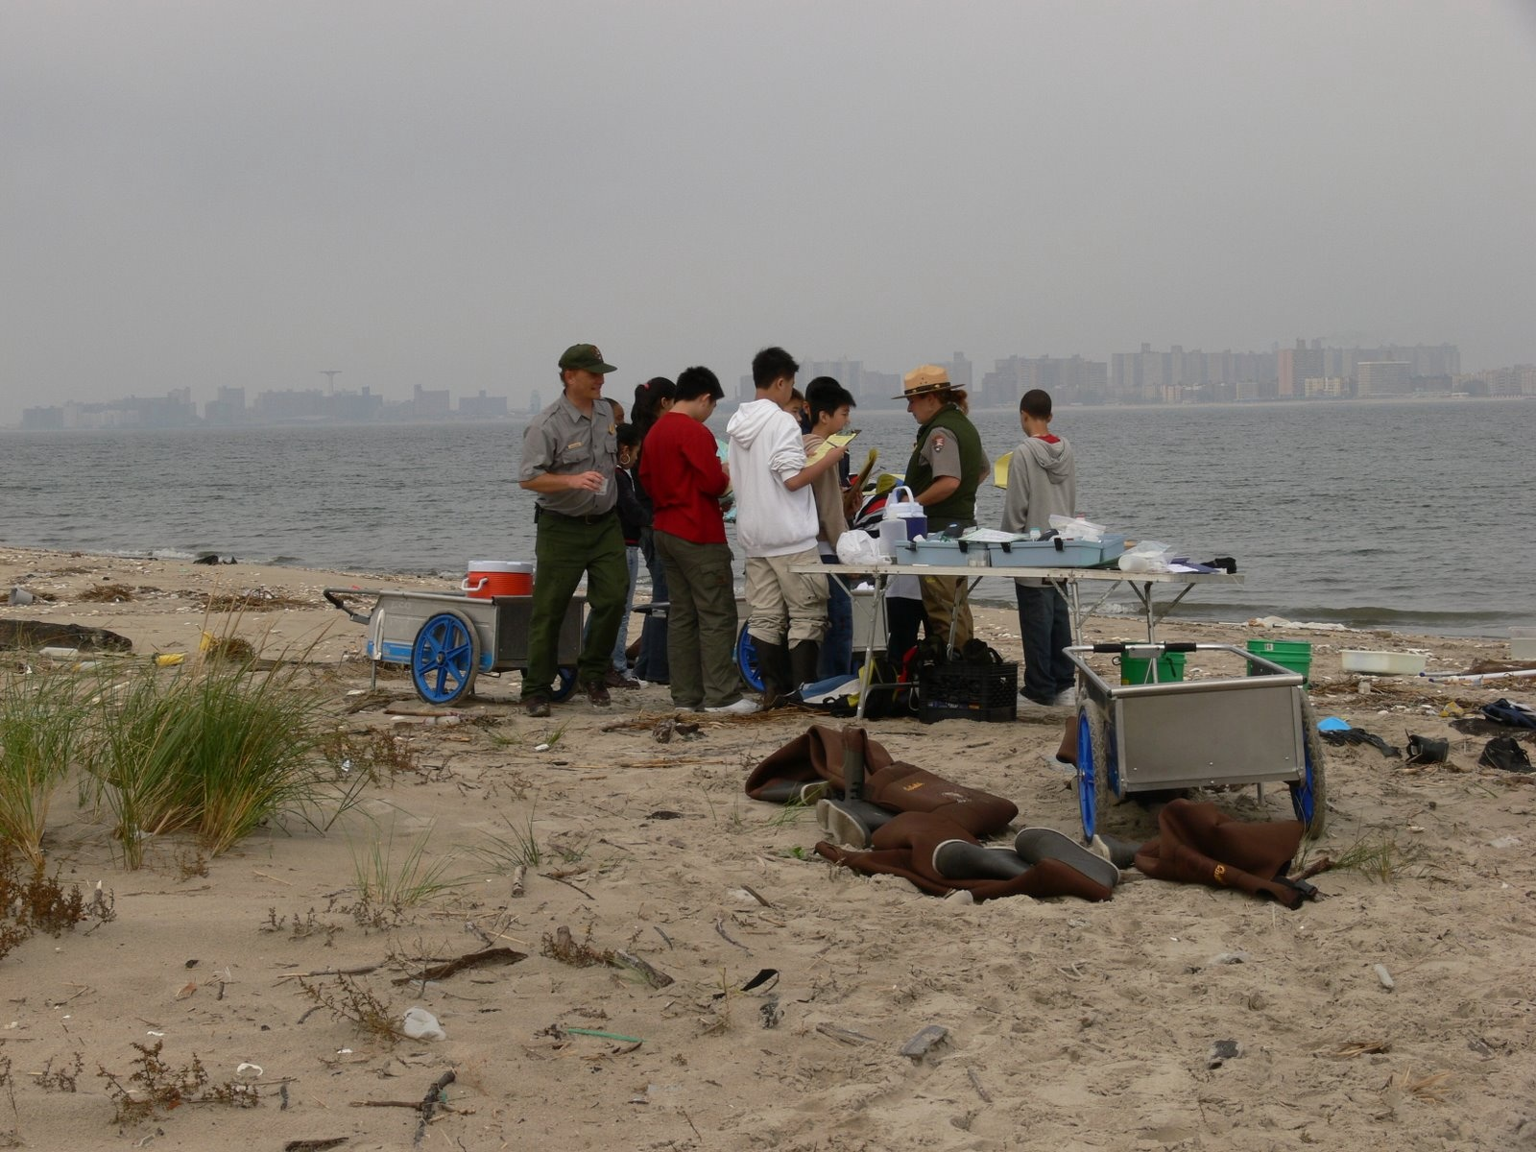
Location: Breezy Point, Queens, Jamaica Bay
Area: Bay side of Breezy Point facing north towards Coney Island

ITEM | Time |  | Reading 1 | Reading 2 | Comments
Physical
Air Temperature | 10:30 AM |  | 70° F  23° C
Cloud Cover | Partly cloudy
Weather yesterday | Rainy ~ 1 inch
Water Temperature | 10:39 AM | F 65°  C 17° |  | Water depth 1 ft. | Open water
Turbidity |  | 71.1 cm |  |  | Site tube
 |  | 28 inches
Chlorophyll
Chemical
DO  (Hach DR820 colorimeter) | 10:44 AM | 7.1 mg/L |  | Temp. 17° C | 75% saturated
pH | 10:39 AM | 8.0
Phosphate | n/a
Nitrate | n/a
Alkalinity | n/a
Salinity | 10:40 AM | 9.3 ppt |  |  | Generally 26.8 ppt (last night’s rain effect?)
Fish Catch | Number Caught | Species |  |  | Seine net
 | 25 | Atlantic Silversides
Macroinvertebrates | 2 | Hermit Crab
 | 10 | Grass Shrimp
 | 1 | Horseshoe Crab
Tides
 | 10:30AM | 33 cm |  | Rising
Currents

