Snapshot Day 10/12/06 Data
(Salt Front RM 53.5)
RIVER MILE -3 (Red Hook)
Ludger Balan, The Urban Divers/Gowanus Canal
Kathy Palmer, PS 91 from the Bronx (6th grade)
Janine King & Debbie Argenziano, PS 27 from Red Hook (6thgrade)
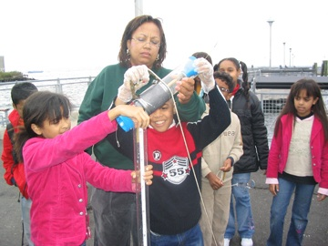 |  | 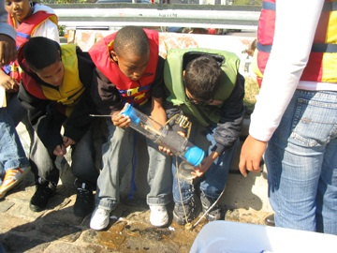

Location: Valentino Piers is located at Coffey and Ferris in Red Hook, Parallel to the Battery, Governors Island , along the coast of Brooklyn.
Area: Beach Front and Pier, Common Public Usage: small boat launch, Picnic, Fishing, Occasion Swimming.
Surrounding Land Use: Mixture of RipRap, Sheet Metal Bulk Head, Banks altered.
Bulkhead, Collected Wood Debris in the area.
Sampling Site: At the end of the pier the river bottom has significant mussel beds. Vegetation only exits on the park section of the area. The plants are native species which were planted by the NYC Parks.
Plants in area: None of the area was covered with plants in the water.
Water Depth: 3 to 12ft incline towards open water
River Bottom: Rocky, Gravelly, Sandy

ITEM | Time | Reading 1 |  | Reading 2 |  | Comments
Physical
Air Temperature | 11:25 AM | 25° C |  | 25° C
Wind Speed | 17/21 knots | South/East |  |  |  | Water Choppy
Cloud Cover | Mostly cloudy
Weather today | No rain. Day began with cloud cover but over timd clouds broke up in the west
Weather recently | Rain yesterday and last night
Water Temperature | 1:30 PM | Surface 23° C
Turbidity | 11:20 AM | 3 ft. |  |  | 3 ft. | Both Secchi  & sight tube
Chlorophyll
Chemical
DO  (ampules) | Unable to read due to contaminated kit
pH - Lamotte test & colorimeter | 12:05 | 7.5 |  |  | 7.5 | 7.5
Phosphate | n/a
Nitrate | n/a
Alkalinity | n/a
Salinity - hydrometer | 11:20 AM | 26 ppt |  |  | 22 ppt | 26 ppt
Fish Catch | Number Caught
Ran out of time so unable to seine | Previous seine records from around same time of year  In 2 pulls  (not included in cumulative totals for Snapshot Day) |  |  |  | 45 Silversides  6 mud crabs  6 jelly fish  6 grass shrimp
Sediment Core | No core, but sediment is sand/gravel/pebbles
Tides | 10:30 AM |  | 3 feet |  | Rising
Currents
 | North/South |  | ~2.5 knots |  | Flood

