Snapshot Day 10/12/06 Data
(Salt Front RM 52.5)
RIVER MILE -7 Ft. Wadsworth

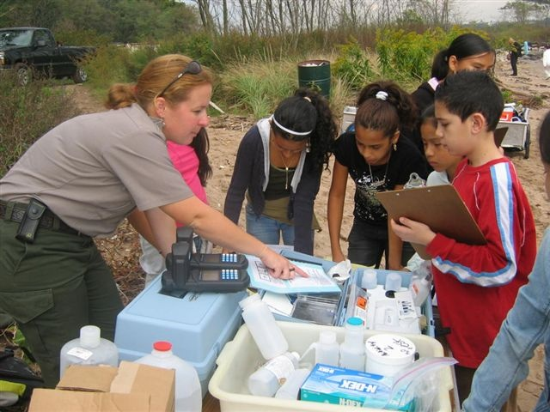 | 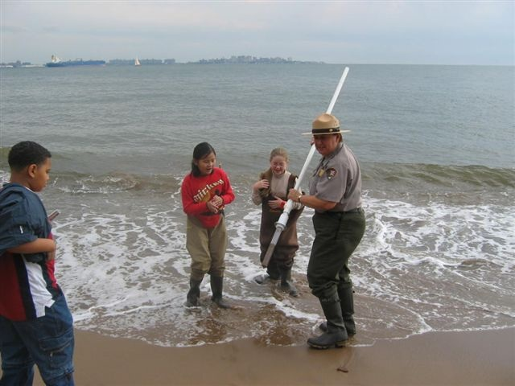

GPS latitude N40.59918 W 074.05427
Dan Meharg, Geri Kobryn-Blatter, Jen and Liz at Ecology Village,
National Parks Service Rangers
Mrs. Crane’s Class at I.S. 220
Location: Fort Wadsworth, Verrazano Bridge
Area: Facing south toward Sandy Hook (confluence of Hudson, Raritan and Atlantic Ocean

ITEM | Time |  | Reading 1 | Reading 2 | Comments
Physical
Air Temperature | 12:30 PM |  | 73° F  23° C
Cloud Cover | Partly cloudy
Weather yesterday | Rainy ~ 1 inch
Water | Very Choppy water – high tide
Water Temperature | 12:30 PM | F 70°  C 22° |  | Water depth 1 ft. | Open water
Turbidity
Chlorophyll
Chemical
DO  (Hach DR820 colorimeter) | 12:44 PM | 8.1 mg/L |  | Temp. 22° C | 95% saturated
pH | 12:30 PM | 7.0 |  | 8.0 | 7.5
Phosphate | 12:30 PM | .4 mg/L |  | .6 mg/L | Taken near Verrazano Br.
Nitrate | 12:44 | .30 mg/L |  | .34 mg/L
Alkalinity | n/a
Salinity | 12:34 PM | 22.5 ppt
Fish Catch | Number Caught | Species
 |  |  |  |  | Tried seining but too choppy
Core Sample |  |  |  |  | Taken by Verrazano Br.
Tides
 | 12:30PM | 10 cm |  | Rising
Currents

