Snapshot Day 10/12/06 Data
(Salt Front RM 52.5)
RIVER MILE East River 1 East
Joshua Wiese, New York Soil & Water Conservation District
Kathleen Rucker, Brooklyn International High School, 11th grade
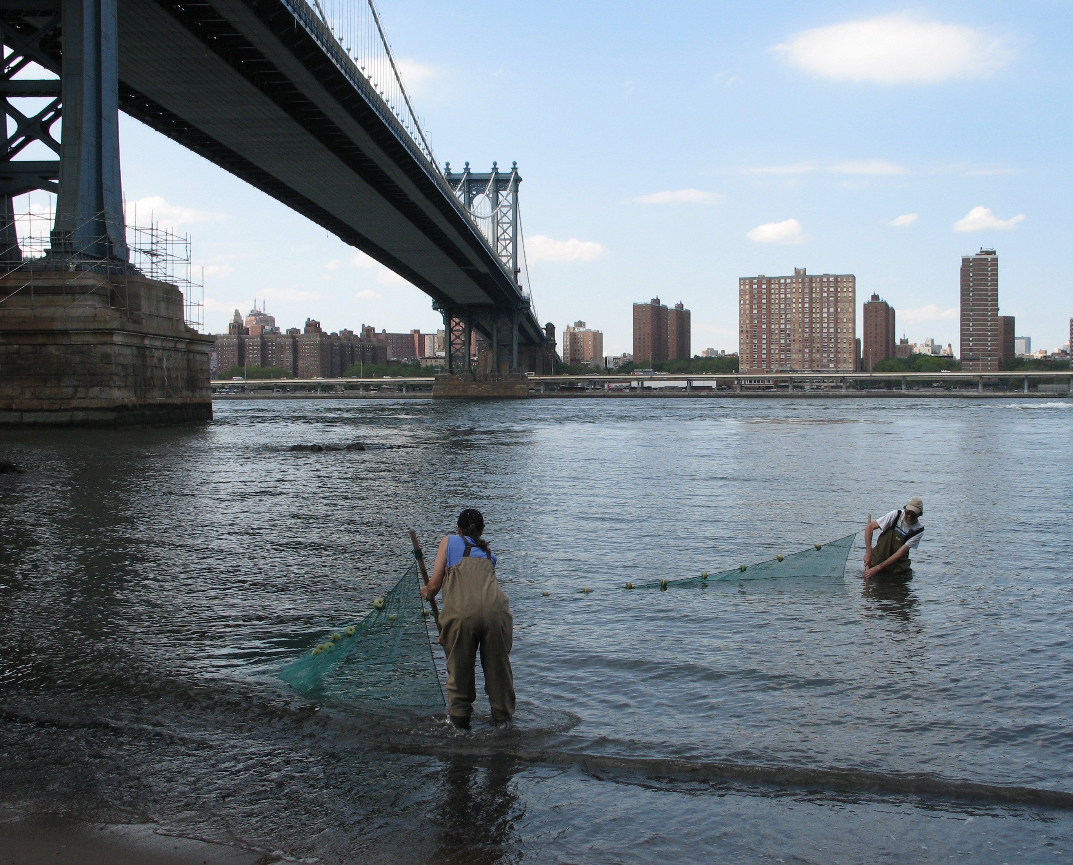 | 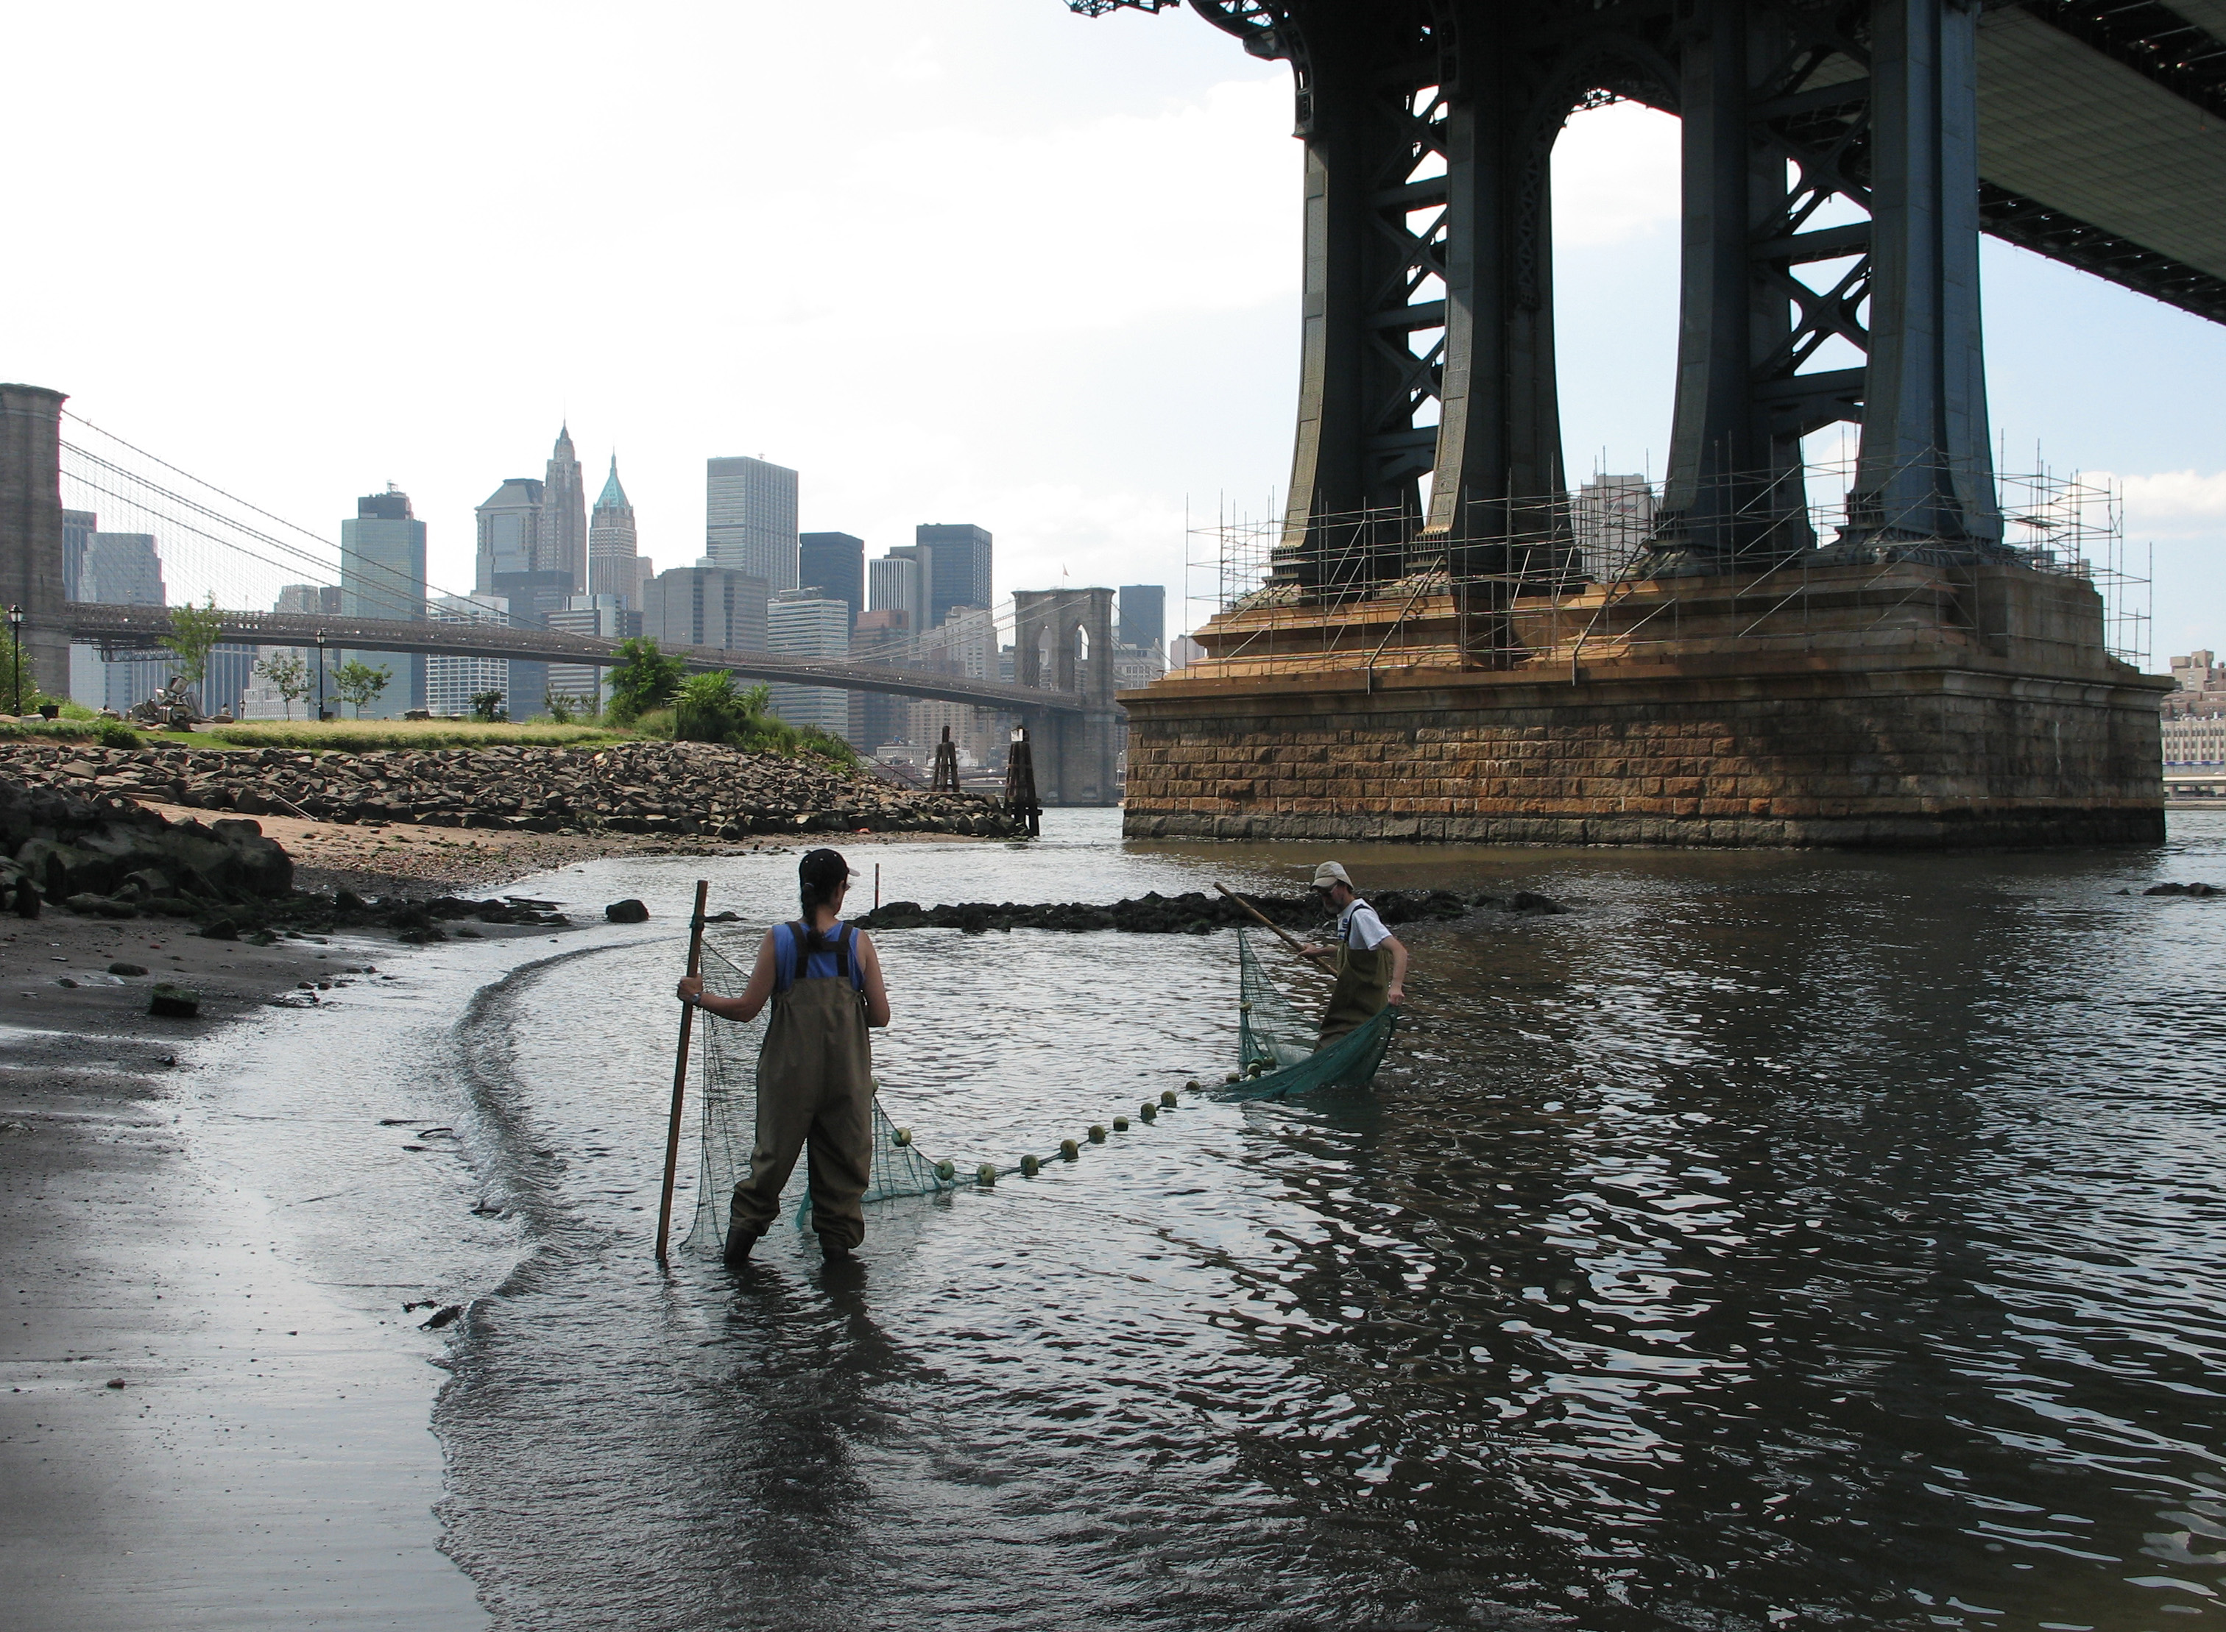
Location: South of the Manhattan Bridge
Area: Urban park surrounded by old warehouses, stores, apartments
Surrounding Land Use: 30% large rocks; 35% grass; 8% playground; 15% plants (landscaped); 2% sidewalk, steps; 10% pier and buildings (park office, old brick warehouse)
Sampling Site: Rocky shoreline (large black rocks), pier, small sandy beach
Plants in area: green & brown seaweed
Water depth: 6 ft.
River Bottom –rocky

ITEM | Time |  | Reading 1 | Reading 2 | Comments
Physical
Air Temperature | 10:00 AM |  | 18° C  65°F | 10:30 AM | 19° C  66°F
 | 11:45 AM |  | 22° C  70°F | 12:00 noon | 22° C  70°F
 | 2:00 PM |  | 25° C  68°F | 2:30 PM | 25° C  68°F
 | 2:40 PM |  | 24.2° C  75.7°F | 2:45 PM | 23° C  71°F
Wind Speed | 10:00 AM |  | Beaufort 3 | 11:00 AM | Beaufort 3
 | 2:00 PM |  | Beaufort 4  19-30 km/hr  Southeast | 2:40 PM | Beaufort 4  19-30 km/hr  Southeast
Cloud Cover | cloudy |  |  |  | Small waves in H2O
Weather today | Light rain, cloudy and overcast in the AM, shift to partly cloudy as day went on.
Weather last 3 days | Yesterday - Heavy rain throughout PM, thunderstorms, cooler.  Past two days was sunny and warm
Water Temperature | 10:00 AM | 17.2°C |  | 2:00AM | 17.3 °C
Turbidity | 11:36 AM | 1.12 m |  | 11:36 AM | 1.12 m
 | 2:15 PM | 43 cm |  | 2:15 PM | 43 cm
Chlorophyll | 11:45 AM | 0.5 |  | 11:45 AM | 0.5
 | 2:32 PM | 0.5 |  | 2:32 PM | 0.5
Chemical
DO | 10:32 AM | 5.1 ppm |  | 17.2 ° C | 53%
 | 11:00 Am | 5.2 ppm |  | 17.2° C | 53%
 | 1:00 PM | 4.83 ppm |  | 17.3° C | 48%
 | 2:00 PM | 5.2 ppm |  | 17.3° C | 53%
pH | 10:00 AM | 7.5
 | 11:00 AM | 8.0
 | 1:00 PM | 8.3
Nitrate | 10:00 Am | 1.1-2.2ppm |  | 11:00 AM | 0.1ppm
 | 1:55 PM | 1.33 ppm |  | 1:55 PM | 1.125 ppm
Alkalinity
Salinity | 10:32 AM | 25.6ppt
 | 11:00 AM | 26.7ppt
 | 2:00 PM | 28 ppt
Fish Catch | Number Caught | Species
 | Japanese crabs - | 5, about 2 inches in diameter
Tides | 10:15 AM | 70 cm |  |  | Class J
 | 10:40 AM | 95 cm |  | Rising
 | 11:10 AM | 22 cm |  |  | Class I
 | 11:30 AM | 17 cm |  | Falling
 | 1:55 PM | 1.5 m |  |  | Class K
 | 2:25 PM | 1.5 m |  | None -Slack
 | 1:57 Am | 150 cm |  |  | Class L
 | 2:25 PM | 150 cm |  | None-slack
Currents | 10:20 AM | South |  |  | Class J
 | 11:26 AM | southeast |  |  | Class I
 | 1:52 PM | Southwest |  |  | Class K
 | 1:52 PM | South |  |  | Class L
Other Items | Small Oil slick noted | Particles in water |  | Garbage on beach & in water
Core Description | Total Length | Top Layer |  | Second Layer | Describe
Core #1 | 14 cm | 1 cm |  | 4 cm | Small rocks: black, orange, brown  Dark brown sand
Core #2 | 9 cm | No layers |  |  | Small rocks: black, white, green and brick color

