Snapshot Day 10/12/06 Data
(Salt Front RM 52.5)
RIVER MILE East River 1 West
Tara LaPorte, Lower East Side Ecology Center
Suzanne Lamb, Rudoplf Steiner School
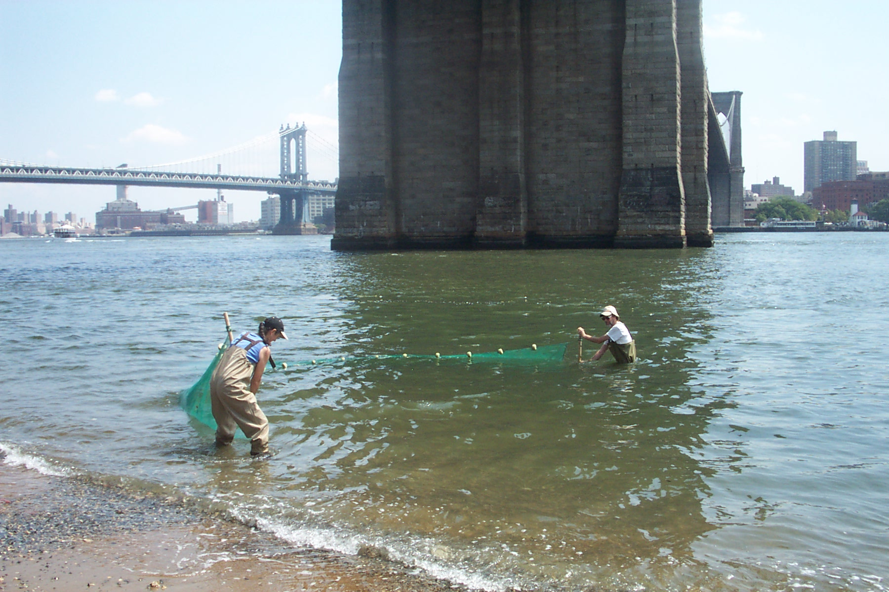
Location: Beach under Brooklyn Bridge, 125 ft. North of Dover St.
Area: Pier, Used for picnics, Includes a Parking Lot,
Surrounding Land Use: Urban/Residential 100% ; Industrial/Commercial 25%; Beach 5%
Sampling Site: Shoreline sandy and rocky, banks altered, bulkhead with timbers, piping noted entering river (CSO sign)
Plants in area:
Water depth: 6 ft.
River Bottom –rocky

ITEM | Time |  | Reading 1 | Reading 2 | Comments
Physical
Air Temperature | 11:00 AM |  | 19° C
 | 11:25 AM |  | 21.3° C
Wind Speed | 11:06 AM |  | 4-7 mph | From South
Cloud Cover | Mostly cloudy |  |  |  | Small waves in H2O
Weather last 3 days | Yesterday - Heavy rain throughout PM, thunderstorms, cooler.  Past two days was sunny and warm
Water Temperature  in 2 inches of water | 10:45 AM | 18.8°C |  | 11:00AM | 19.2 °C
Turbidity | 10:45 AM | 6 ft.
Chlorophyll | 10:30 AM | 0.3 |  | 10:50 AM | 0.3
Chemical
DO | Not read
pH (test kit) | 10:45 AM | 7.4 |  | 7.4 | 7.6
Ammonia | 10:50 | 0.25 ppm |  | 0 ppm | 0.25 ppm
Nitrite |  | 0.2 ppm |  | 0.2 pm | 0.2 ppm
Nitrate |  | 2.5 ppm |  | 2.5 ppm | 2.5 ppm
Alkalinity
Salinity | 10:42 AM |  |  | 11:20 | 7
 | 21 ppt | 24 ppt |  | 24 ppt
Fish Catch | Number Caught | Species
Plankton | Small shrimp | Algae |  | zooplankton
Other organisms | Lacy red weeds | Agardh’s red weed |  | Bushy weed | P. denudata (seaweed)
Tides
 | 10:25 AM | 7 ft. from dock |  | rising
 | 11:35 Am | 6 ft. down from dock
Currents | 10:30 Am | 2.3 ft./sec |  | flooding
Other Items | Small Oil slick noted | Particles in water |  | Garbage on beach & in water
Water Description | Greenish | Salty odor

