Snapshot Day 10/12/06 Data
(Salt Front RM 52.5)
RIVER MILE 2
The River Project – Pier 40
Latitude N 40°43.267 Longitude W074°00.784
UTM E 583352 N4508267
J. T. Boehm, The River Project
Bob Wallace - The Wallerstein Collaborative for Urban Environmental Education/NYU
Karen Johnson & 3rd grade teachers - Trevor Day School – full 3rd Grade
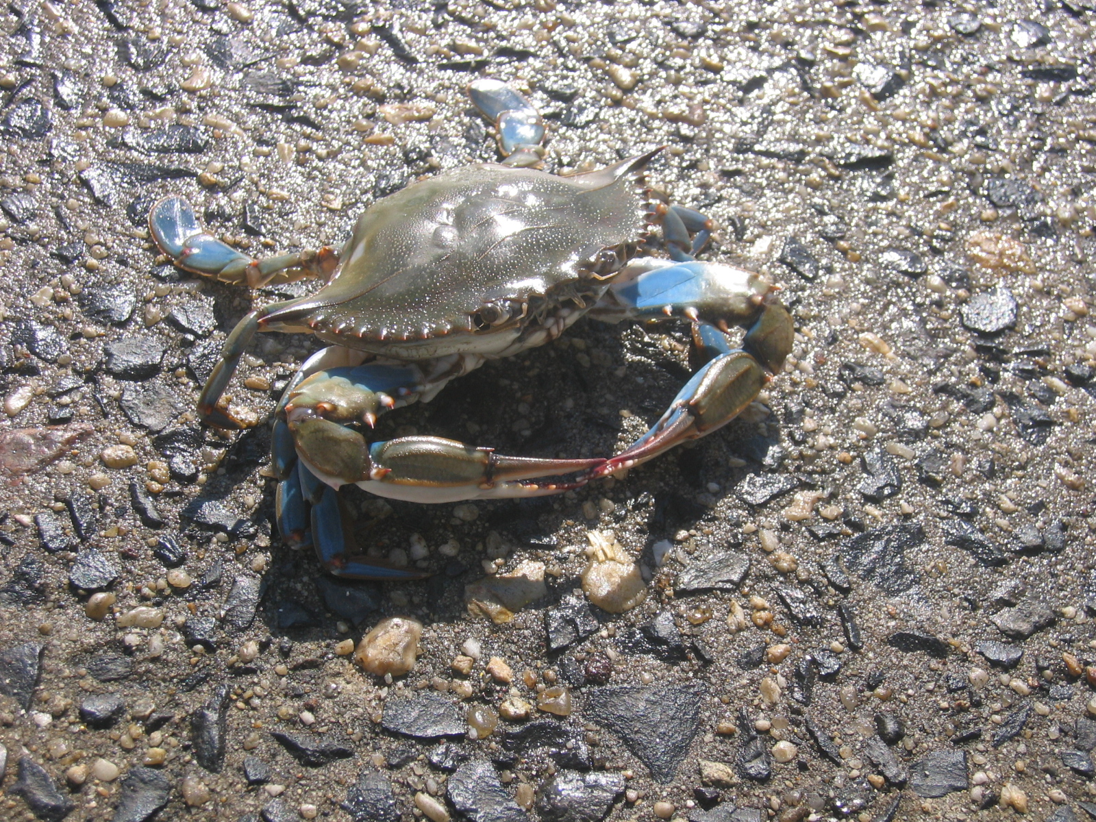
Location: Pier 40 Hudson River (also historically called the North River)
Area: large pier surrounding water access – 400 feet of waterfront
Surrounding Land Use: urban/residential 100%
Sampling Site: Banks altered; concrete & wood pilings
Plants in area: None
Water depth: 15 ft.
River Bottom – muddy
(Measurements were taken from 11:30 AM to 1:30 PM, average given when possible)
ITEM | Time |  | Reading 1 | Reading 2 | Comments
Physical
Air Temperature | 11:45 AM |  | 64° F | 12:20 PM | 66° F
Wind Speed | 11:45 AM |  | 6 - SW | 12:20 PM:  4 - SW | Water choppy
Cloud Cover | Overcast
Weather today | Post rain, getting warmer
Weather recently | Heavy rains through previous night
Water Temperature | 11:45 AM | F 68° (average)  C °
Turbidity | 12:20 | 110 cm (average) |  |  | secchi
Chlorophyll | 1:30 PM
Chemical
DO  (drop count kit) | 1:30 | 4.6 mg/L (average) |  | Temp. 68° C
pH | 11:45 | 7.66 (average) |  |  | Indicator sol.
Phosphate | n/a
Nitrate | n/a
Alkalinity | n/a
Salinity | 1:15 | 16 psu (average) |  |  | hydrometer
Invertebrate Catch | Number Caught | Species |  |  | Minnow traps
 | 9 | Blue crab
 | 23 | Grass shrimp
 | 2 | Mud crabs (black tip)
 | 1 | Spider crab
 | 3 | isopods
Tides | Flood-rising
Currents

