Snapshot Day 10/12/09 Data
(Salt Front RM 52.5)
RIVER MILE 7
79th Street Boat Basin
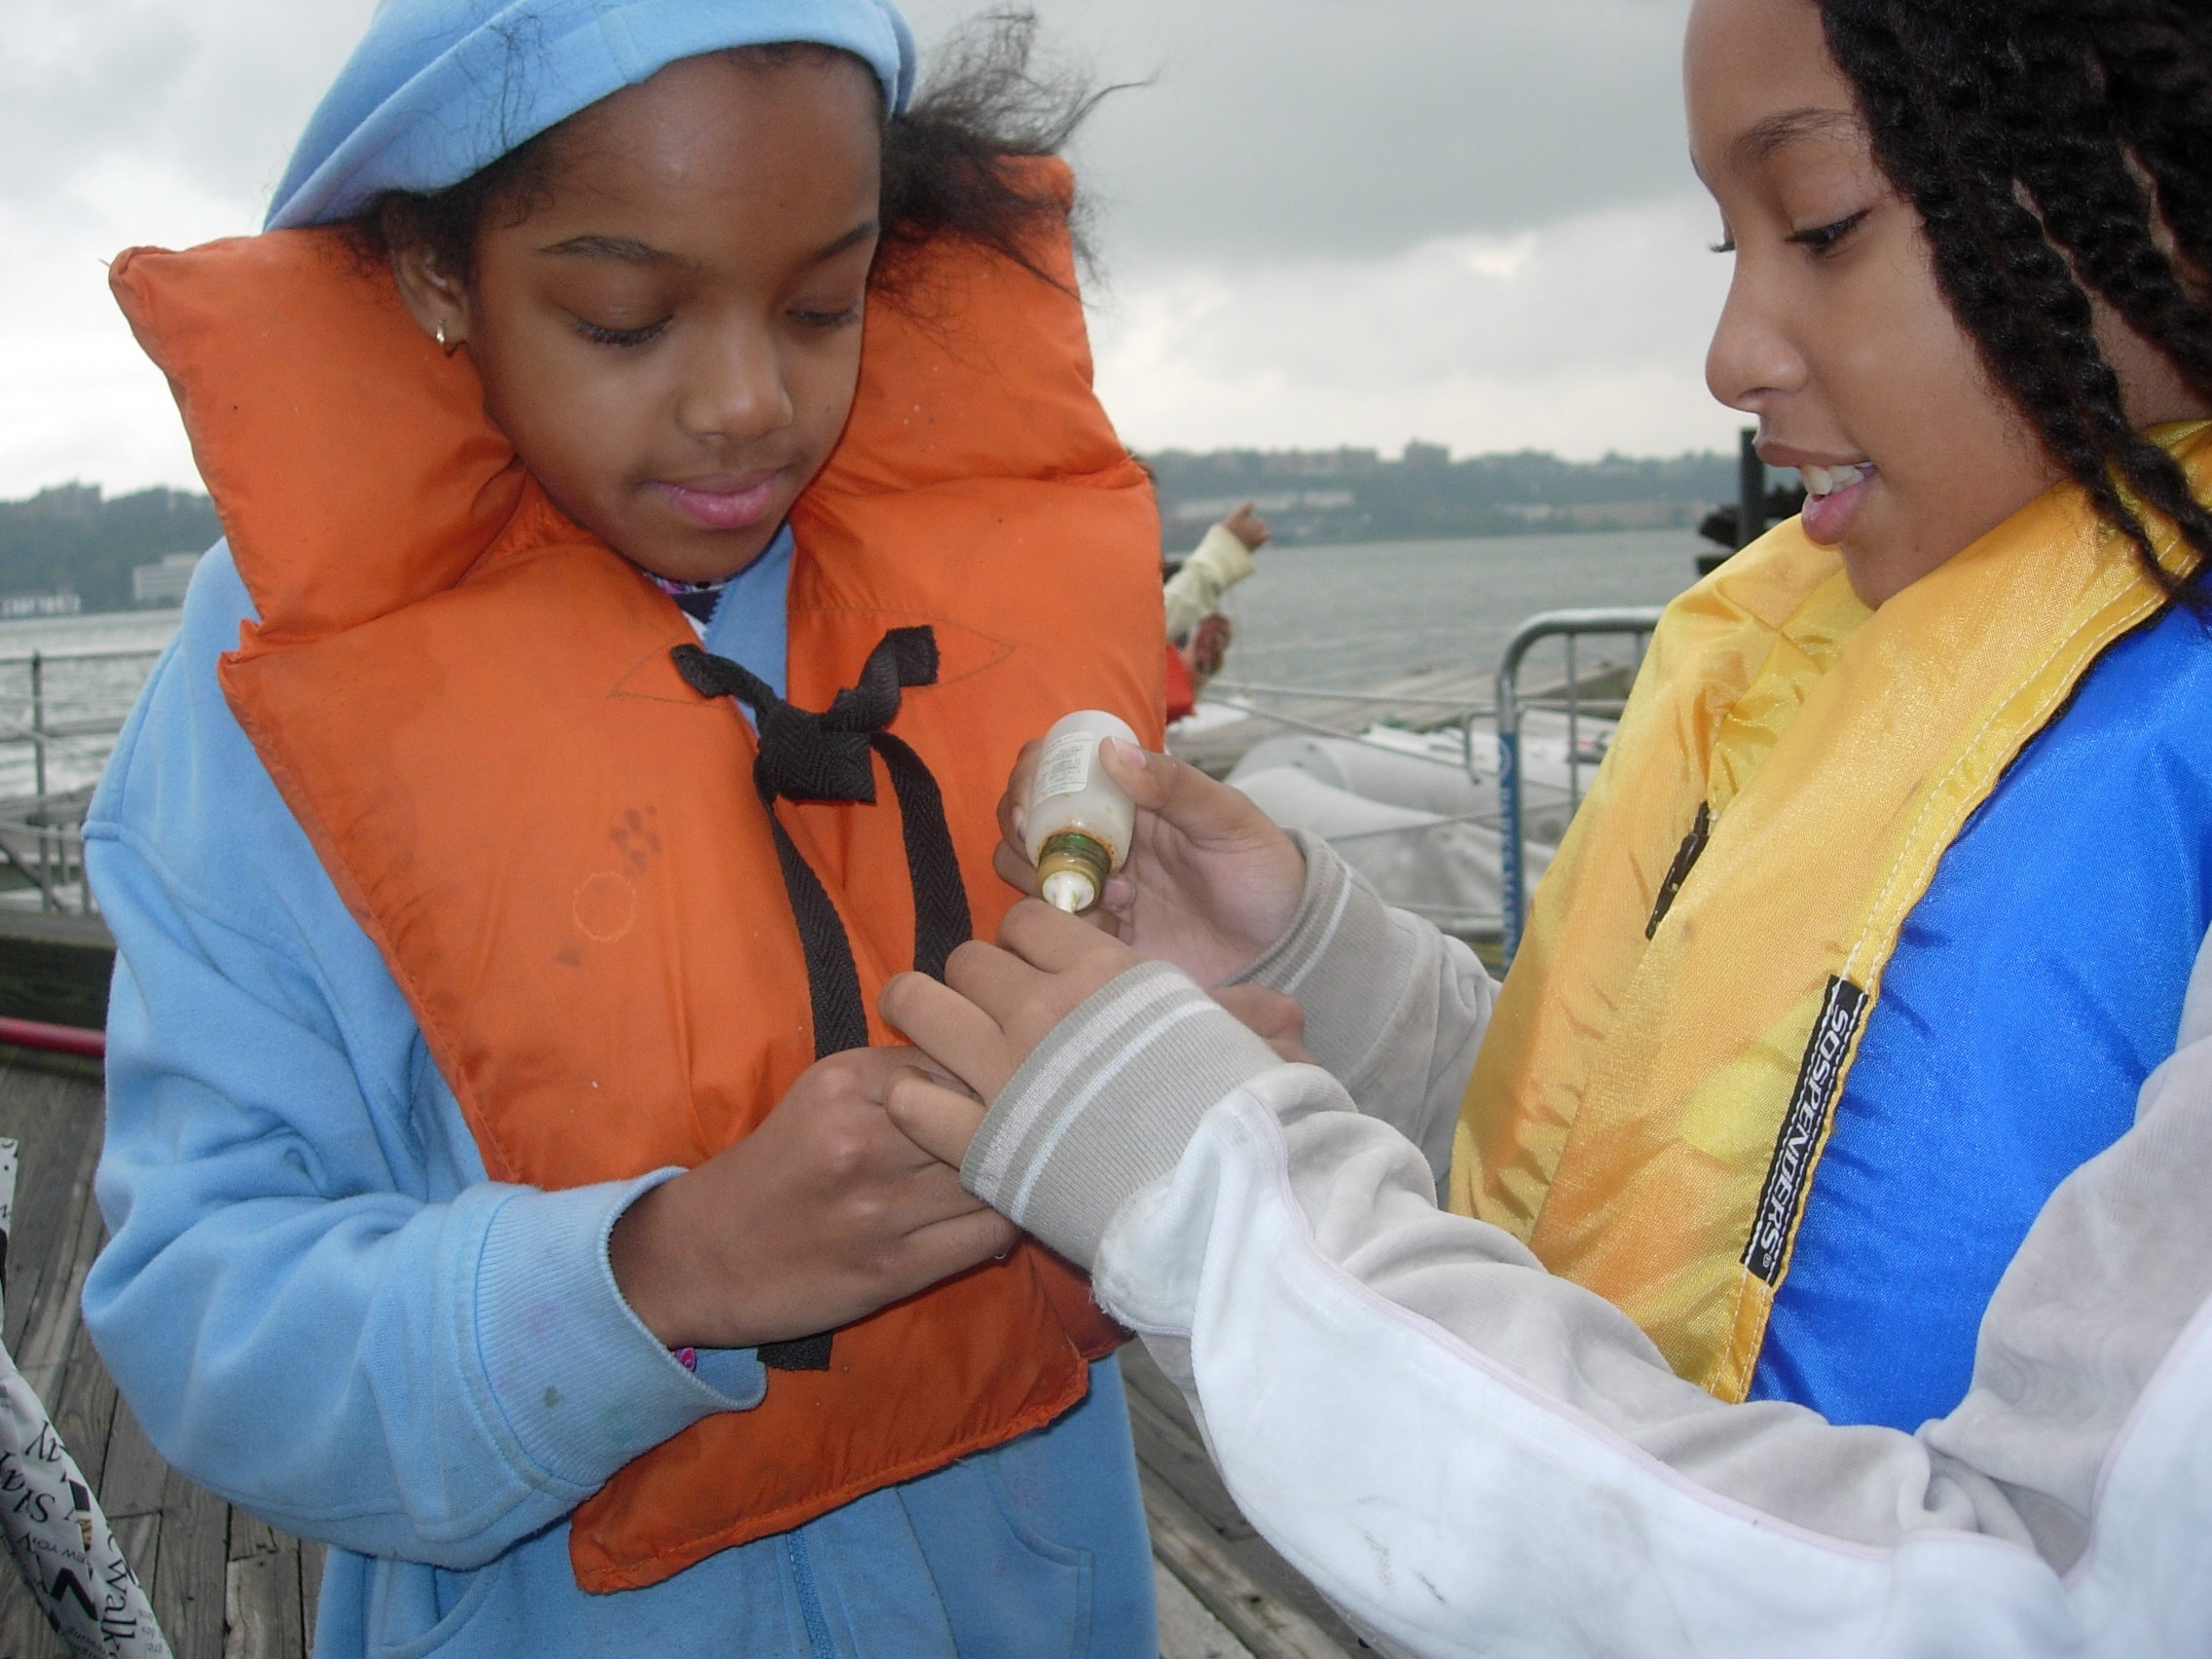 | 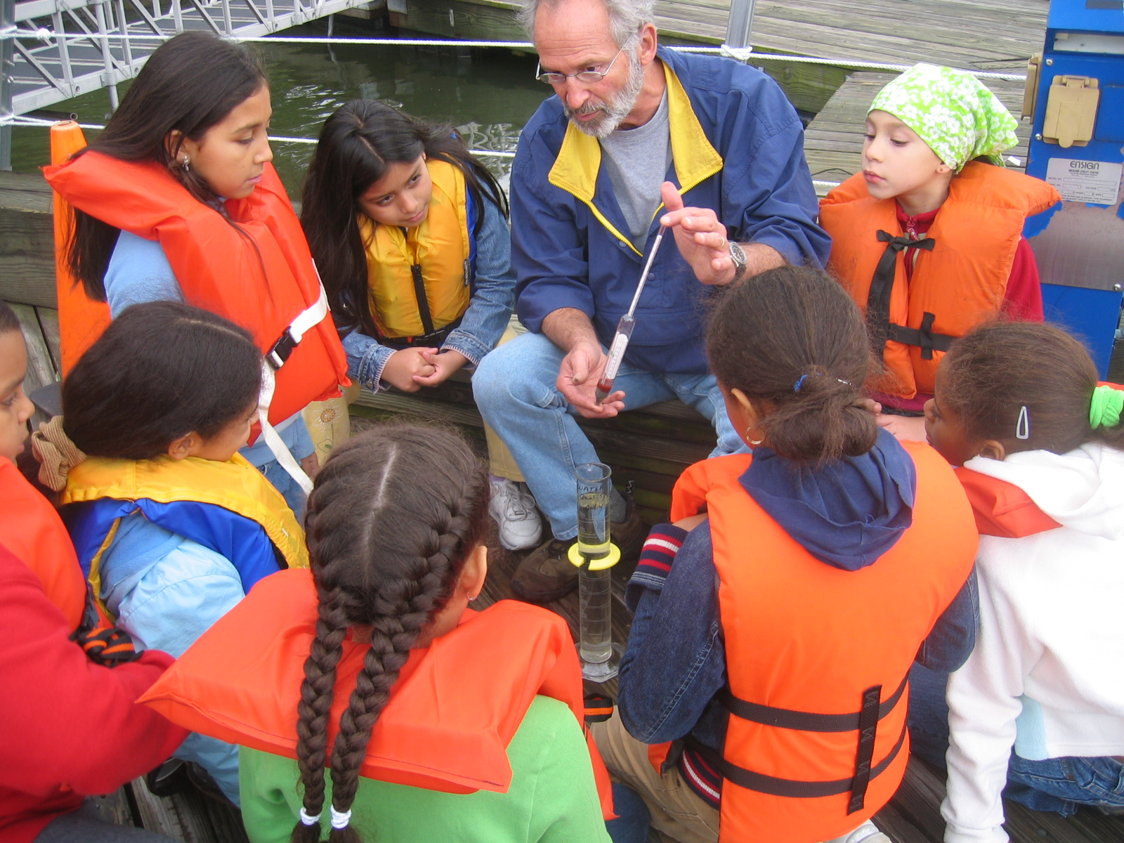

The School in the Forest @ Black Rock Forest
Judy Gutierrez & Wendy Aponte PS/IS 311 4th grade
Location: 79th street boat basin.
Area: On docks
Surrounding Land Use: Forested 5% ; Industrial/Commercial 10%; Park 85%
Sampling Site: Shoreline stone and cement
Plants in area: None
Water depth: 15 ft. measured form dock about 50 ft. from shore
River Bottom –unable to determine

ITEM | Time |  | Reading 1 | Reading 2 | Comments
Physical
Air Temperature | noon |  | 20° C  68° F
Wind Speed | 2-5 mph |  | Light air
Cloud Cover | Overcast in AM to clearing by mid afternoon
Weather yesterday | Rainy, calm wavelets to surface ripples
Water Temperature | noon | 20° C
Turbidity | noon | 3 ft. |  | 91.4 cm | secchi
Chlorophyll
Chemical
DO  (drop count kit) | 10:52 AM | 10 mg/L |  | Temp. 20° C | 110% saturated
 | 11:15 AM | 12 mg/L |  |  | 130% saturated
 | 11:25 AM | 11 mg/L |  |  | 120% saturated
 | 1:25 PM | 12 mg/L |  |  | 130% saturated
pH | 12:40 | 7.5 |  | 7.6 | Digital probe
Phosphate | n/a
Nitrate | n/a
Alkalinity | n/a
Salinity | 10:52 AM | 8.0 ppt |  | 1:25 PM | 8.3 ppt
 | 1.013 density | @ 68°F |  |  | hydrometer
Fish Catch | Number Caught | Species |  |  | Minnow traps
 | 1 | Fish too small to ID
Tides | 8:30 | 36 inches out of water |  |  | Tides rose at least 40 inches during sampling time
 | 10 AM | 10 inches out of water |  |  | Tides rose at least 40 inches during sampling time
 | 11:30 AM | .5 inches out of water |  |  | Tides rose at least 40 inches during sampling time
 | 12:30 PM | 2 inches below water |  |  | Tides rose at least 40 inches during sampling time
 | 1:30 PM | Further below water |  |  | Tides rose at least 40 inches during sampling time
Currents | 11:18 Am | 45 seconds |  | Flood (north bound) | Students timed the stick as it traveled 50 feet along the front of the dock.
 | 11:22 | 50 seconds
 | 11:23 | 50 seconds
 | 11:44 | 60 seconds
 | 11:47 | 70 seconds
 | 12:50 PM | 80 seconds
 | 12:55 PM | 90 seconds
Traffic
Comments from Students:
Question #1 What are the uses of the Hudson River? Most popular answers:

- homes for fish
-for people to travel from New York to New Jersey
-for adventures
-boating
-food for animals (birds)
-fishing
-swimming
-for people to live on houseboats
-for experimenting
-transportation
-walking aside the river
-for beauty (makes city beautiful)
-to learn about it
-for water life (sea animals)
-to catch crabs
-keep boats there (like a parking lot for boats)
-for shipping (goods, materials, garbage, food, liquids)

Question #2 What do you observe in general? (about the river, what's happening) Most popular answers:

-It's cold, therefore the water is propably cold too
-the wind makes the waves go on that direction (north)
-theres garbage in the river
-there are canadian geese (going back to Canada)
-there is pollution in the water
-people boating
-men in a paddle boat
-houses on the edge of the river on the other side
-boats
-houseboats
-little waves and bigger waves
-big ships passing by
-ducks and birds flying around
-the temperature affects the water temperature
-leaves from the trees fall into the river

