Snapshot Day 10/7/08 Data
Salt Front RM 63.4
Newtown Creek, off East River
Min Kan, New York City Department of Environmental Protection
Walter Ditman, Denise Lee, and Scott Dennis, PS 78Q
5th grade, 37 students
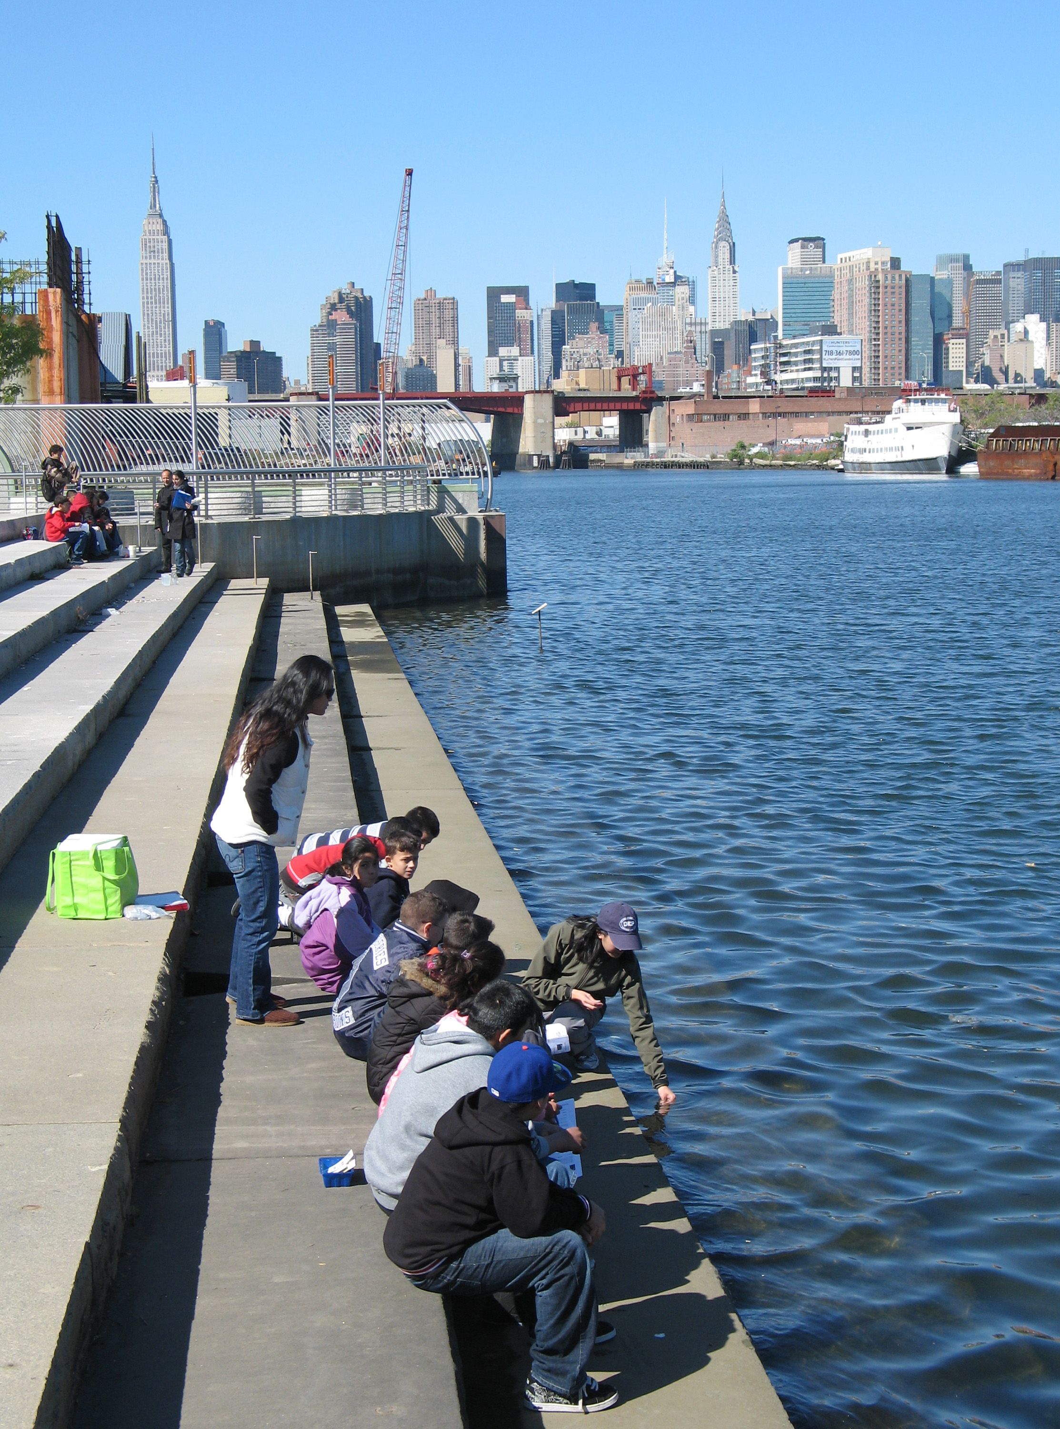
Location: Newtown Creek Nature Walk, along Newtown Creek’s Brooklyn waterfront
Area: Nature Walk for public use
Surrounding Land Use: Urban 100%; Industrial/Commercial 95%; Nature Walk 5%
Sampling Site: Nature Walk is paved with cement with sandy, gravel sections.
Plants in area: A few trees and tall grasses.
Water depth: unknown
River Bottom: unknown

ITEM | Time |  | Reading 1 | Reading 2 | Comments
Physical
Air Temperature | 12:08 PM |  | 68°F  20°C | 68°F  20°C
 | 12:34 PM |  | 68°F  20°C | 68°F  20°C
Wind Speed  (Beaufort Chart) | 12:08 PM |  | Beaufort 2 | Beaufort 1-3 | West
Cloud Cover | 12:08 PM |  | Clear
 | 12:34 PM |  | Clear
Weather last 3 days | Seasonally low temperatures
Water Temperature | 12:00 PM | 59.5°F  15°C |  | 59.5°F  15°C | 59.5°F  15°C
 | 12:50 PM | 56°F  13°C |  | 50°F  10°C | 59.5°F  15°C
Turbidity | 12:15 PM | 1.5 ft.
Secchi off Walk | 1:15 PM | 2 ft.
Chlorophyll | 12:15 PM | 0.1
 | 1:00 PM | 0.1
Chemical
DO  (LaMotte Tablet Kit) | 12:00 PM | 15°C |  | 8 ppm | 75%
 | 12:50 PM | 13°C avg |  | *4 ppm | 36%
• test kit has limited range – only allows for 0, 4, and 8 ppm
pH (paper) | 1:10 AM | 7.5 |  | 6.5 | avg 7
Phosphate
Nitrite
Nitrate
Alkalinity
Salinity  (Hydrometer) | 1:10 PM | 1.018 |  | 1.018 | Avg. 23 ppt
Fish Catch | Number Caught | Species
Other organisms
Tides
Currents
Other Items
Water Description

