Snapshot Day 10/7/08 Data
(Salt Front RM 63.4)
RIVER MILE East River 4
Chris Kennedy - SOLAR ONE
Erin Lubick – PS33 Chelsea Prep – 5th grade – 40 classes
Mitchell Preslin - - MS 324 – 20 students
Susan Price and Mark Testa - M anhattan Comprehensive Night and Day High School – 40 HS chemistry students

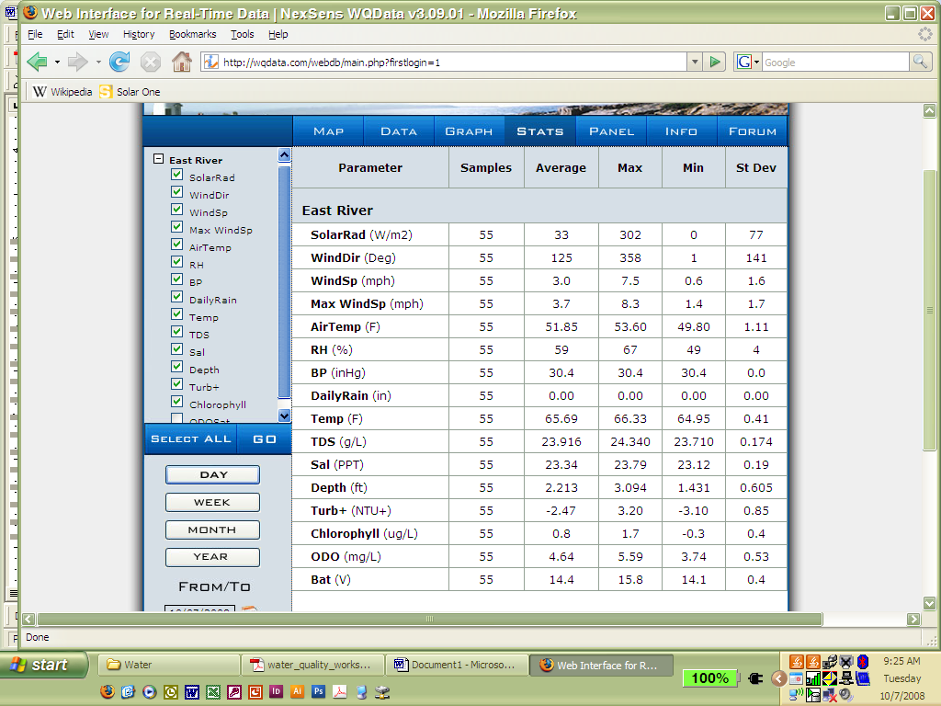

CHARTS SHOWING TRENDS FOR PARAMETERS OVER LAST WEEK -

