Snapshot Day 10/7/2008
(Salt Front RM 63.4)
RIVER MILE 7 up to RM 11 and back
Starting @ 79th St. Boat Basin – up to the GW Bridge & back
Schooner Lettie G. Howard, South Street Seaport
Rebecca Grussgott and Margaret Flanagan,
The Harbor School, 9th and 10th grade - 17 students
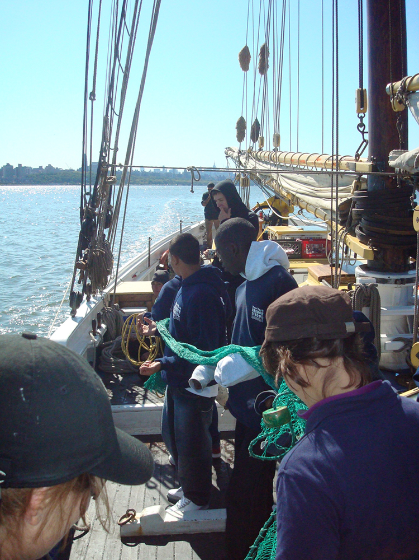
Location: 79th St. Boat Basin for plankton & minnow traps. Chemistry and trawl from Mid River South of the George Washington Bridge by Edge Water, New Jersey
Area: public boat basin and mid river
Surrounding Land Use: marina

ITEM | Time |  | Reading 1 | Reading 2 | Comments
Physical
Air Temperature | 2:25 PM  2:25 PM |  | 13°C | 15°C | Average  14°C
Wind Speed | 4-6 knots |  |  |  | Wind direction from the North
Cloud Cover | Clear
Weather today | Clear
Weather recently | Cool and windy; cirrostratus
Water Temperature | 1:52 PM | 16°C  17°C  16.5°C |  |  | Average 16.5°C
N40°50.762 W73°57.324 | 1:54 PM | 21°C  22°C  21°C |  |  | Average 21.33°C
Turbidity
Chlorophyll
Chemical
DO  (color comparator) | Boat times 1:52 PM | 8 mg/L |  | 16°C | Collected water in the shade
pH  indicator solution  surface sample | 1:36 PM
Phosphate
Nitrate  Lamotte test kit | 1:03 PM
Salinity refractometer |  | 12 ppt |  |  | Avg 12 ppt
Turbidity
Fish Catch | Number Caught | Species |  | CPUE | Trawled
W73°57.78  N 40°50.48 | 1 (18 cm) | Oyster toad fish |  |  | Depth 16 ft.
 | 100 + (about 3-10 mm across carapace) | Small crabs
Trawl net became fouled by two old fish traps. Traps covered with seaweed and housed a few mussels and sea squirts. Traps also accumulated marine debris: many plastic bags, an old cup, an old can, and a piece of tire.
Tides

