Snapshot Day 10/7/08 Data
(Salt Front RM 63.4)
RIVER MILE 102
Saugerties Light House, Town of Saugerties, Ulster Co.
Betsy Blair, NYSDEC HREP
Matthew Essery, Woodstock Day School grades 5th, 6th, 10th , 11th , – 32 students

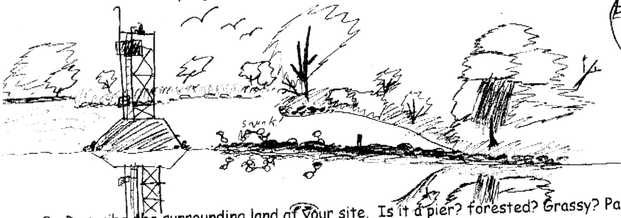
Location: Saugerties Light house @ northern bank of peninsula
Area: fishing, swimming beach, has a building with restrooms
Surrounding Land Use: Forested 60%, Beach 10%, Commercial (bed & breakfast) 10%, Marsh & Tidal wetlands 20%
Sampling Site: beach, altered banks years ago, covered with vegetation, collected wood/debris in area, shoreline riprap at lighthouse.
Water depth: unknown
River Bottom : sandy, weedy and rocky bottom
Plants in area: South side 15% cover, 0% northside - Note there was a frost previous to the sampling day.
Shallows: 75% water celery; 25% Water chestnut
Tidal Marshes: Common Reed 30%, Sedges 30%, River Bulrush 30%; Wildrice 5%; Clasping Pondweed 5%
ITEM | Time |  | Reading 1 | Reading 2 | Comments
Physical
Air Temperature | 10:00 AM |  | 41°F | 12:40 PM | 65°F
Wind Speed | 4-2 on beaufort |  | calm
Cloud Cover | clear
Weather today | No rain - the wind was calm out of the south at first, then about 12:30 PM it came out of the North and was a moderate breeze.
Weather recently | Rainy and unseasonably cool
Water Temperature | 10:00 AM | 16°C
Water Calm | 10:25 AM | 17°C
 | 10:47 AM | 17°C
 | 12:00 PM | 17°C
 | 12:30 PM | 19°C
Turbidity  secchi | 10:00 AM | 2.25 meters  2.0 meters  2.25 meters |  |  | 2.25 meters average
Chlorophyll | 10-noon | 0.3 |  | As the day went on the chlorophyll # increased
Chemical
DO  (ampules) | 10:00 AM | 8 mg/L  decreased a bit through the day |  | 16°C | 80%
pH – pH meter | 10- noon | 8.2 average
Phosphate
Nitrate |  |  |  | 0 | 0
Alkalinity
Salinity | 10-noon | 0.1  0.5  0.8 |  | 0.4 ppm avg. | Drop count test kit
Fish Catch - 50’seine | Number Caught | Species |  | CPUE | Seine
 | 89 | Banded Killifish
 | 36 | Spottail Shiner
 | 2 | Snail
 | 65 | Zebra Mussels
 | 3 | Backswimmers
TOTAL CATCH | 70
Tides
 | 10:00 AM | 45 cm |  | falling
 | 10:15 AM | 43 cm |  | falling
 | 10:22 AM | 40 cm |  | Falling
 | 10:37 AM | 37 cm |  | Falling
 | 10:50 AM | 34 cm |  | Falling
 | 11:05 AM | 31 cm |  | Falling
 | 12:00 PM | 21 cm |  | Falling
 | 12:15 PM | 19 cm |  | Falling
 | 12:21 PM | 17cm |  | Falling
 | 12:36 PM | 13 cm |  | Falling
Currents
Traffic | 10:45 AM | Large Ship |  | North | Light
 | 11:00 AM | Fishing Boat |  | Around lighthouse
 | 12:30 PM | Sailboat |  | South
Other Items | A flock of swan flew in and swam around most of the day, immature bald eagle, several cormorants, mallard ducks

