Snapshot Day 10/7/08 Data
(Salt Front RM 63.4)
RIVER MILE 14
Inwood Hill Park Nature Center, NYC
Sgt. Taylor, New York City Park Rangers
Matthew
Susan Vincent - Young Women’s Leadership School – 12th grade – 24 students
Latitude 40°52.509’N/ Longitude 73°55.28’W
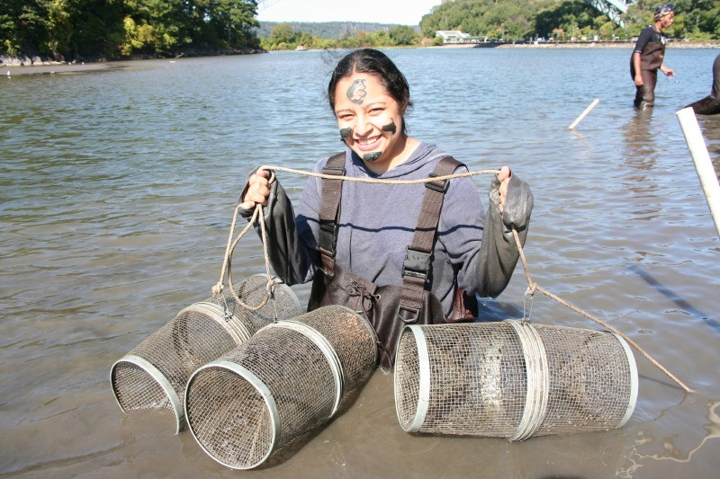
Location: In the cove of Inwood Hill Park
Area: Forested
Surrounding Land Use: Forested 85%; urban residential 5%; Industrial/commercial 2%; 8% estuary: pipes that exit sewage, drainage, main pipes. Forested and used by people for picnics, jogging, sitting on park benches.
Sampling Site: large riprap on shoreline, drainage pipes in area, vegetation
Plants in area: Phragmites australis 10% , Spartina Alterniflora 10%, most of plants unidentified
Water depth: 15-100 cm where seining
River Bottom – mostly mud with large rocks, some vegetation
ITEM | Time |  | Reading 1 | Reading 2 | Comments
Physical
Air Temperature | 9:30 AM |  | 57 °F | 1:00 PM | 67 °F
Wind Speed | 2.5 Knots |  | NW
Cloud Cover | clear
Weather today | Temperature warmed during day, wind calmed
Weather recently | Sunday light rain, cloudy; Monday sunny but cool
Water Temperature | 11:16 AM | 17.8 °C  18.2 °C  17.6 °C |  |  | 17.9°C
Water surface: | calm
Turbidity  (long Site tube)_ | 11:30AM | 57.2 cm  75.0 cm  75.6 cm  84.0 cm  86.0 cm  97.0 cm |  |  | Average 79.1 cm
Chlorophyll | 12:30 PM | 2.0 water’s edge |  | 0.7 10 m from edge
Chemical
DO  (drop count kit) | 11:16 AM | 7.42 mg/L |  | Temp.17.8° C | 75%
pH | 12:38 AM | 7.4  7.6  7.8 |  | 7.6 avg. | Indicator sol.
Phosphate
Nitrate | 12:56 PM | 5.0  0  0 |  |  | 1.67 mg/L
Alkalinity
Salinity | 11:25 AM | 9.6 ppt  6.5 ppt  7.1 ppt |  | 7.7 ppt average | YSI meter
Conductivity | 11:16 AM | 14.42 mS  7.46 mS  9.98 mS |  | 10.62 mS | meter
Fish Catch | Number Caught | Species |  | CPUE | Seine
Used seine 12 ft.  Pull 18 ft. - | 2 | Grass Shrimp |  |  | Seine net
Seined – 3 | 2 | Atlantic Silverside
 | 2 | Blue crab
 | 17 | mummichogs
12:30 PM | 7 catch | 15 ft. pull |  | 1.3 CPUE | Seine 1
12:45 PM | 4 catch` | 15 ft. pull |  | 0.8 CPUE | Seine 2
1:00 PM | 19 catch | 15 ft. pull |  | 3.7 CPUE | Seine 3
Tides | 11:25 AM | 15cm |  | Rising
 | 11:40 AM | 24cm |  | Rising
 | 11:55 AM | 28cm |  | Rising
 | 12:10 PM | 33 cm |  | Rising
 | 12:25 PM | 38 cm |  | Rising
Currents | 11:25 AM | 480 cm/60 secs |  | 8cm/sec | 0.16 knots
 | 12:35 PM | 490 cm/60 secs |  | 8.2 cm/sec | 0.163 knots
Traffic | 12:03 PM | Circleline |  | Northbound | Loaded - people
Sediment Core description | 19 cm core | No layering |  | Very fine silt | Collected 10 m from shore
Other observations
