Snapshot Day 10/7/08 Data
(Salt Front RM 63.4)
RIVER MILE 17
Mt. St. Vincent College Campus, NYC
Pat Grove – Mt. St. Vincent College – undergraduate students 30 sophomores
Latitude 40°91282 N/ Longitude 73°91150 W
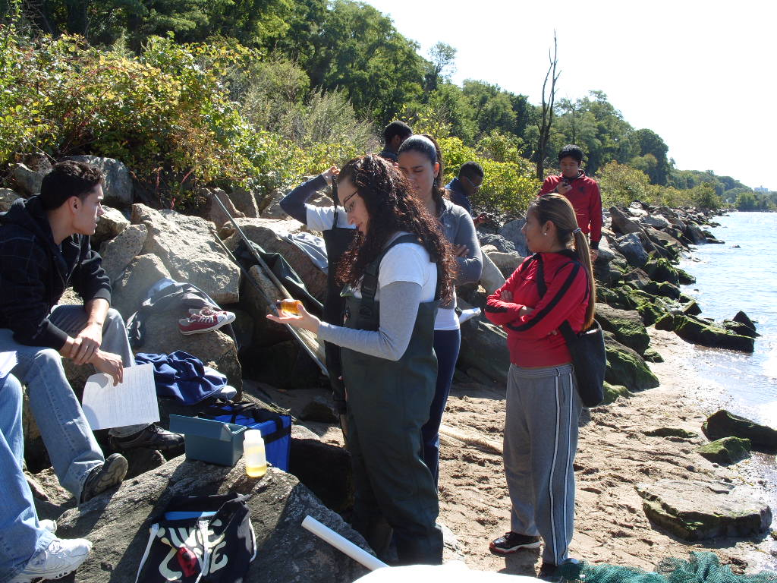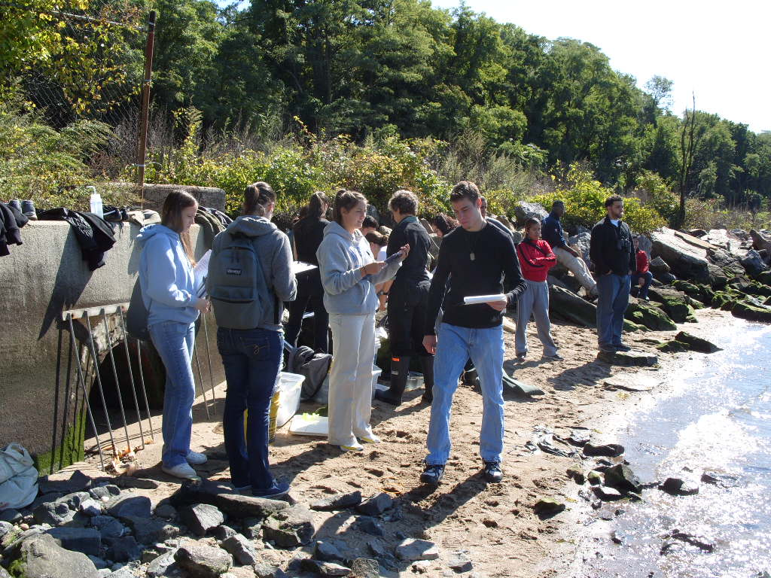
Location: Waterfront of Mt. St. Vincent’s
Area: Forested
Surrounding Land Use: Urban/residential 20%; Forested 45%, 25% industrial/commercial (RR tracks); when tide is low 10% beach. Beach, shoreline riprap
Sampling Site: large riprap on shoreline, drainage pipes in area
Plants in water of sampling area: 1% - Water celery 0.005% of this
Water depth: 38.5 cm
River Bottom – sandy, rocky
ITEM | Time |  | Reading 1 | Reading 2 | Comments
Physical
Air Temperature | 12:40 PM |  | 18°C
Wind Speed | 2-3 knots |  | SW
Cloud Cover | clear
Weather today | Cool and clear
Weather recently | Colder than normal overnight
Water Temperature | 12:37 PM | 20 °C  68°C |  | 19 °C  66.2°C | 19.5 °C  67.1°C
 | 1:00 PM | 18 °C  64.4°C |  | 19 °C  66.2°C | 18.5 °C  65.3°C
 | 1:06 PM | 18 °C  64.4°C |  | 18.5 °C  65.3°C | 18.25 °C  64.9°C
Water surface: | choppy
Turbidity  (Secchi) | 12:30 | 62 cm  62 cm  63 cm |  |  | >62 cm
Chlorophyll | 12:50 PM | 0.2
Chemical
DO  LaMotte kit 7414 | 1:05 PM | 7.8 mg/L |  | Temp.19.5° C | 82% saturated
pH – LaMotte kit 5858 | 12:43 PM | 8  8  8 |  | 8 avg.
Phosphate | 12:20 PM | 15  12  15 |  | 14 ppm
Nitrate | 1:15 PM | 0 ppm  1.0 ppm  0 ppm |  | 0.3 ppm
Alkalinity | 12:45 PM | 70 ppm  60 ppm  60 ppm |  | 63 ppm
Salinity -  refractometer | 1:00 PM | 8 ppt  8 ppt  7 ppt |  | 7.6 ppt
Fish Catch | Number Caught | Species |  | CPUE | Minnow Traps
seine – 30 ft. net  (DEC) | 2 | Asian shore crab |  |  | 1 shrimp
 | 4 | Atlantic Silverside
 | 1 | Shore shrimp
 | 1 | Blue crab
 | 1 | Rock Crab
Tides | 12:48 noon | 34 cm |  | Rising
2:25 PM High Tide per charts | 12:57 PM | 37 cm |  | Rising
 | 1:07 PM | 40cm |  | Rising
 | 1:13 PM | 42 cm |  | Rising
 | 1:20 PM | 42 cm |  | still
Currents | 1700 cm/60 secs | 28.3cm/sec |  | North/Flood | 0.566 knots
 | 1700 cm/60 secs | 28.3cm/sec |  | North/Flood | 0.566 knots
 | 1650 cm/60 secs | 27.5cm/sec |  | North/Flood | 0.55 knots
 | 1650 cm/60 secs | 27.5cm/sec |  | North/Flood | 0.55 knots
Core | 12:36 PM | 5 cm  no layers evident |  | Abundant  Sand  Gravel  Pebbles
Traffic | 12:05 PM | Tugboat- |  | Northbound
 | 12:07 PM | Recreational |  | Southbound
 | 12:36 PM | Recreational |  | Southbound
 | 12:57 PM | Karmar |  | Southbound
 | 1:07 PM | Sailboat w/CA flag
Other observations | Unidentified warbler hopping on rocks

