Snapshot Day 10/7/08 Data
(Salt Front RM 63.4)
RIVER MILE 18
Vicki Garufi - Beczak Environmental Education Center
Harry Hall - Saunders Trade & Technical High School
(28 students) 10th -12th grade
Latitude – N 40.9381 Latitude – W -73.90289
Location: Seining beach, Beczak Center, Yonkers in Westchester County
Area: Riverfront property used for fishing, boats, seining, field trips and education programs
Surrounding Land Use: Urban/residential 10%, Forested 30%, Beach 50%, industrial/commercial 15%;
Sampling Site: beach, marsh area covered with vegetation, sandy area, banks altered, large riprap on shoreline, collected wood/debris in area –
Plants in area: no plants in the water
Water depth: 3-4 feet
River Bottom – muddy (sticky), rocky
Plants – Goldenrod 20% mugwort 25% shrubs 23% Spartina alterniflora in marsh
Note plants are allowing beautiful scenery and provide oxygen. It gives insects like bees feed and coverage.
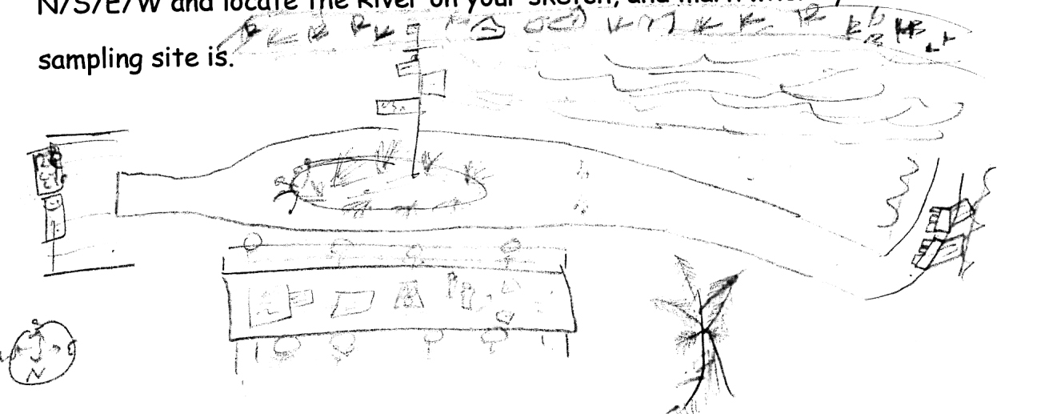

ITEM | Time |  | Reading 1 | Reading 2 | Comments
Physical
Air Temperature | 9:27 AM |  | 14°C  57.2°F | 9:42 AM | 12°C  53.6°F
 | 9:56 AM |  | 16°C  60.8°C | 10:04 | 16°C  60.8°F
 | 10:32 AM |  | 14°C  57.2°F | 10:43 AM | 17°C  62.6°F
 | 11:04 AM |  | 16°C  60.8°F | 11:14 AM | 18°C  64.4°F
Wind Speed – NOTE Same all morning | 2 Beaufort |  | 6-11 km/hr | 4-6 knots | North
Cloud Cover | clear
Weather today
Weather recently
Water calm | choppy
Water Temperature | 9:20 AM | 9 °C 48.2 °F  9 °C 48.2 °F  9°C 48.2 °F |  | 9:30 AM | 9 °C 48.2 °F  9 °C 48.2 °F  9°C 48.2 °F
 | 9:50 AM | 15 °C 59°F  14 °C 57.2°F  14.5°C 58.1°F |  | 10:00 AM | 15 °C 59°F  15 °C 59°F  15°C 59°F
 | 10:35 AM | 16°C 60.8°F  16°C 60.8°F  16°C 60.8°F |  | 10:45 AM | 16°C 60.8°F  16°C 60.8°F  16°C 60.8°F
 | 11:00 AM | 17°C 62.6°F  17°C 62.6°F  17°C 62.6°F |  | 11:10 AM | 17°C 62.6°F  17°C 62.6°F  17°C 62.6°F
Turbidity – sight tube – NOTE used in area where group was seining – so stirred up the mud | AM | 31 cm  44 cm  10 cm  5.5 cm  11 cm  13 cm  11.5 cm  11 cm |  |  | 17.125 cm  average
 | 11:04 | 32.3 cm
Chlorophyll | 9:30 AM  10:20 AM | 0.1  0.6
Chemical
DO  (chemette) | 9:30 AM  9:40 AM | 9°C  9°C |  | 8 mg/L  11 mg/L | 70% saturated  100% saturated
Sampled north end of marsh | 10:20 AM  10:20 AM | 15°C  15°C |  | 11 mg/L  10 mg/L | 110% saturated  100% saturated
 | 10:40 AM  10:40 AM | 16°C  16°C |  | 10 mg/L  9.5 mg/L | 105% saturated  95% saturated
 | 11:20 AM  11:10 AM | 17°C  17°C |  | 8 mg/L  8 mg/L | 85% saturated  85% saturated
pH – color match | 9:30 AM | 7.8  7.8  7.7 |  | 9:40 AM | 7.5  7.5  7.5
 | 10:00 AM | 7.7  7.7  7.7 |  | 10:10 AM | 7.7  7.7  7.7
 | 10:35 AM | 7.8  7.7  7.8 |  | 10:40 AM | 7.8  7.8  7.8
 | 11:00 AM | 7.7  7.7  7.7 |  | 11:20 AM | 8.0  7.8  8.0
Salinity - hydrometer | 9:20AM | 6 ppt  6 ppt  5 ppt |  | 9:30 AM | 6 ppt  6 ppt  6 ppt
 | 10:00 AM | 6 ppt  6 ppt  6 ppt |  | 10:20 AM | 6 ppt  6 ppt  6 ppt
 | 10:30 AM | 6 ppt  6 ppt  6 ppt |  | 10:40 AM | 6 ppt  6 ppt  6 ppt
 | 11:00 AM | 6 ppt  6 ppt  6 ppt |  | 11:10 AM | 6 ppt  6 ppt  6 ppt
Fish Catch | Number Caught | Species |  | Size of largest | Type
Seine net 30 feet X 4 ft., 1.4 inch mesh  34 ft. pull | 1 | Naked Goby |  | 4 cm | Fish Catch
9:30 -11:30 AM | 1 | Atlantic Silverside |  | 8 cm
 | 22 | White perch |  | 23 cm
 | 1 | Striped Bass
 | 3 | Northern Pipefish |  | 18.5 cm
 | 1 | Herring, Shad |  | 10 cm
 |  | Blue Crab |  | Macroinvert
 |  | Grass Shrimp
 |  | Sand Shrimp
 |  | Soft shell clam
Tides | 9:21 AM | 18 cm |  |  | Pair #1
 | 9:36 AM | 15 cm |  | falling | RESULT
 | 9:52 AM | 16 cm |  |  | Pair #2
 | 10:04 AM | 17 cm |  | rising | RESULT
 | 10:26 AM | 23 cm |  |  | Pair #3
 | 10:41 AM | 27 cm |  | rising | RESULT
 | 11:00 AM | 31 cm |  |  | Pair #4
 | 11:12 AM | 33 cm |  | rising | RESULT
Currents
 | 9:25 AM. |  |  | Still | * area where current taken may have caused the high number of still readings
 | 9:38 AM |  |  | ebb
 | 9:55 AM |  |  | Still
 | 10:04 AM |  |  | ebb
 | 10:29 AM |  |  | Still
 | 10:42 AM |  |  | ebb
 | 11:03 AM |  |  | still
 | 11:12 AM |  |  | flood
Core Sample | Entire Length | Grain Size |  | Smell | Description
Group 1  River Sample  (came out as much) | 10 cm | mix |  | Smells more than the marsh | dark color  Worm inside
Group 2  Marsh sample | 9 cm | Fine grain |  | No smell | Dark with layers of green
Traffic | 10:00 AM | red/black |  | southbound | full
 | 9:15 AM | white |  | southbound
Other Items | Hummingbirds, minnows, crab, not lots of people fishing, train and factory workers

