Snapshot Day 10/7/08 Data
(Salt Front RM 63.4)
RIVER MILE 25E
Village of Irvington
Philip Levine and Irvington’s 5th grade Main Street School (155 students)
Ben Kwiatkowski and Irvington High School Science Club (15 students)
N 41°, W 73°
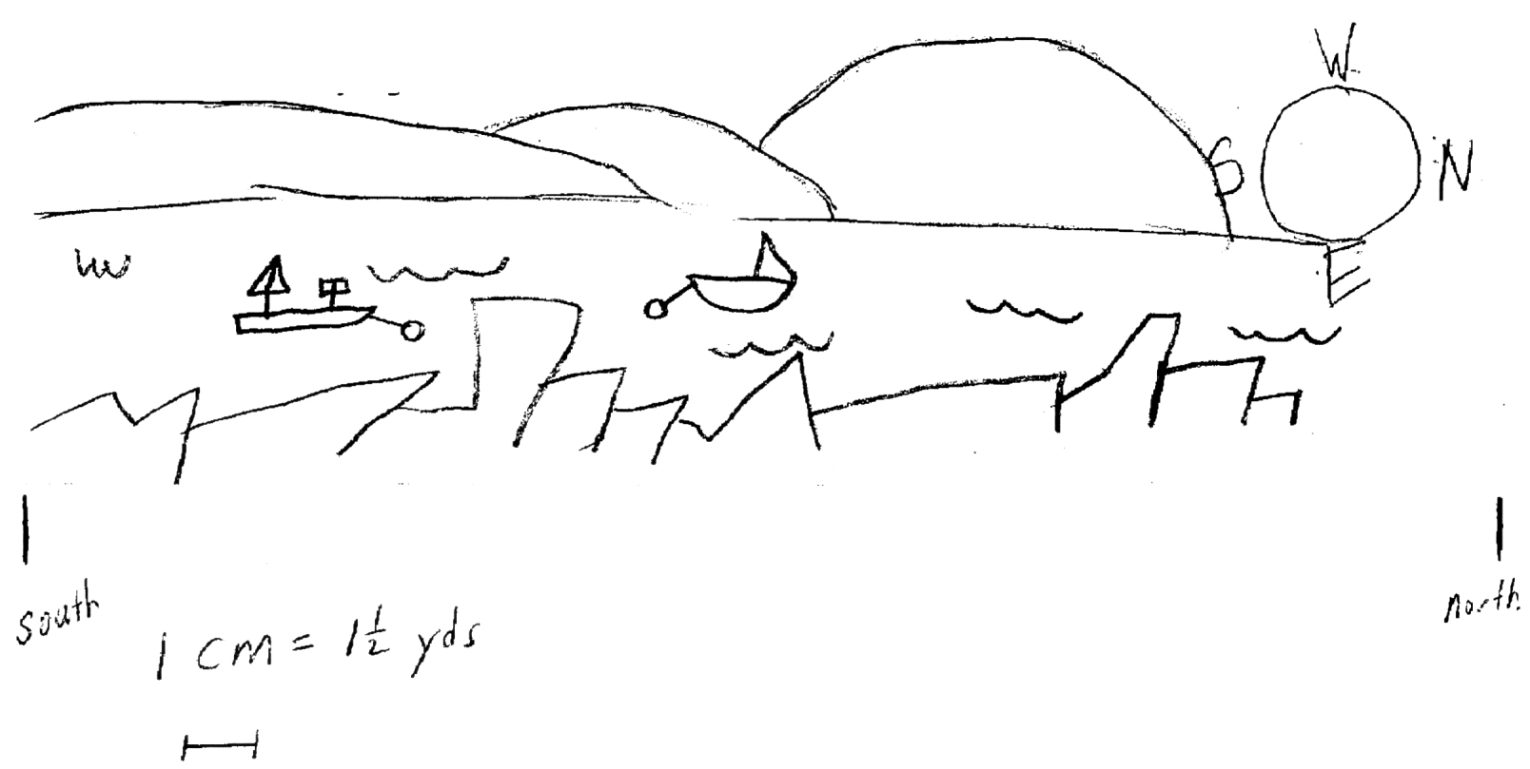
Location: Matthiessen Park, Village of Irvington, Westchester County
Area: Beach in the park, covered with vegetation
Surrounding Land Use: Urban/Resdiential 20=25%; Forested 25%, Beach 10%, Industrial Commercial 15-20%, Open and Grassy 15-20% (groomed park with ballfields)
Sampling Site: Beach, covered with vegetation, banks altered, riprap on shore, collected wood & debris in area
Plants in area:
Water depth:
River Bottom – rocky bottom, water choppy

ITEM | Time |  | Reading 1 | Reading 2 | Comments
Physical
Air Temperature | 9:45 AM |  | 16°C  61°F
 | 10:15 AM |  | 15°C  60°F
Wind Speed | Beaufort# 2 |  | SE
Cloud Cover | Clear
Weather today | Clear and cool
Weather recently | Windy, cloudy A little rain (drizzly), Cold
Water Temperature | 9:30 | 16°C
 | 11:00 AM | 15°C
 | 12:30 AM | 15°C
 | 1:30 PM | 17°C
Turbidity |  | 40 cm  75 cm  10 cm |  |  | Long site tube  42 cm avg.
 |  | 42 JTU |  |  | Short site tube
Chlorophyll | 10:30 AM | 0.6
Chemical
DO (estuary kit) | 10:30 | 4 ppm  5 ppm |  | 15°C | 35% saturated
pH | 11:00 AM | 7.0  8.0  7.5 |  |  | Average 7.5
Phosphate
Nitrate | 11:00 AM | > 50 mg/l
Alkalinity
Salinity  *This seems really high | 11:30 AM | 14 ppt  16 ppt  17 ppt |  |  | *15.5 ppt  estuary test kit
Fish Catch | Number Caught | Species |  | CPUE | Seine
15ft. long seine/4 ft wide | 1 | Blenny
5-10 seines | 1 | Flounder
 | 4-7 | Striped Bass
 | 20-30 | Atlantic Silversides
Tides | 8:00 AM | 11 cm
 | 9:30 AM | 0 cm |  | Falling
 | 10:30 AM | 0 cm |  | Falling
 | 11:00 AM | 0 cm |  | Ebb
 | 11:30 AM | - |  | Rising
 | 12:15 PM | 13cm |  | Rising
Currents | Cm/60 sec | Ebb/Flood/Still
 | 41 | Ebb
 | 46 | Ebb
 | 60 | Ebb
Traffic | 10:30 AM | Barge |  | Northbound | Loaded

