Snapshot Day 10/7/08 Data
(Salt Front RM 63.4)
RIVER MILE 57
Donahue Memorial Park, Cornwall Landing, Village of Cornwall-On-Hudson, Town of Cornwall, Orange County, NY
Christopher O’Sullivan, NYSOPRHP Trailside Museums & Zoo
Deborah Gilson, Willow Ave. Elementary - 4th grade – 70 plus - students
GPS Latitude 41°26’36”N Longitude 74°0’1”W

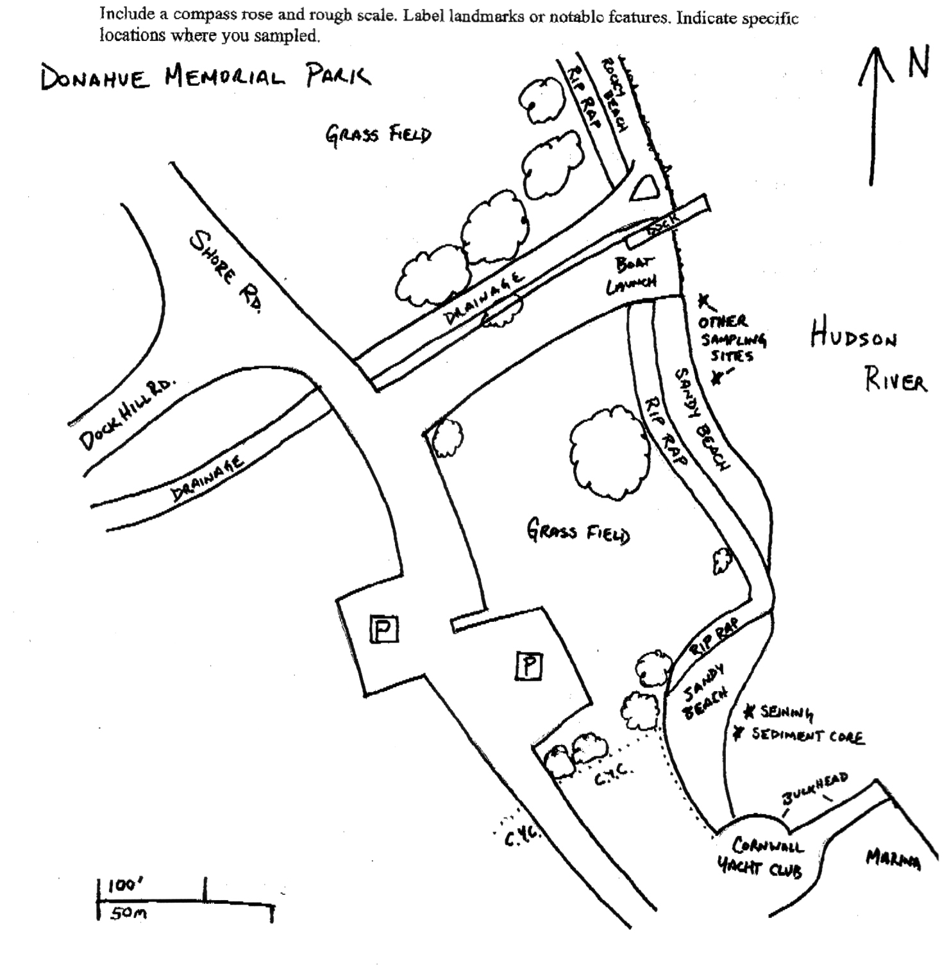
Location: Donahue Memorial Park
Area: Sandy beach used for seining & sediment core, 2nd beach are for other sampling.
Surrounding Land Use: Forested 5%, beach 20%, 75% open and grassy
Sampling Site: sandy beach, altered banks, shoreline riprap, bulkhead, collected wood & debris in area,
Plants in area: 10% of sampling area: 30% of plants Water Milfoil ; 70% - water celery.
Water depth:
River Bottom –Claylike mud mixed with sand and rocks

ITEM | Time |  | Reading 1 | Reading 2 | Comments
Physical
Air Temperature | 12:19 PM |  | 26°C
Wind Speed | 1-3 knot |  | East
Cloud Cover | clear
Weather today | Clear and cool
Weather recently | Cool - 4 °C to 17 °C. Negligible Precipitation
Water Temperature | 10:45 AM | 60° F  9°C |  | 63° F  9°C |  | 61.5° F avg.  9°C
 | 12:00 PM | 70° F  19°C |  | 70° F  20°C |  | 70° F  19.5°C
 | 1:35 PM | 70° F  20°C |  | 68° F  19°C |  | 69° F  19.5°C
Water Calm | Water moved by wind | Not whitecaps
Turbidity  sight tube | 10:55 AM | 55 cm  81 cm |  |  |  | 68 cm
Chlorophyll | 9:45 AM | 1.5
 | 10:15 AM | 1.5
 | 10:45 Am | 2.0
Chemical
DO  meter | 10:25 AM |  |  | 18°C |  | 79.1% - meter displayed only % saturation
pH (litmus paper) | 12:05 PM | 7.5  7.5  7.5 |  |  |  | 7.5 average
Salinity -  Quantabs – low range strips – | 10:10 AM | 81 ppm
 | 10:50 AM | 81 ppm
 | Noon | 73 ppm
 | 1:40 PM | 73 ppm
Fish Catch  30 ft. seine X 4 ft. with bag – ¼ inch mesh - 15 ft. pull | Number Caught | Species |  | CPUE |  | Seine -  3 seines
 | 8 | Alewife |  |  |  | 216 Total
 | 6 | American Shad
 | 20 | Banded Killifish
 | 3 | Blue crab
 | 40 | Blue back herring
 | 4 | Golden Shiner
 | 15 | Herring
 | 38 | Pumpkin Seed
 | 10 | Smallmouth Bass
 | 39 | Spottail Shiner
 | 6 | Striped Bass
 | 1 | Sunfish
 | 19 | White Perch
 | 2 | Brown Bullhead
 | 2 | Largemouth Bass
 | 3 | Unidentified
Seine | Time | Total Catch |  | Length Pull |  | CPUE
1 | 10:00 AM | 40 |  | 15 ft. |  | 4.37
2 | 10:30 AM | 44 |  | 15 ft. |  | 4.81
3 | 12:30 PM | 132 |  | 15 ft. |  | 14.44
Tides* | 10:05 AM |  |  | * Tidal range in this section of the Hudson is less extreme than further up or downriver, and on this date, with the moon in first quarter, the predicted water levels at high and low tide were only a bit more than a foot apart. Low tide was ~ noon but students might have missed subtle changes.
 | 10:25 AM | Unchanged
 | 10:55 AM | Unchanged
 | 12:00 PM | Unchanged
 | 1:45 PM | Rising
Currents | 10:05 AM |  |  | Ebb
 | 10:25 AM |  |  | Ebb
 | 11:05 AM |  |  | Ebb
 | 12:05 PM |  |  | Flood
Core -  2 ft. water depth  11:35 AM | 26 cm –  ½ cm oxidized top | Abundant –  Sand |  | Common –  Gravel |  | Rare –  Clay  Mud  Leaves
Other Observations | 2 Double crested cormorants | 1 Great Egret |  | 10 Ring Billed Gulls |  | 1 Herring Gull
 | 26 American Crow | 3 Monarch Butterflies

