Snapshot Day 10/7/08 Data
(Salt Front RM 63.4)
RIVER MILE 61W
Newburgh Landing, Newburgh
Rich Parisio, Stony Kill, NYS DEC
Alice Kish, Matt Barbero, Horizons on Hudson School, 4th grade – 20 students

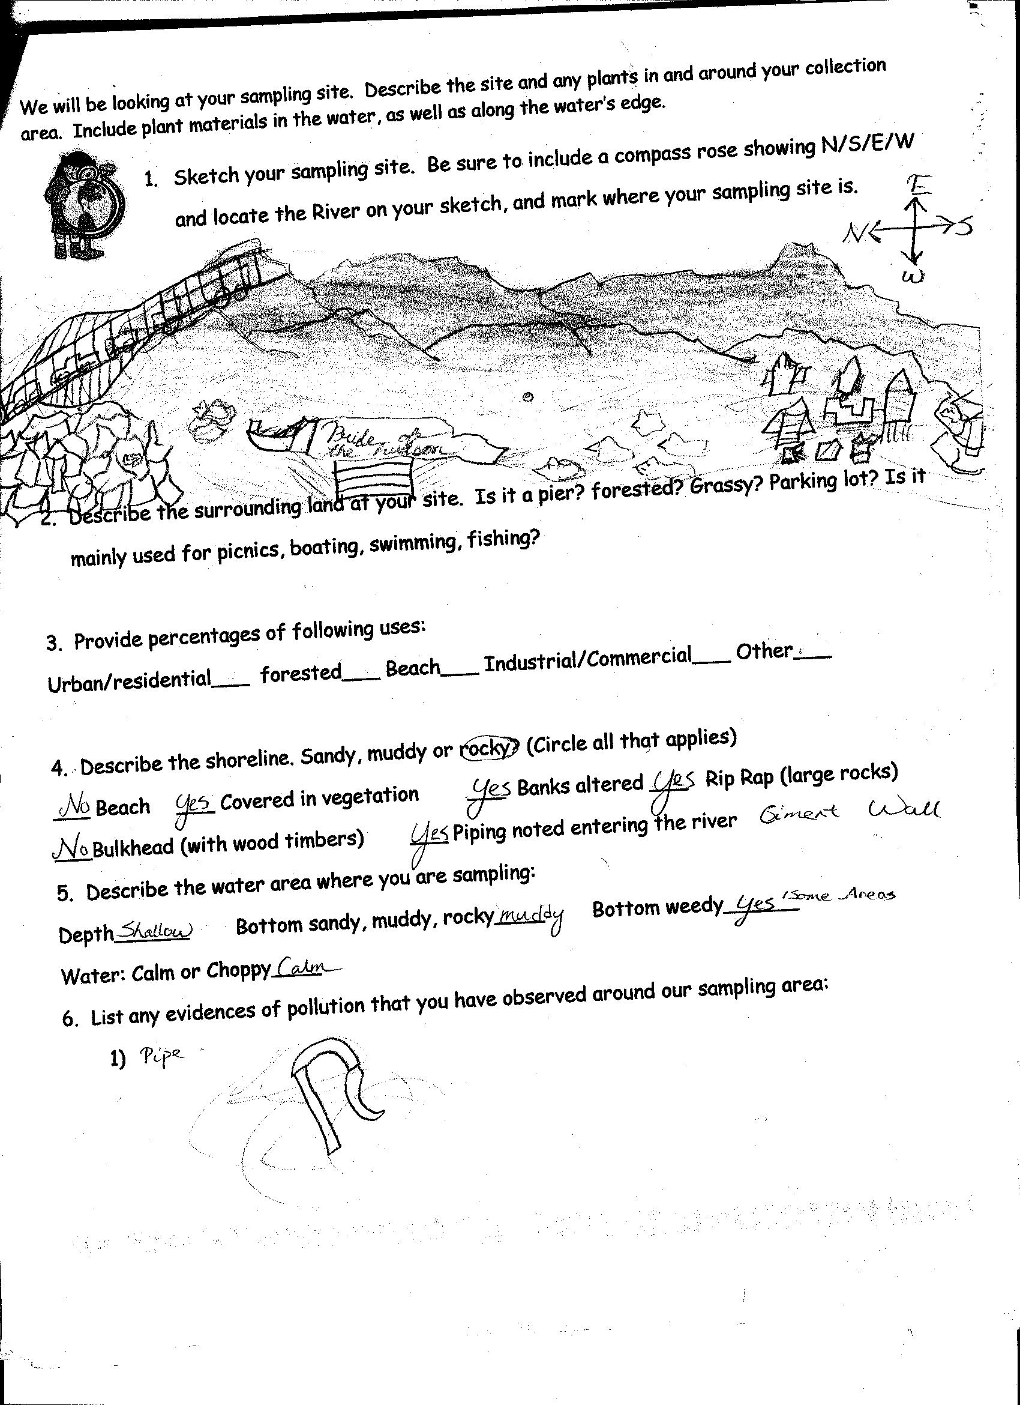
Location: Newburgh Landing, Newburgh, Orange County NY
Area:
Surrounding Land Use:
Sampling Site Shoreline: shoreline rocky, banks altered, large rip rap, piping entering the river, cement wall
Plants in area: banks covered in vegetation
Water depth: shallow
Bottom Surface: muddy, bottom weedy in some areas
Plants in water – eel grass 15% coverage. Looks like a minnow. Indigenous plant.

ITEM | Time |  | Reading 1 | Reading 2 | Comments
Physical
Air Temperature | 10:52 AM |  | 14°C  58°F
Wind Speed
Cloud Cover
Weather today
Weather recently
Water Temperature
Water Surface | calm
Turbidity - | 1:00 PM |  | 72 inches  6 ft.  2 yds. |  | AVERAGE  60 inches  5 ft.
60 inches
5 ft.
48 inches
4 ft.
Chlorophyll
Chemical
DO

pH –
Salinity -
Fish Catch | Number Caught | Species
 |  | American Eel
Tides | 10:26 AM | Dropping |  | Tide Going OUT
 | 11:17 AM | Dropping
 | 12:00 noon | Dropping
 | 1:15 PM | Rising
Currents | 10:30 AM | 2.5 feet per sec.
Traffic | 10:06 | Pride of Hudson |  | White | Full Southbound
 | Noon | Pride of Hudson |  | White | Full  Northbound
 | 1:10 PM | Kayak |  | Yellow | Full!  Southbound
 | 1:59 PM | Pride of Hudson |  | White | Empty  Northbound
Other Observations | Saw: Pigeon, people, rat, birds, ducks, seagull  Found – Cigars, bottled, shoes, plastic, oil in water, straw, bridge over the water with cars.  The impact of these is:  Bad for animals in water, CO2 is bad for people to breathe, oils in water is bad for animals.

