Snapshot Day 10/7/08 Data
(Salt Front RM 63.4)
RIVER MILE 92
Kingston Point Park, Kingston
GPS Latitude 41°55.6 N Longitude 73°57.80 W
Steve & Julie Noble, Forsyth Nature Center
Jamie Carey, Dutchess ARC – 8 adult participants
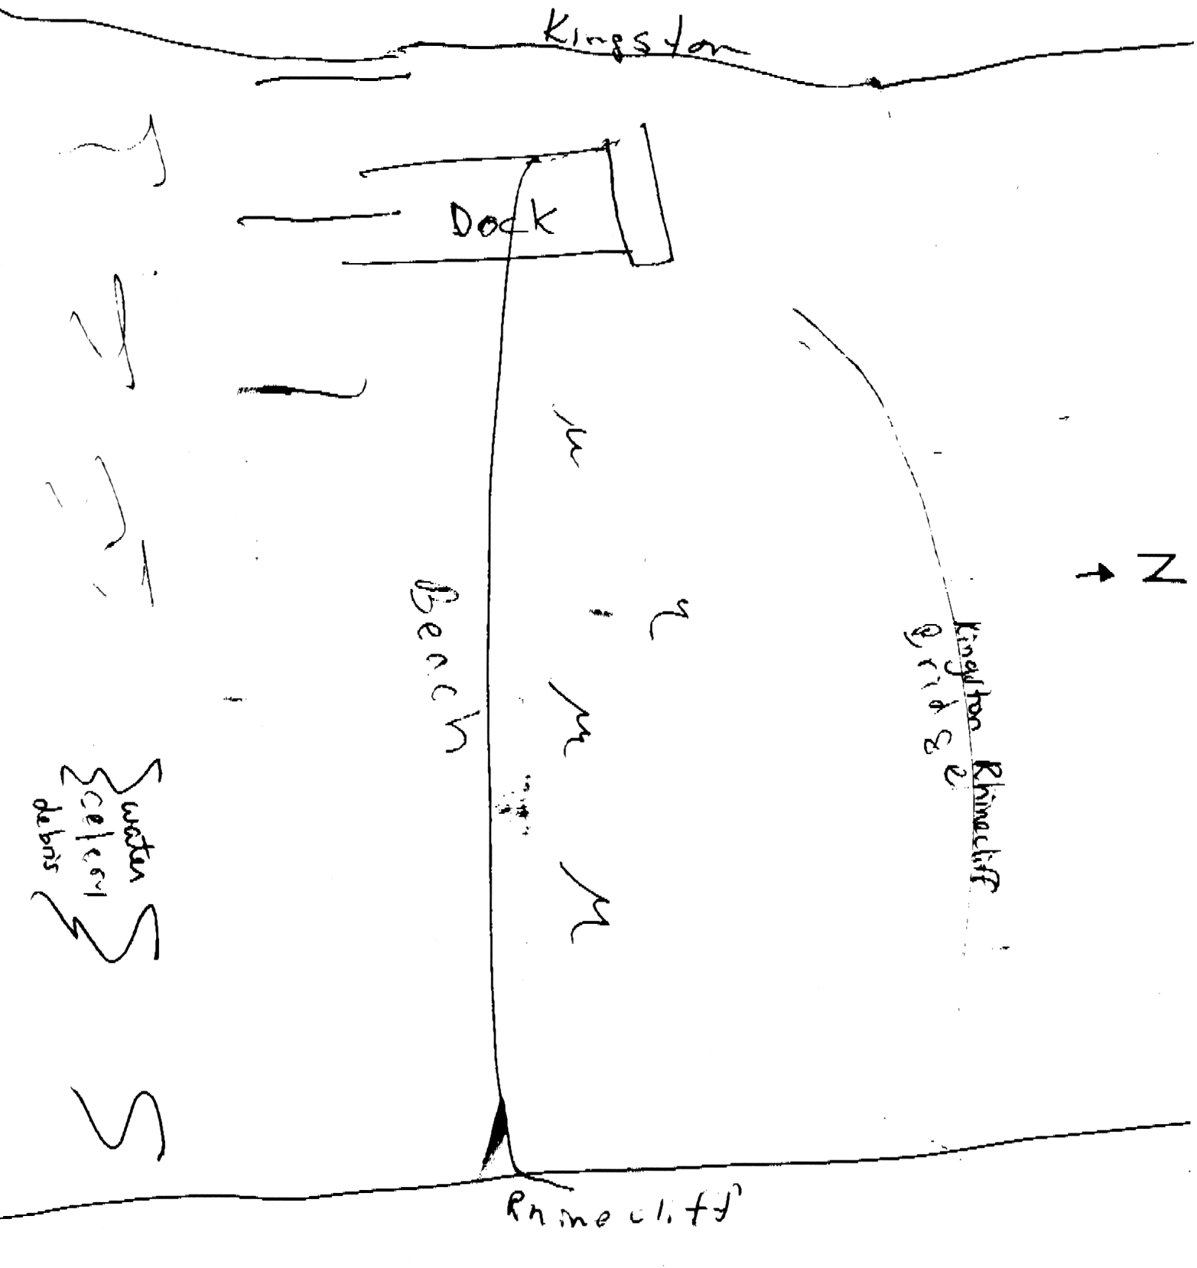
Participant Sketch of Site
Location: Kingston Point Beach, beach and parking lot
Area: Used for picnics, boating, fishing, swimming
Surrounding Land Use: 20% forested; 80% beach
Sampling Site: shoreline is sandy with some bricks, banks are altered, collected wood debris in the area
Plants in area: 1% of the area is covered in plants – 1% water celery plus in the water
duckweed.
Water depth: 0-4 feet in depth – gradual slope on the beach – 4 ft. deep much further out
River Bottom : sandy and muddy bottom

ITEM | Time |  | Reading 1 | Reading 2 | Comments
Physical
Air Temperature | 11:20 AM |  | 55°F
Wind Speed | 1-3 knots
Cloud Cover | clear
Weather today | No precipitation
Weather recently | Frost last night with low precip.  Brief rain shower yesterday
Water Temperature | 11:22 AM | 63°F  65°F  64°F |  |  | 64°F avg
 | 11:45 AM | 61°F
Water calm | yes
Turbidity  Site tube | 11:35 AM | 30 JTU |  | 6 inch depth
 |  | 20 JTU |  | 12 inch depth
 | 12:10 PM | 20 cm
Chlorophyll | 10:30 AM | 0.1 |  | Least amount
Chemical
DO  ampules | 11:48 AM | 8.0 mg/L |  | 17.78°C | 85% saturated
pH
Phosphate  chemets | 12:00 PM | 0.1 ppm
Salinity | Not tested
Fish Catch  20’seine | Number Caught | Species |  | Largest Size | Seine
X 3’ | 5 | Banded killifish |  | 6 cm max.
Tides | 10:30 AM | 25.5cm |  | 10 inches | Falling
 | 11:30 AM | 14.5 cm |  | 5.75 inches | Falling
 | 12:30 PM | 0 cm |  | 0 inches | Falling  Tide went out past the stick location on the beach
Currents |  | No current measurable on shoreline – we are out of the channel |  |  | Site is in a cove. Waves come directly onshore from the N.
Traffic | None seen
Other Items | 3 migrating butterflies!
Core | 14 cm total length | 2 cm top  brown |  | 12 cm bottom grayish color with small brick pieces present | 2 distinct layers

