Snapshot Day 10/7/08 Data
(Salt Front RM 63.4)
RIVER MILE -7 Ft. Wadsworth
Dan Meharg & John Warren National Parks Service, NPNH Education Center
Mrs. Bridgman - I.S. 27 – 8th grade, 30 students
GPS latitude N40.60537 W 074.05367
Location: Battery Weed, just north of the Verrazano Bridgeo, Staten Island
Area: Shoreline is rocky, banks are stone wlls next to fort, collected wood/debris in the area
Surrounding Area: 100% historic fort next to the Varrazano Bridge
River Bottom: Rocky
Water Depth:not noted
Plants in water: 80% -
Tidal Shallows: Fucus vesiculosus (Bladder wrack) 75%, Polysiphonia (red algae)10%, Ulva lactuca, (Sea lettuce) 5%, otherweed 10%
Tidal Marshes: Phragmites (Common reed) 3%, Saltwater cordgrass 1%
ITEM | Time |  | Reading 1 | Reading 2 | Comments
Physical
Air Temperature | 10:30 AM |  | 65° F  18.3° C
 | 10:40 AM |  | 52° F  11.12° C
Wind Speed | 4-6 knots |  | South
Cloud Cover | Partly cloudy
Weather | Nice,
Weather yesterday | Warm and sunny
Water Calm | yes
Water Temperature | 11:07 AM | 15 ° C  59 F°
 | 11:08 AM | 15.6°C  60 F°
 | 11:09 AM | 15 °C  59 F°
Turbidity | 10:37 AM | 1.7 m  1.9 m  2.2 m |  |  | Average 1.9 m
Chlorophyll | 11:15 AM
Chemical
DO  (ampules) | 11:10 AM | 11.1 mg/L |  | Temp. 11° C | 89.67% saturated
pH (litmus paper) | 10:35 AM | 8.0 |  | 8.0 | 8.0
Phosphate | 10:45 AM | 1.2 mg/L
Nitrate | 10:35 AM | 0.06 mg/L
Alkalinity | n/a
Salinity  Instant ocean hydrometer | 10:35 AM | 22.2 ppt  19.6  20.9 |  |  | Average 20.9
Fish Catch | Number Caught | Species
Killitrap | 5 | Atlantic Silversides
Core Sample |  | Orange, Sandy Core
Tides | 10:55 AM | 15 cm |  | Rising
 | 11:05 AM | 20 cm |  | Rising
 | 11:15 AM | 20 cm |  | -
 | 11:25 AM | 25 cm |  | Rising
 | 11:35 AM | 30 cm |  | Rising
Currents | 167cm/60 sec | 0.05566 knots
 | 137 cm/60 sec | 0.05124 knots
 | 270 cm/60 sec | 0.0900 knots
 | 530 cm/60 sec | 0.17666 knots
Traffic | 11:35 AM | Cargo |  | APL | Northbound
 |  | Cargo |  | Minerva* | Anchored
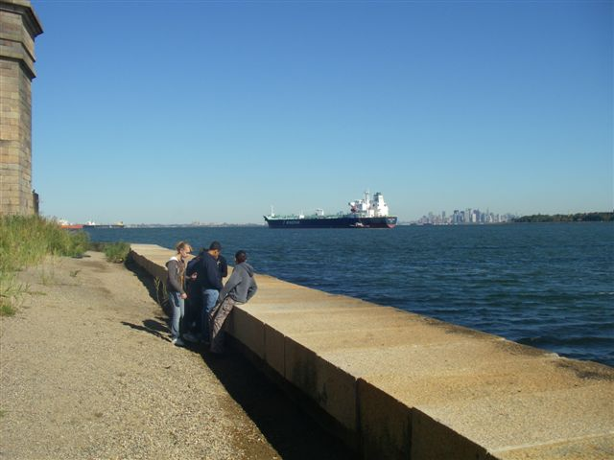 |  | 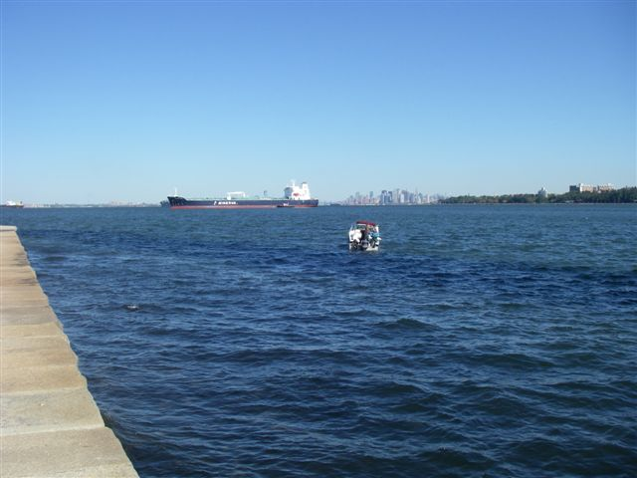 |  | 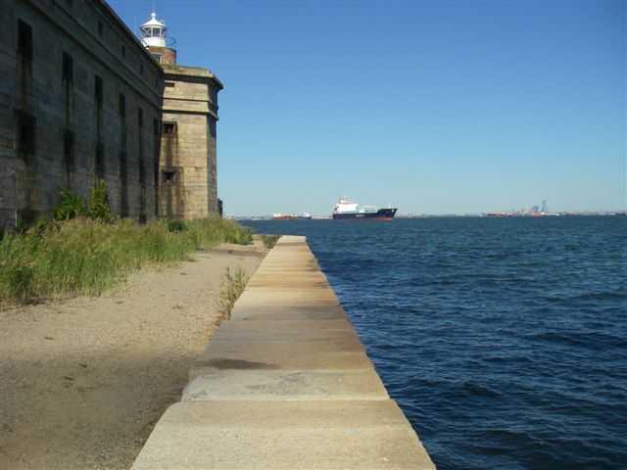
10:00 AM 11:30 AM 12:10 PM
Minerva anchored and during the switch of the currents it turned to face the opposite direction

