Snapshot Day 10/7/08 Data
(Salt Front RM 63.4)
RIVER MILE 127 – Stuyvesant Landing
Leanna O’Grady, Columbia County Soil & Water Conservation District
The Alternative Learning Center (TALC) – 7-10 yrs. – 10 students
Latitude 47 N Longitude 73W (topo map)
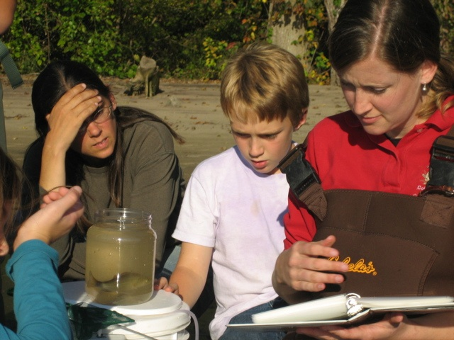

Location: ¼ mile South of Stuyvesant Landing
Area: Park/Boat launch, sandy beach area on the point
Surrounding Land Use: 90% forested, 10% beach – used for picnics, swimming, campfires, sandy beach and dense woods behind
Sampling Site: Beach, covered with trees, dead trees on shoreline –
water area is sandy with little mud further out – gently sloped beach, shallow quite a distance and then shipping channel
Plants in area: none
Water depth: 0-100 cm
River Bottom –sandy

ITEM | Time |  | Reading 1 | Reading 2 | Comments
Physical
Air Temperature | 3:30 PM |  | 70.8°F  21.6°C
 | 3:45 PM |  | 70°F  21.1°C
Wind Speed | Beaufort 6 |  |  | NW
Cloud Cover | clear |  |  | Water calm
Weather today | Perfect!
Weather last 3 days | Some rain
Water Temperature | 3:50 PM | 65°F  18.35°C
 | 4:00 PM | 65°F  18.35°C
 | 4:15 PM | 64°F  17.79°C
Turbidity | 3:45 PM | 60 JTU X 3 |  |  | 60 JTU average
Chlorophyll | 3:30 PM | 1.5
Chemical
DO  Drop count | 4:45 PM | 8.5 mg/L |  | 18.35 ° C | 92%
pH  pen | 3:50 PM | 8.0  8.2  8.5 |  |  | Average 8.23
Salinity  Test strip | 3:50 PM | < 31 mg/L
Fish Catch | Number Caught | Species |  |  | 1 seine with fish catch
Seine 40 ft. X 4 ft.  Mesh 0.25 inch | 7 | Banded Killifish |  |  | 19 fish total
 | 1 | Pumpkinseed
 | 3 | Spottail shiner
 | 6 | Young of Year
 | 2 | White Perch
Tides | 3:15 PM
 | 3:30 PM |  |  | falling
 | 3:45 PM |  |  | falling
 | 4:00 PM |  |  | rising
 | 4:30 PM |  |  | unchanged
 | 5:00 PM |  |  | rising
Currents | 3:30 PM | south |  | ebb
Other Items
Core Description | Total Length | Top Layer |  | Second Layer | Describe
 | 25 cm | No distinct layers
 | Abundant – sand | some -  mud |  | Some –  Clay | Sulfur smell
Commercial Traffic | 3:20 PM | Pleasure craft |  | White | Southbound
 | 3:22 PM | Pleasure craft |  | White & Blue | Southbound
 | 3:42 PM | Large Pleasure craft |  | American Spirit | Southbound
 | 4:12 PM | Motorboat |  | Blue & white | Southbound
 | 4:45 PM | Pleasure craft |  | White | Southbound
Other

