Snapshot Day 10/7/08 Data
(Salt Front RM 63.4)
RIVER MILE 145
Captain Chip Reynolds & The Half Moon & New Netherlands Museum, Corning Preserve, Albany
Jane Platania, Rensselaer Middle School, 6-7th grade, 4 students
N42°38.971’ and W73°44.812’
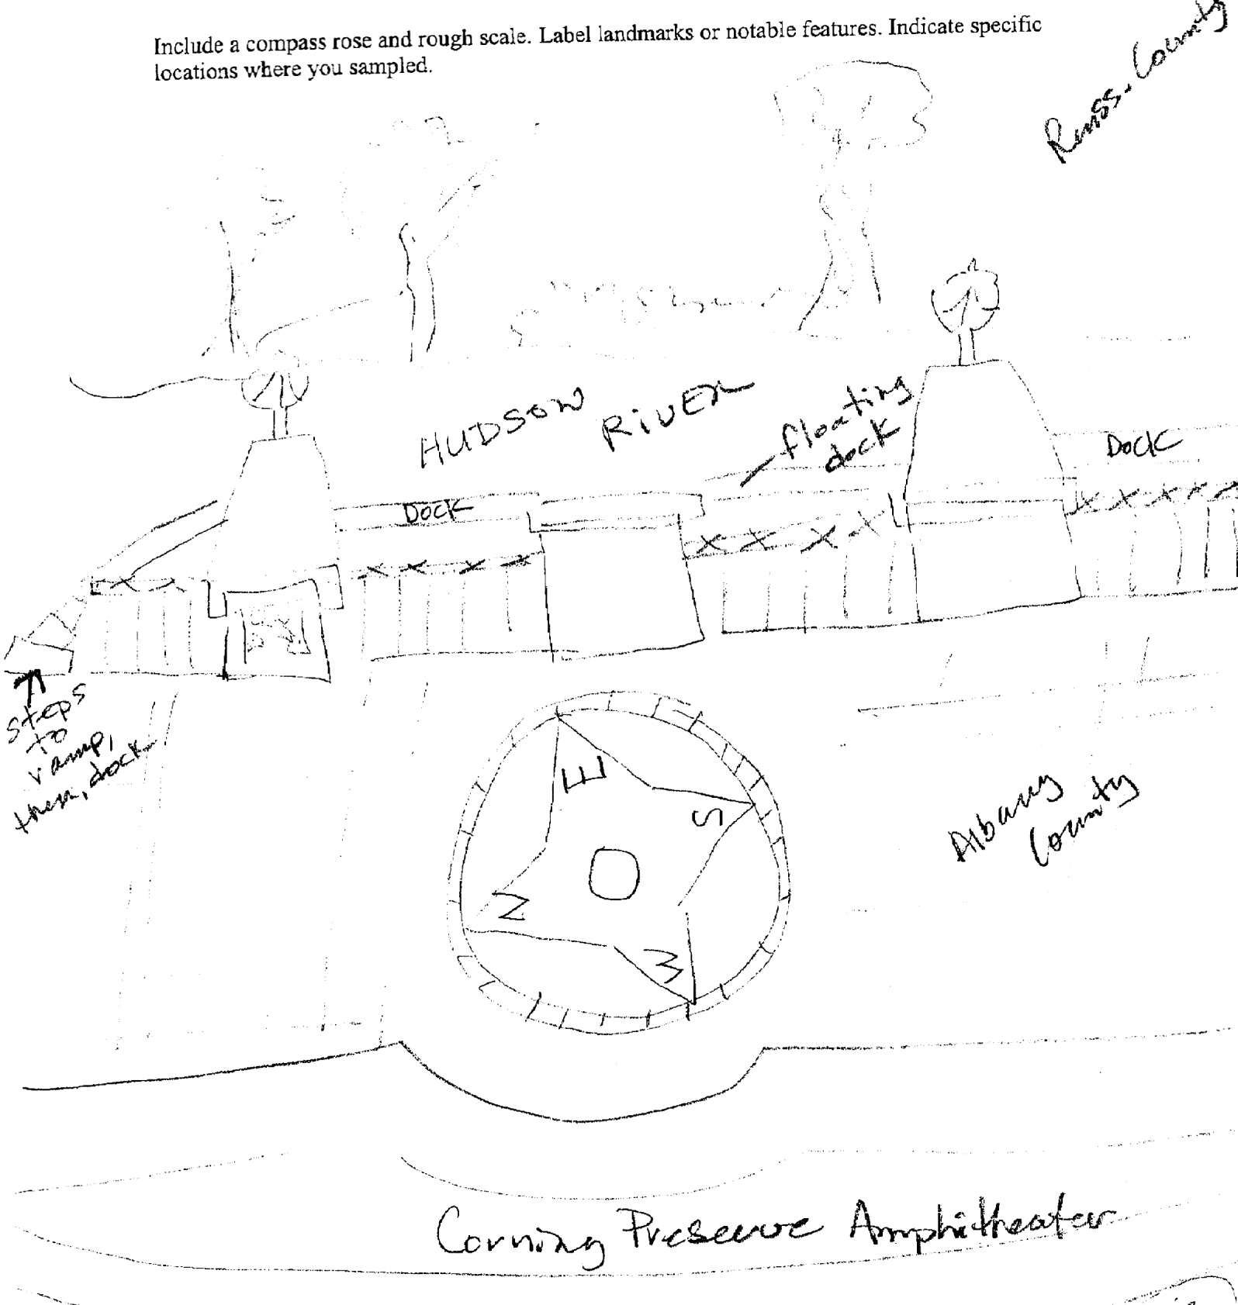
Location: Rocky beach surrounded by rising forested land and small yard and driveway
Area: A path along the beach with rising forested hills and yard with house and driveway
Surrounding Land Use: Urban with sidewalks & amphitheater, picnic tables
Sampling Site: vegetation, banks altered, shoreline with raprap – floating dock
Water depth:
River Bottom –
Plants in area: 0 % of Hudson River water area has plants
Plants in sampling area:

ITEM | Time |  | Reading 1 | Reading 2 | Comments
Physical
Air Temperature | 12:50 PM |  | 13°C | 1:10 PM | 14°C
Wind Speed | Beaufort #4 |  | 14 knots | North
Cloud Cover | clear
Weather today | Clear, breeze – perfect day!
Weather recently | 10/5 – partly cloudy; 10/6 rain
Water Temperature | 10:00 AM | 14.5°C
 | 11:10 AM | 14.5°C
Water calm
Turbidity - secchi | 10:00 AM | 8 ft.
 | 10:15 AM | 9 ft
 | 10:30 AM | 9 ft. |  |  | 8.66 ft. avg.
Chlorophyll | Time | Color Code
Location noted as RM 153 | 12:05 PM | Between 0.3 and 0.5
 | 12:10 PM | Between 0.0 and 0.1
Chemical
DO  (drop count kit) | 10:00 AM | 14.2 mg/L |  | 14.5°C | 110%
 | 11:10 AM | 10 mg/L |  | 14.5°C | 100%
pH  Litmus paper | 12:35 PM | 7.8  7.2  6.8 |  |  | Average 7.26
Phosphate
Nitrate
Alkalinity | 12:35 PM | 80 ppm  80 ppm  80 ppm |  |  | Average 80 ppm
Salinity
Fish Catch | Number Caught | Species |  | CPUE | Seine
Tides | 10:00 am | 554 cm
 | 10:15 am | 564 cm |  | Rising
 | 10:30 am | 572 cm |  | Rising
 | 10:45 AM | 572 cm |  | Rising
 | 11:15 AM | 605 cm |  | Rising
 | 11:30 PM | 645 cm |  | RIsing
 | 11:45 AM | 618 cm |  | Falling
 | 12:24 PM | 602 cm |  | Falling
Currents | Cm/60 secs | Cm/sec |  | Knots – (cm/sec)/50 | N/S -  Ebb/Flood/Still
 | 853 | 14.22 |  | .28 | ebb
 | 721 | 12.03 |  | .24 | ebb
 | 946 | 15.76 |  | .32 | ebb
 | 946 | 15.76 |  | .32 | ebb
 | 1167 | 19.45 |  | .39 | ebb
Traffic
Other Items | 10:25 AM | Helicopter |  |  | Westbound
 | 10:30 AM | Tug |  | Grey MARGO | Southbound
 | 11:10 AM | National Guard Helicopter |  |  | Westbound
 | 11:17 Am | Sailboat with no sail |  |  | Southbound
 | 11:22 AM | Amtrack Train |  |  | Eastbound
 | 11:23 AM | Pleasure Boat |  |  | Northbound
 | 11:30 AM | Sailboat – no sail |  | bluebottom | Southbound
 | 12:15 PM | Train |  | Cargo | Eastbound
RIVER CORE  10:30 AM | Length | Abundant |  | Common | Smell
Water 4 inches deep | 1.75 inches | Sand |  | Clay  Mud  Gravel  Pebbles | H2S

