Snapshot Day 10/7/08 Data
(Salt Front RM 63.4))
RIVER MILE 300
Henderson Lake/Hudson River
Sarah Fink, Minerva Central School District
9 -12th graders, 20 students
44°05.5135’ N, 74°03.5894’W
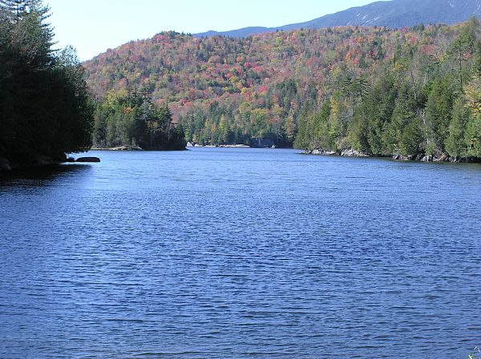
Photo taken at the Lake Henderson dam where the outflow forms the Hudson River. This part of the lake is about 500 ft. wide.
Location: Hudson headwaters at Calamity Brook and Lake Henderson, Newcomb, NY
Area: Adirondacks New York
Surrounding Land Use: Forested 90%; Beach 5% (about .5 mi upriver from sampling site is a small beach/kayak site; 5% Industrial/Commercial – site includes some historic alteration from mining operations throughout the 1900’s - the mining (iron) site is at Tahawus, where a dam used to support a small lake,.
Sampling Site: Heavily forested, collected wood and debris from fallen trees has been caught in the rocks, .5 mi upriver is a small concrete dam that is the outflow of Lake Henderson.
Plants in area: The shoreline is planted with trees, shrubs and flowers.
Water depth: maximum depth 58 cm, average depth across profile is 43.8 cm
River Bottom –rocky
Plants in water – 5% protruding grasses along shoreline in some places.
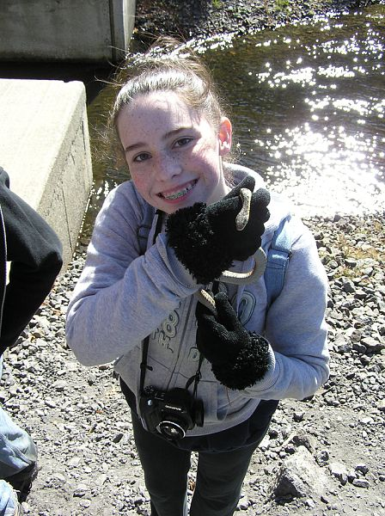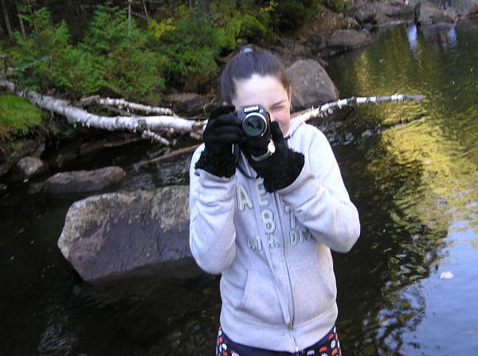

ITEM | Time |  | Reading 1 | Reading 2 | Comments
Physical
Air Temperature | 9:00 AM |  | 46° F  7.8° C | 12:55 PM | 60° F  15.6° C
Wind Speed | 9:00 AM |  | 0-5 kts | Variable
Cloud Cover | clear
Weather yesterday | Some rainfall on the morning before measurement. Night-time temps. Have been in the 30’s-40’s° F. Frost on the ground the morning of measurements.
Water Temperature | 9:00 AM | 6.1° C  43 ° F |  | 6.1° C  43 ° F
 | 12:45 PM | 6.7° C  44 ° F |  | 7.2° C  45 ° F | 7.8° C  46 ° F
Water surface | Water movement is swift over many rocks
Turbidity  Large sight tube | 9:00 AM | 0 cm
Chemical
DO  (ampules) | 9:00 AM | 7 mg/L  shallow pool |  | Temp 6.1° C | 57% saturated
 | % saturation is quite low, no plants in water so O2 source is aeration.
pH | Time | pH Paper |  | Universal Ind. Soluiton
 | 9:00 AM | 5.0 |  | 5.0
Phosphate | 9:00 AM | No color change in test |  | 0.0 mg/L
Nitrate | 9:00 AM | No color change in test |  | 0.0 mg/L
Alkalinity | n/a
Salinity | Time | Method |  | Reading
 | 9:00 AM | Chloride strips |  | No reading
Fish Catch | Number Caught | Species |  |  | Minnow traps
Dip Nets | 1 | Dragonfly nymphs
 | 2 | Damselfly Nymphs
 | 3 | Mayfly Nymphs
 | 4 | Stonefly Nymphs
Currents | 1300cm/60 secs | 22.17cms/sec. |  | *South | 0.44 kts.
*NON TIDAL SECTION OF HUDSON | Measured from river center but there is not an even profile across the river so rocks in the center probably slowed movement. Water too cold for 2nd trial
Other Items | Garter snake along shore
Almanac Entry | MCS students enjoyed a day in our outdoor classroom. Although the weather and water were cold, the students took the opportunity to wear boots, waders and gloves to take water samples and search for macroinvertebrates. Students remarked about the clarity of the water and the overall peacefulness of the scene, and about how grateful they are to call this end of the Hudson “home”.

