Snapshot Day 10/7/08 Data
(Salt Front RM 63.4)
RIVER MILE 31 – Hook Mountain State Park
Laurie Seeman – Strawtown Art & Garden Studio
Lorraine Marden Komar -Blue Rock School – 4th & 5th – 17 students
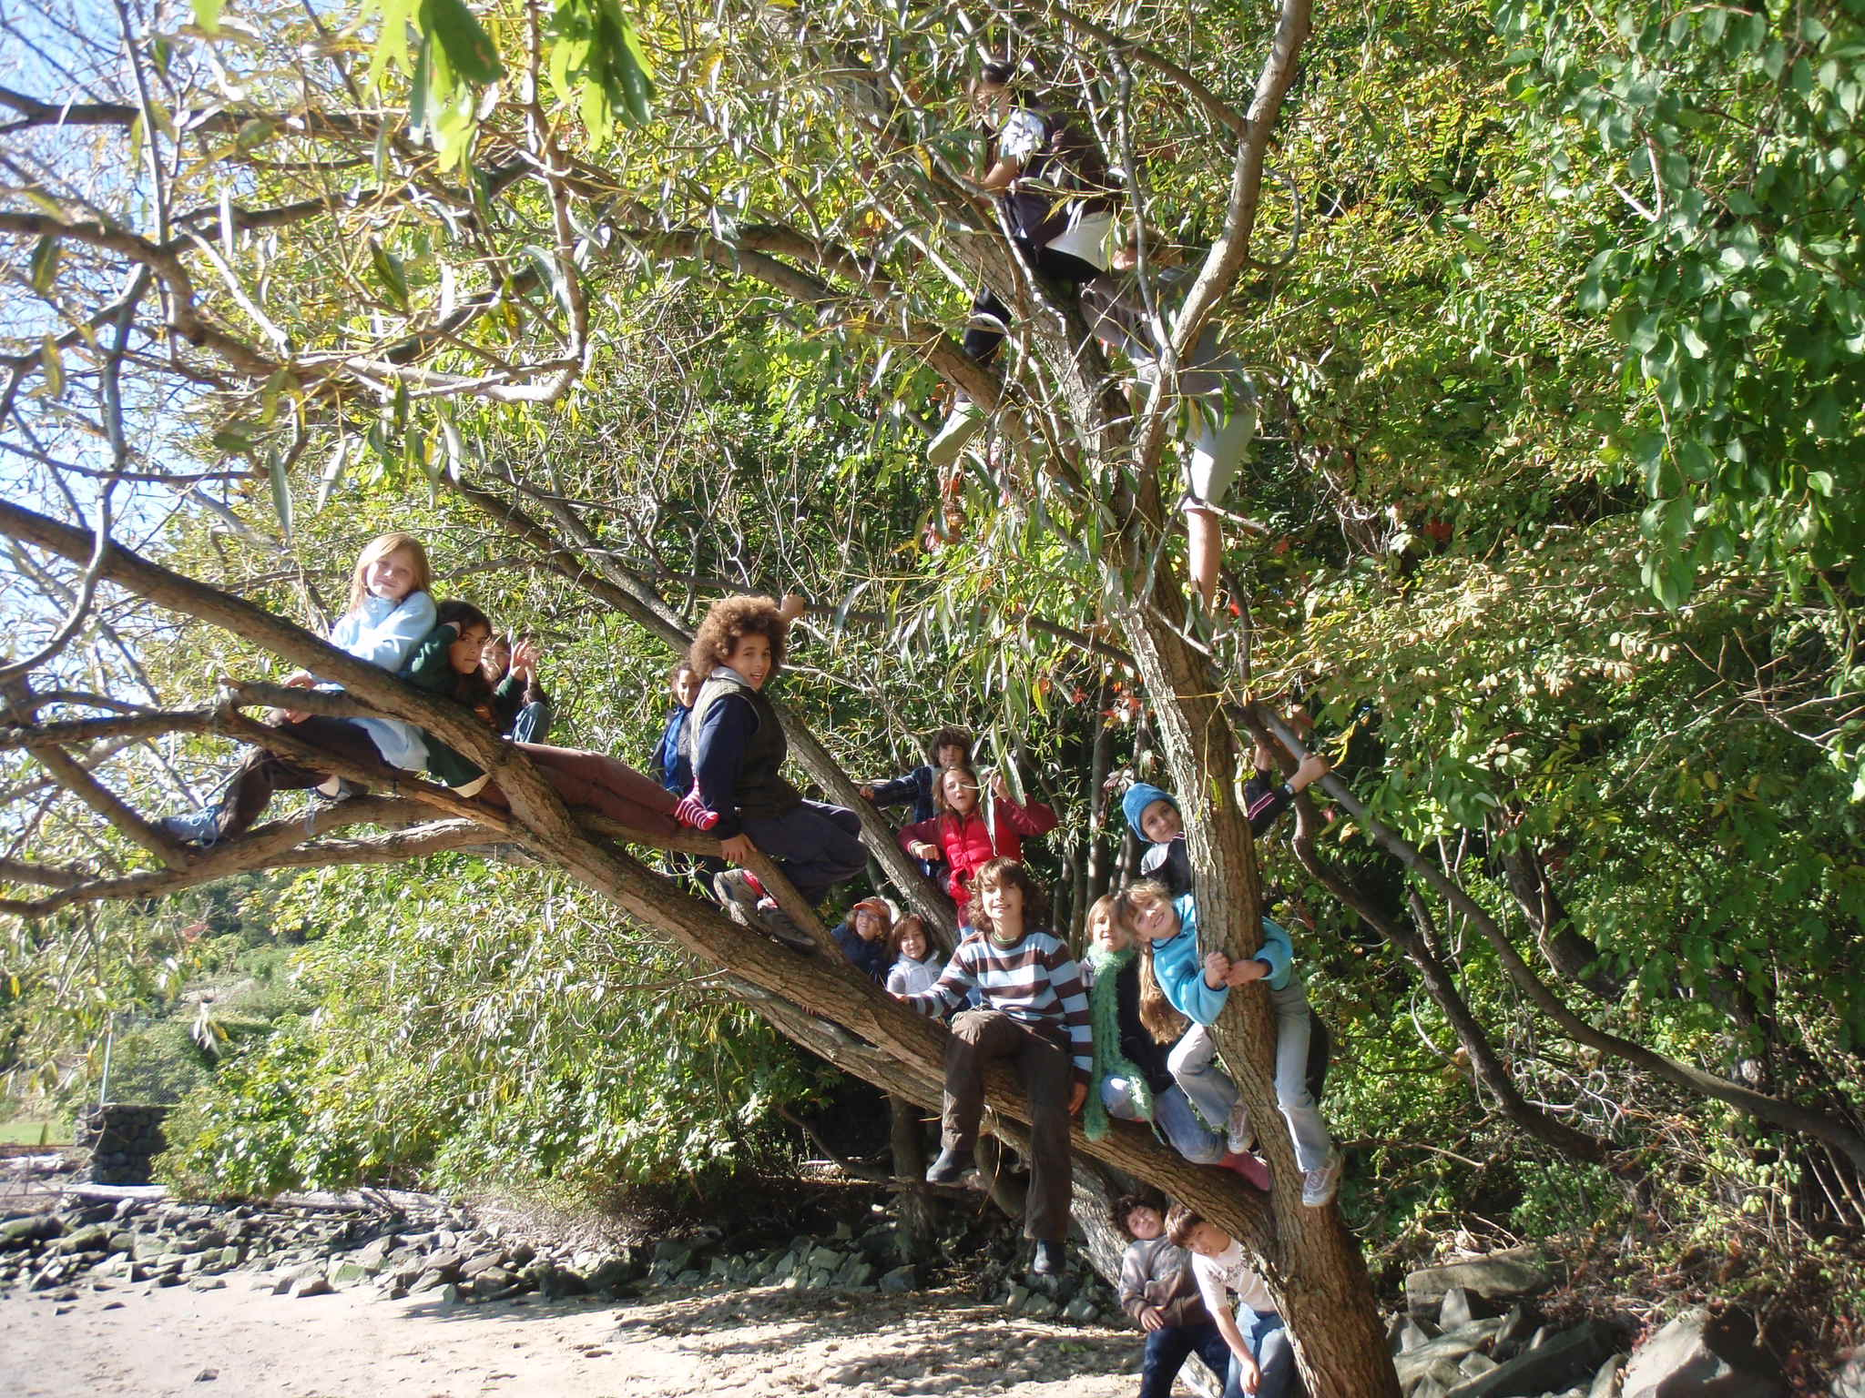

Location: Nyack Beach near Hook Mountain Sandy Beach right side of riverfront area
Area: Park/Boat launch, sandy beach area on the point
Surrounding Land Use: 70% forested, 5% urban/residential, 20% beach – used for recreation & picnics
Sampling Site: Beach – sandy and rocky at edges, covered with vegetation beyond the beach, stone wall, riprap shore, collected wood debris –
Piping coming into river south of sampling site
Plants in area: 1% water celery
Water depth: 3 ft.
River Bottom –sandy

ITEM | Time |  | Reading 1 | Reading 2 | Comments
Physical
Air Temperature | 11:06 AM |  | 61°F  17°C
 | 1:00 PM |  | 50°F  10°C
Wind Speed | 20 kts |  |  | NW
 |  |  |  |  | Water Choppy
Cloud Cover | clear
Weather today | No rain – wind picked up
Weather last 3 days | Very windy, a bit chilly but no precip.
Water Temperature | 11:10 AM | 20°C |  | 20°C | 20°C
 | 1:04 PM | 21°C |  | 21°C | 21.5°C
 | 1:44 PM | 21°C |  | 21°C | 21°C
Turbidity | 1:04 PM | 5 JTU  10 JTU  5 JTU |  |  | 6.7 JTU average
Chlorophyll | 3 tests | 0.3 each
Chemical
DO  Drop count | 11:10 AM | 8 mg/L |  | 20 ° C | 90%
pH  Colormetric kit | 11:49 AM | 7.0 |  | 3 tests | Average 7
Salinity  Test strip/ | 11:33 AM | 513 ppm  512 ppm  513 ppm |  | 5.13 ppt  5.12 ppt  5.13 ppt
Fish Catch | Number Caught | Species
Seine 12 ft. X 6ft.  Mesh 0.25 inch | 4 | American Eel |  |  | 28 total catch
 | 2 | Blue Crab
 | 2 | Grass Shrimp
 | 20 | Silverside
Tides | 11:20 AM | 45 cm
 | 12:00 PM | 55 cm |  | rising
 | 12:44 PM | 70 cm |  | rising
 | 1:15 PM | 84 cm |  | rising
 | 1: 40 PM | 90 cm |  | rising
Currents | CM/60 secs | Cm/Sec |  | North/South Ebb/Flood/Still | Knots
11:22 AM | 400 cm | 6.66 |  | South (Ebb) | 8 kts
12:50 | 390 cm | 6.5 |  | South (Ebb) | 7.8 kts
1:45 PM | 222 cm | 3.66 |  | South (Ebb) | 4.4 kts
Other Items
Core Description | Total Length | Top Layer |  | Second Layer | Describe
 | 8 inches –  Top layer ½ inch | On one end a rusty color – a bit of a rusty smell. |  | On the tip of this end small pebbles – sandy layer
Commercial Traffic | 1:05 PM | Black Cargo |  | Sargeant 2 | Southbound - light
 | 11:40 AM | white |  |  | Southbound - light
 | 12:42 PM | white |  |  | Southbound - light
Other | 11:35 AM | 4 ducks swimming |  | Close to shore

Journal: A bright sunny day greeted us when we arrived at Nyack Breach. Immediately the children set out exploring. They found a very climbable tree at the edge of the beach. About mid-day we noticed that the wind had picked up. We observed ducks swimming northward. The water became choppy.

