Snapshot Day 10/7/08 Data
(Salt Front RM 63.4)
RIVER MILE 4
Pier 84
N 40.76544 W-73.99765
Lauren Donnelly & Crist Figueroa, Hudson River Park Trust
Mark Soobyiah, Dana Goldberg& PS 51 Elias Howe School (44 fourth graders)
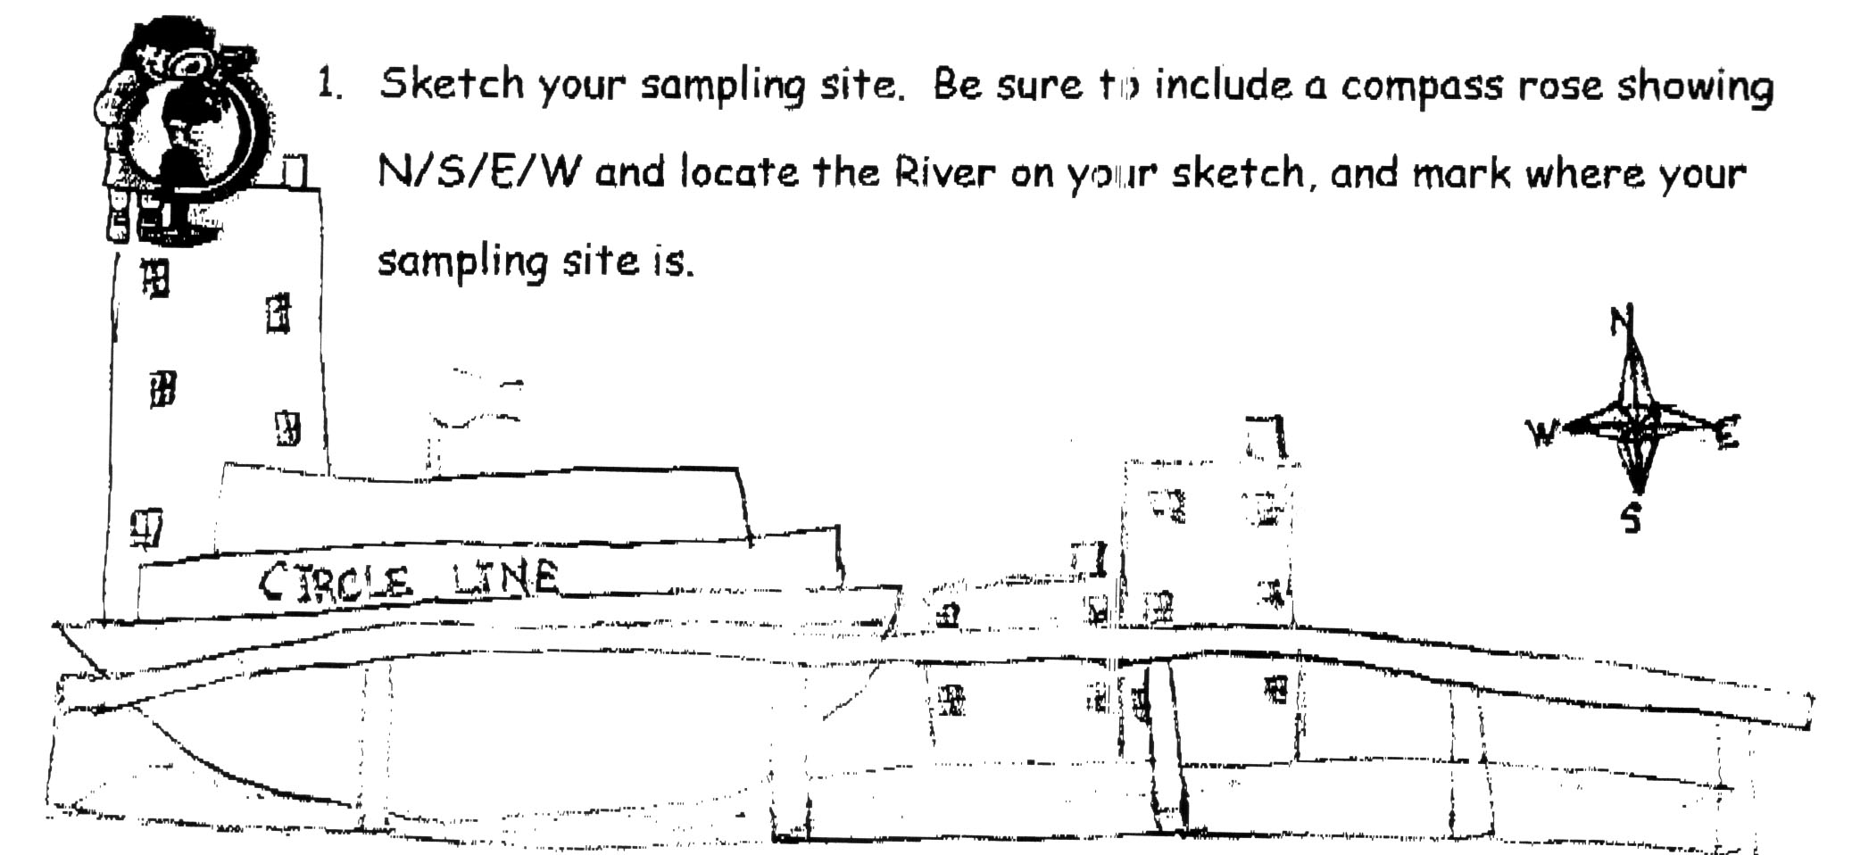

Location: Pier 84, an educational pier. Picnics, boating, fishing take place at our sample site.
Area: Pier – bulkhead – mainly concrete & wood
Surrounding Land Use: 80% urban/residential; 20% industrial/commercial
Sampling Site: Recreational pier – rocks near the edge, banks altered
Depth: 400 cm, rocky bottom
Plants in area: None

ITEM | Time |  | Reading 1 | Reading 2 | Comments
Physical
Air Temperature | 9:26 AM |  | 15°C  59 °F
 | 9:55 AM |  | 15°C  59 °F
Wind Speed | 11-16 kts |  | West |  | Water choppy
Cloud Cover | clear
Weather today | No rain - clear
Weather recently | Chilly, clear with medium to low wind
Water Temperature | 9:50 AM | 14°C  13°C  13.5°C |  | 57.2 °F  55.4 °F  56.3°F | Avg.  13.5°C  56.3°F
 | 10:05 AM | 14°C  14°C  14°C |  | 57.2 °F  57.2 °F  57.2 °F | 14°C  57.2 °F
 | 10:10 AM | 14°C  14°C  14°C |  | 57.2 °F  57.2 °F  57.2 °F | 14°C  57.2 °F
 | 10:15 AM | 14°C  13°C  14°C |  | 57.2 °F  55.4 °F  57.2 °F | 13.5°C  56.6 °F
Turbidity  Short site tube | 10:50 AM | 20 JTU  20 JTU  20 JTU |  |  | 20 JTU
Chemical
DO  (drop count kit) | 10:50 AM | 4.0 mg/L |  | 14 ° C | 39% saturated
pH  indicator solution | 10:05AM | 7.4  7.4  7.4 |  |  | 7.4
Salinity (hydrometer) | 10:15 AM | 14 ppt  14 ppt  14 ppt |  |  | 14 ppt
Fish Catch
Tides (from dock) | 9:12 AM | 375 cm
 | 9:40 AM | 400 cm |  | falling
 | 9:56 AM | 400 cm |  | unchanged
 | 10:26 AM | 400 cm |  | unchanged
 | 10:50 AM | 410 cm |  | rising
 | 11:11 AM | 405 cm |  | * difference probably due to wave action
Currents | Cm/60 secs | Cm/sec  North/South |  | Knots | Ebb/Flood/  Still
9:12 AM | 800 | 13 cm |  | .26 kts | Still
9:40 AM | 800 | 13 cm |  | .26 kts | Still
9:56 AM | 200 | 3 cm South |  | .06 kts | Ebb
10:26 AM | 800 | 13 cm South |  | .26 kts | Ebb
10:50 AM | 900 | 15 cm South |  | .3 kts | Ebb
Boats
Other Observations

