Snapshot Day 10/8/09 Data
(Salt Front RM 60.3)
Brighton Beach, Brooklyn NY
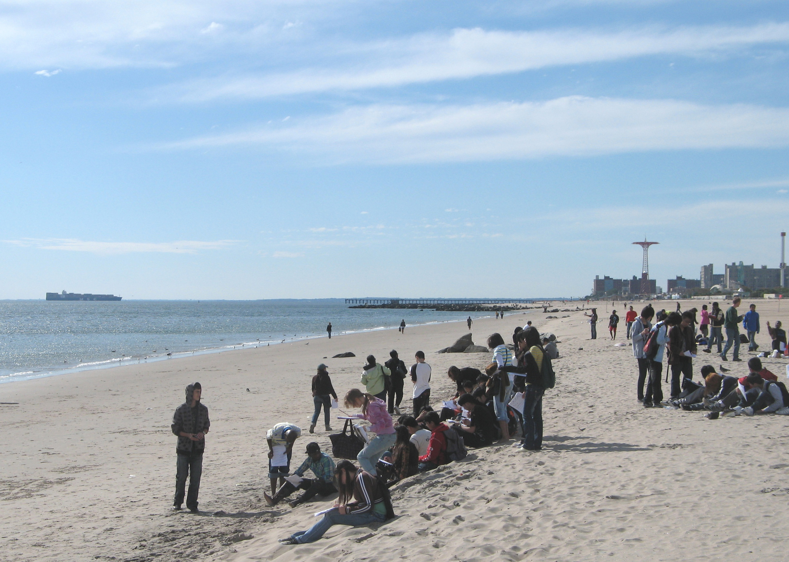
Carol Ma – International HS @ Lafayette, K337
48 students, 9th & 10th graders
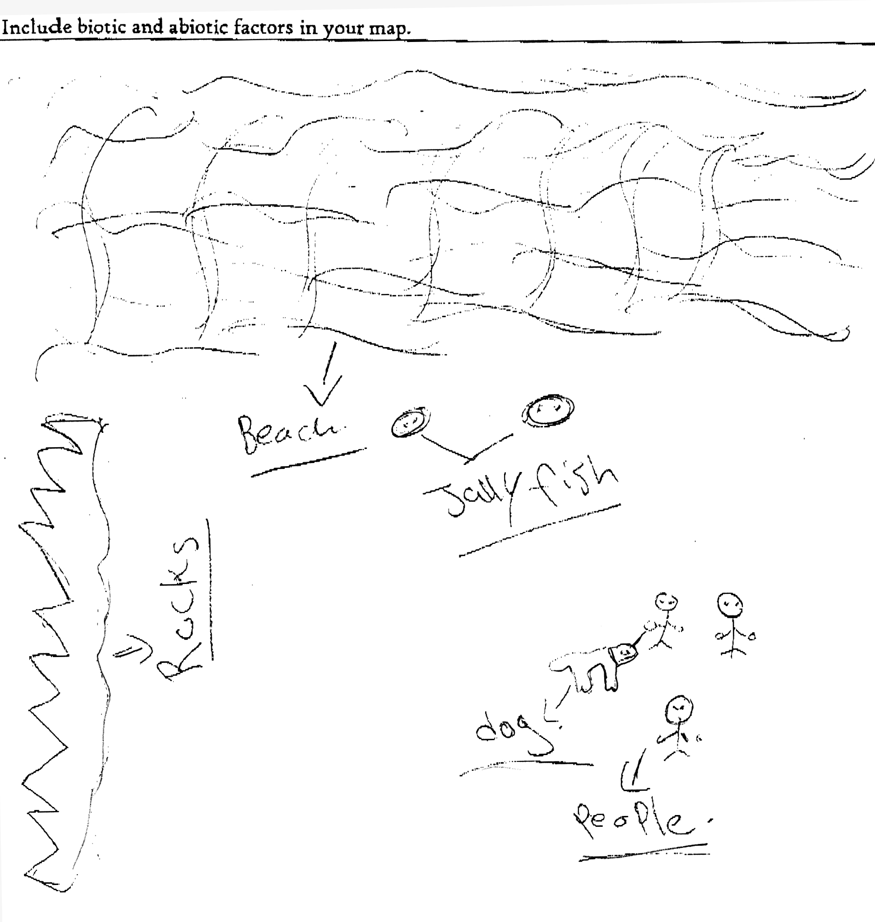

Location: Brighton Beach, Brooklyn
Area: Beach mainly
Surrounding Land Use: 80% beach; 5% commercial; 10% residential; 5 % forested
Sampling Site: Beach,
Depth:
Plants in area: No plants in the water

ITEM | Time |  | Reading 1 | Reading 2 | Comments
Physical
Air Temperature | 12:04 PM |  | 21°C  70°F
 | 1:04 PM |  | 20°C  68°F
Wind Speed
Cloud Cover | Partly cloudy
Weather today | No rain |  | Mild and warm, but a cool wind
Water Condition | Calm at noon but choppy by 1PM
Water Temperature
Turbidity
secchi
Chlorphyll | 12:32 PM | 0.1
Chemical
DO  (drop count kit) | 12:58 PM | 7 mg/L  8  10 |  |  | 8.33 mg/L
pH meter | 12:23 PM | 11  9  9 |  |  | 9.8 average
Salinity
Fish Catch | Total | Fish |  |  | 2 seines
 | ~80 | Atlantic Silverside
 | 2 | Northern Kingfish |  |  | ~82 Total
 | ~20 | Moon Jellies
Tides
Currents

Core – | Length | Abundant |  | Common | Rare
2:45 PM | 4 inches | Mud |  |  | Shells
 | No oxidized top | H2S smell
Other | a common loon fishing just offshore, two northern harriers migrating above the beach,  Saw jelly fish, dog and people. Saw people walking by the sane, saw fish and birds flying.

