Snapshot Day 10/8/09 Data
(Salt Front RM 60.3)
Canarsie Pier, Jamaica Bay, Brooklyn NY
N 40.37’49.0” - W-73.53’00.98”
Ragini Singhal – Robert Van Wyck MS 217
31 students, 10-13 yr. olds. MS
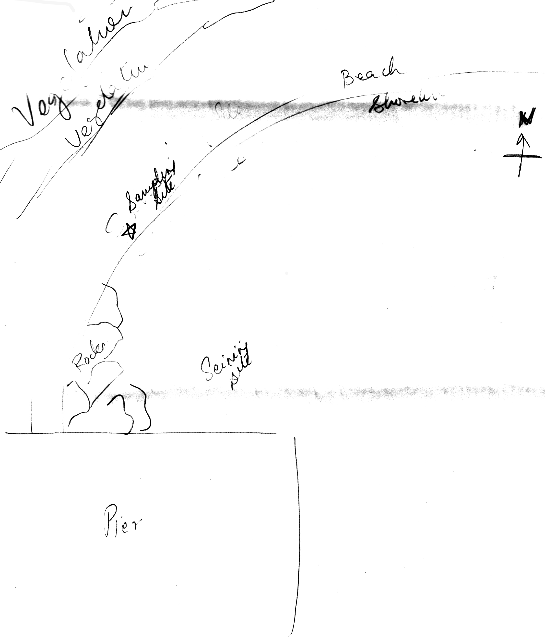
Location: Jamaica Bay, Canarsie Pier,
Area: Beach, large piping entering river
Surrounding Land Use: 50% forested; 40% beach; 10% constructed pier
Sampling Site: Beach, covered with vegetation, concrete pier, some fabric & other debris in rocks, man placed boulders along part of the shoreline near the pier
Recreational pier – rocks near the edge, banks altered
Depth: 1 to 1.5 deep, sandy bottom
Plants in area: 0% of the beach was covered with plants

SAMPLE SITE AT THE WATER

ITEM | Time |  | Reading 1 | Reading 2 | Comments
Physical
Air Temperature | 11:15 AM |  | 20.1°C
Wind Speed | Beaufort #2 |  |  |  | Water calm
Cloud Cover | clear
Weather today | No rain - |  | Weather started calmly but around noon a little breeze started
Weather recently | Approx. 65 degrees with little temp. variation and a little rain.
Water Temperature | 11:00 AM | 17.01°C  17.11°C  17.23°C |  |  | Avg.  17.12°C
Turbidity  secchi | 1:15 PM | 229 cm
Chlorphyll | 11:30 AM | 0.1
Chemical
DO
(drop count kit)
pH meter | 11:00 AM | 7.55  7.77  7.77 |  |  | 7.67 average
Salinity
Fish Catch | Total | Fish |  |  | 1 seine
 | 14 | Barnacles
 | 5 | Bivalves
 | 3 | Blue Crab
 | 15 | Comb Jellies
 | 3 to 4 | Hermit Crabs
Tides | 10:55 AM
 | 12:50 PM | Falling |  | 2 ft. drop
Currents

Boats
Core – 11:10 AM | 5 inches in total with 3 layers - darker layer sandwiched between lighter layers | 2.2 inches top |  | 1 inch second layer – dark middle section | 1 inch bottom layer
 | Abundant – sand | Rare –  Gravel, pebbles, wood |  | Shells inside | Smell of sea water

