Snapshot Day 10/8/09 Data
(Salt Front RM 60.3)
RIVER MILE East RM 4W
Sarah Pidgeon - SOLAR ONE
City-As-School – 20 HS chemistry students
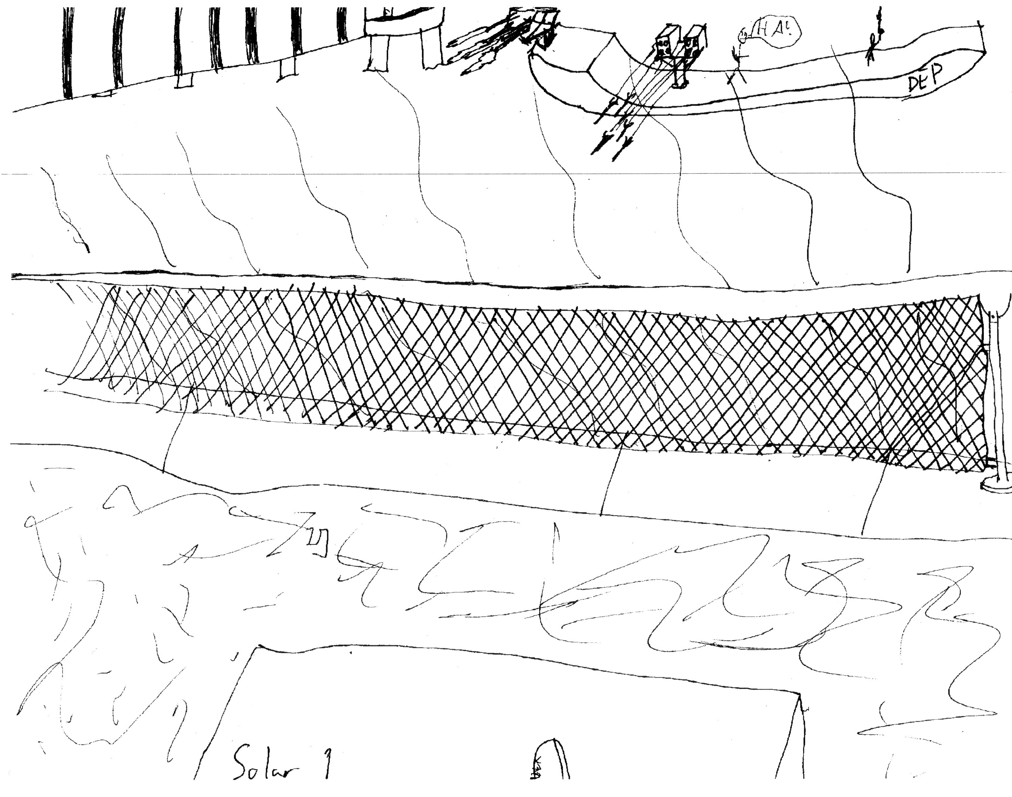
Location: Solar One, The East River at 23rd St.
Area: Beach area
Surrounding Land Use: Stuyvesant Cove Park
Sampling Site: Recreational pier – rocks near the edge, banks altered
Depth: 8 feet at high tide
Plants in area: Native Plants!

ITEM | Time |  | Reading 1 | Reading 2 | Comments
Physical
Air Temperature | 9:30-10:30 AM |  | 22°C  24.5°C  22.25°C | 71.6 °F | 22.92°C average
Wind Speed
Cloud Cover | Clear sky
Weather today | Sunny but breezy & cool
Weather recently | Sunny & cool, Rain 2 nights ago
Water Temperature | 9:30-10:30 AM | 18°C  19.6°C  18.8°C |  |  | Avg.  18.8°C
Turbidity -  meter | 9:30-10:30 AM | <10 NTUs  11 NTUs  ~10.5 NTUs |  | Not a lot of suspended particles in the water | 10.5 NTUs avg.
Chlorphyll | 9:30-10:30 AM | 0.5  0.3  0.4
Chemical
DO  (LaMotte tabs) | 9:30-10:30 AM | 4 ppm  8 ppm  6 ppm |  | 18.8 ° C  avg DO  6 ppm | 65% saturated
pH tabs | 9:30-10:30 AM | 8  6.5  7.25 |  |  | 7.25 average
Phosphate - LaMotte | 9:30-10:30 AM | 1 ppm  1 ppm
Nitrate - LaMotte | 9:30-10:30 AM | 2.0 ppm
Salinity (hydrometer/  refractometer) | 9:30-10:30 AM | 17 ppt  25 ppt  21 ppt |  |  | 21 ppt avg.
Tides (from dock) | 9:30-10:30 AM | High Tide
Coliform | Positive | Positive |  |  | Samples came from area by a CSO & rain last night
Boats | 9:30-10:30 AM | Tug Boat |  | South
 |  | Cargo Ship |  | South
 |  | Speed Boat |  | South
 |  | Sewage Boat |  | North

