Snapshot Day 10/8/09 Data
(Salt Front RM 60.3)
EAST RIVER MILE 8
Barretto Park
Michael Dong P.S. 382
2nd/3rd Grade Students – 32 students
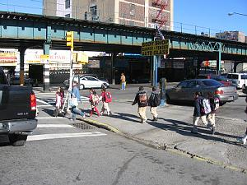 | 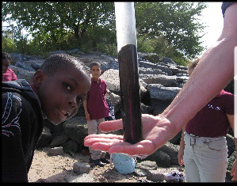 | 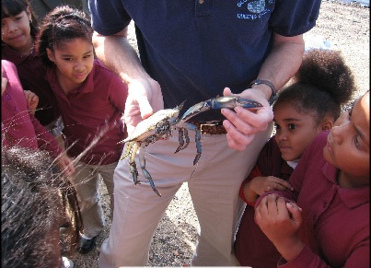

Location: Tiffany Street Pier, Barretto Point Park, Hunts Point, Bronx, East River
Area: amphitheater, Barretto Point Park
Surrounding Land Use: Beach
Plants in area: trees and grass
Sampling times 10AM to 1PM
ITEM | Time | Reading 1 | Reading 2 | Comment
Physical
Air Temperature
Wind Speed
Cloud Cover
Water
Water  Temperature |  | 18°C  18°C  19°C |  | 18.3°C
Turbidity
Chlorophyll
Chemical
pH |  | 6.5  6.5  6 |  | 6.25 average
DO | 20°C |  | % saturated
Salinity |  | 26 ppt |  | 27 ppt hydrometer
 |  | 28 ppt
 |  | 27 ppt
Tides | 10AM | Rising
 | 12:30 PM | Rising
Currents
Ships | 1:30 PM | 2 cargo type ships
Core
Other | Found crab exoskeleton and few snails in the littoral zone.

