Snapshot Day 10/8/09 Data
(Salt Front RM 60.3)
RM 8 at the Bronx River
Hunts Point Riverside Park, Bronx, NY
Damian Griffin & Anne Marie- The Ronfola Bronx River Alliance
Brooklyn T. Washington MS, 54
40 students, 8th graders
Lat 40.8172 – Lon. -73.8810
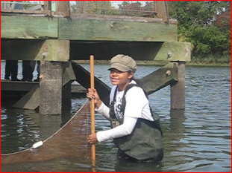
Location: Hunts Point, Riverside Park, Bronx River
Area: Mostly used for boating and fishing
Surrounding Land Use: 5% beach; 95% industrial/commercial
Sampling Site: Beach, pier, shoreline riprap, covered with vegetation, debris in the area
River Bottom: Sandy, Muddy, Rocky
Plants in area: Yes – 10-15%

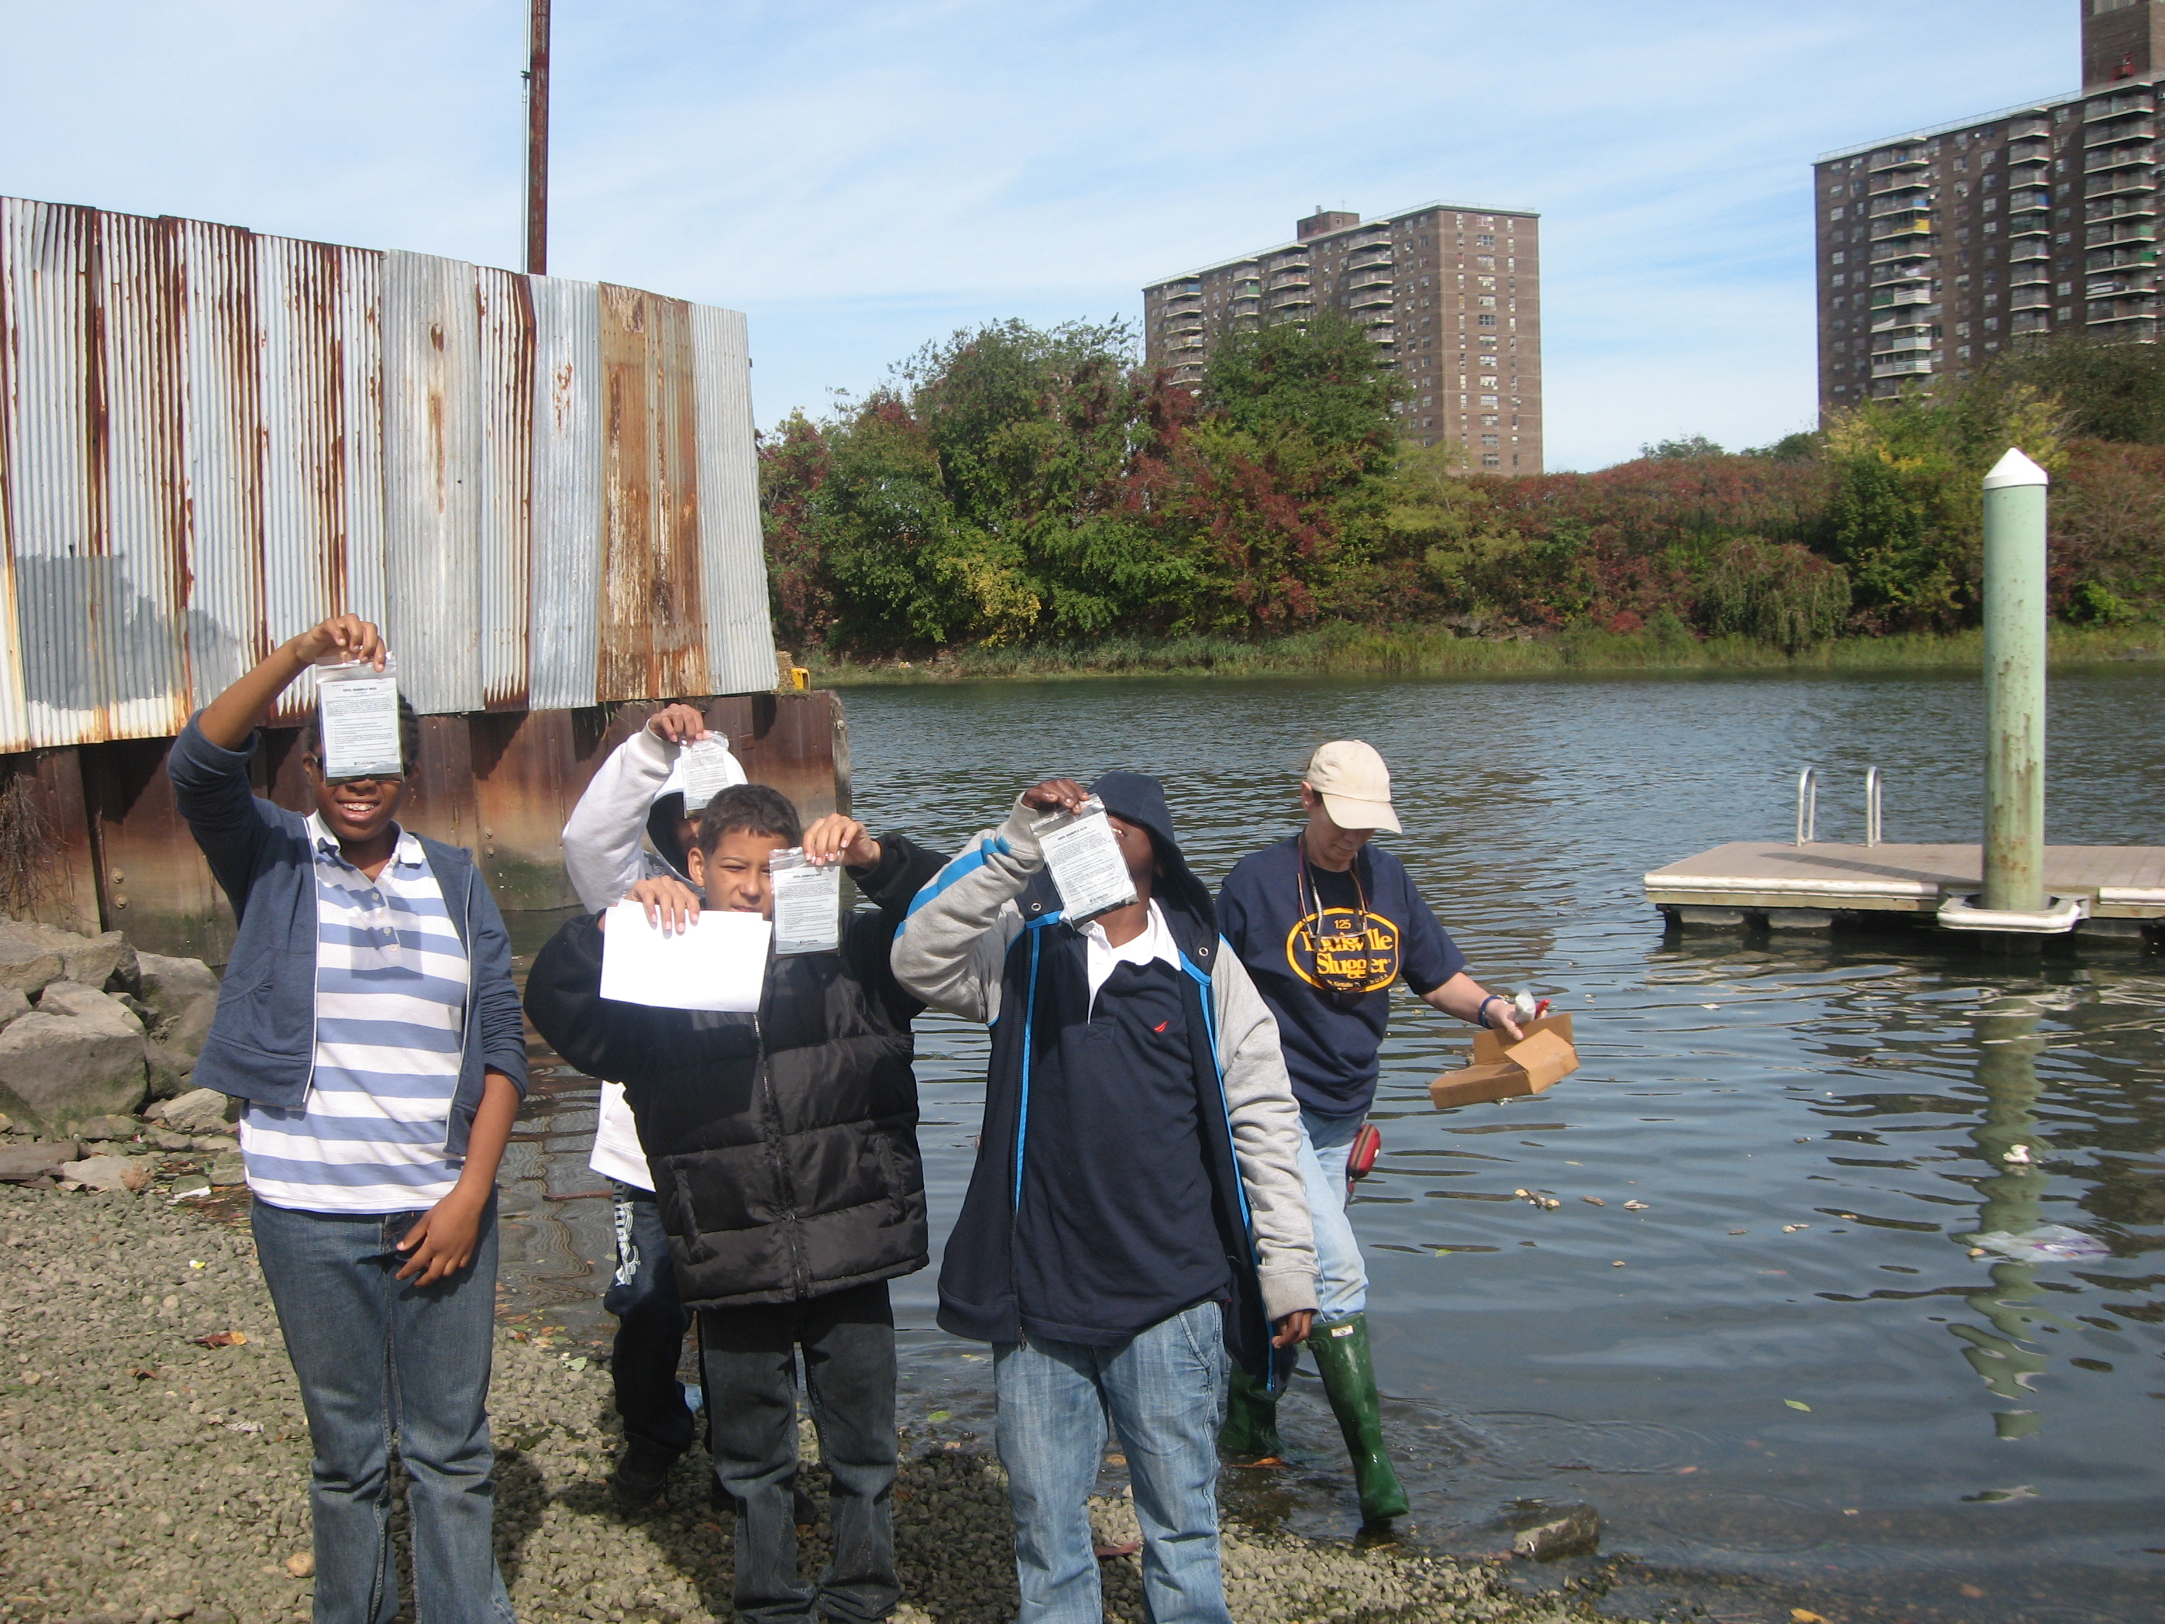 | 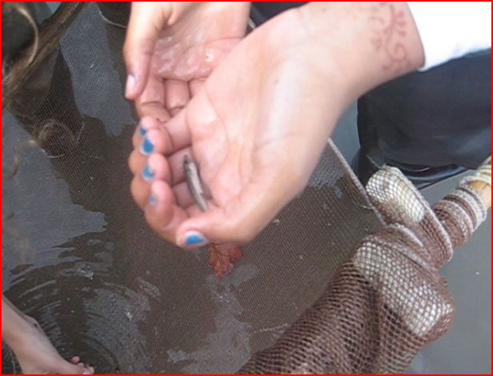 | 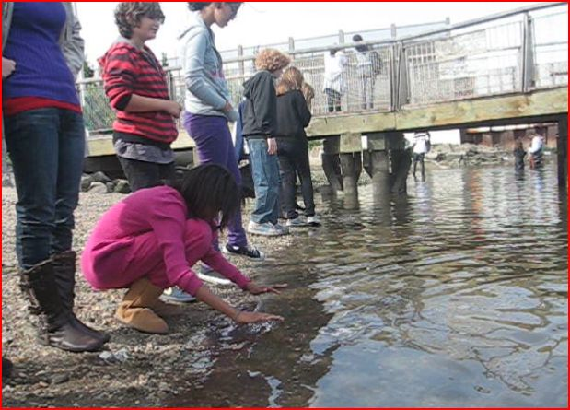

ITEM | Time |  | Reading 1 | Reading 2 | Comments
Physical
Air Temperature
Wind Speed
Cloud Cover | Clear
Weather today | No rain |  | Mild and warm, but a cool wind
Weather last 3 days | Sunny & windy
Water Condition | Calm
Water Temperature | 11:00 Am | 18°C
 | 11:24 AM | 18°C
 | 11:35 Am | 17°C
 | 11:39 AM | 17°C
 | 12:00 PM | 19°C
Turbidity  secchi | 11:00 AM | 44 cm  31  49 |  |  | 41 cm
 | 11:30 AM | 70.2 cm  72 cm  72 cm |  | 88.1 cm from end of pier | 71 cm avr.
 | 12:15 PM | 35 cm  40.03 cm  46.81 cm |  | Read off the dock | 40.5 cm
Chlorophyll | 12:32 PM | 0.1
Chemical
DO  (drop count kit) | 11:20 AM | 5.6  5.75  6.1  Average 5.9 mg/L |  | 18°C | 55% saturation
pH | 11:00 AM | 7.3  8.0  7.4 |  |  | 7.56 average
 | 11:30 AM | 8.1  8.2  8.2 |  |  | 8.2 average
 | 12:00 PM | 7.8  7.6  7.6 |  |  | 7.7 avg
Salinity -  hydrometer | 11:44 AM | 15 ppt  15  15 |  | 11:25 AM | 23.6  21.3 ppt  22.0
Fish Catch | Total | Fish |  |  | 3-4 seines
Seine – 5 ft. – 3 min. pull | 40 | Atlantic Silverside |  | 3 inch | Caught a school
 |  | Glass shrimp
 | 20 | Moon Jellies |  | 4 inches
 | 7 | Asian Shore Crab |  | 2 inches
Tides | 11:12 AM | 217.5 cm |  |  | 7’3”
Falling | 11:29 AM | 195.0 |  | 1.33 cm/min | 6’6”
Falling | 11:32 AM | 190.0 |  | 1.6 cm/min | 6’4”
Falling | 11:51 AM | 187.5 |  | 0.16 cm/min | 5’3”
Currents  1.22.84 | 660.55 cm/60 secs | 11.09 cm/sec |  | 0.22 kts. | South - Ebb
Ships | ? | White |  | Southbound | Light
Other | Test positive for e-coli; boat fishing; crane; bird sitting on the rocks; Fish and crabs in the river,
Observations | Glass shrimp’s tail felt and looked like real-glass- hard and see through and brittle. They had 2 eyes and antennas. They were the size of my ring finger and didn’t move much. Also caught some green seaweed;  The moon jellyfish were clear and almost invisible. Their mouths are microscopic and they do not swim. Since they are almost invisible, species swim into their mouths – that is how they catch their prey. They look like a blob and felt like hand sanitizer, They are very slippery and hard to pick up.  Silversides are silver and grey and are not bottom feeders. They swim very fast and in a school. All three different creatures caught were small and seemed to hide on the bottom.  Asian shore crabs looked like American crabs and they were red and white with 2 antennas and six legs. Their heads are slightly larger than the American crabs of the same size.

