Snapshot Day 10/8/09 Data
(Salt Front RM 60.3)
RIVER MILE 115
Cohotate Preserve, Athens, Greene Co.
Liz LoGuidice, Cornell Cooperative Extension of Greene County
Fran Martino, River Haggie Outdoors Educator
Tony Loughran, Coxsackie Athens High School & Greenville HS,
59 students, 10-12th grade Env. Sci. & AP Bio

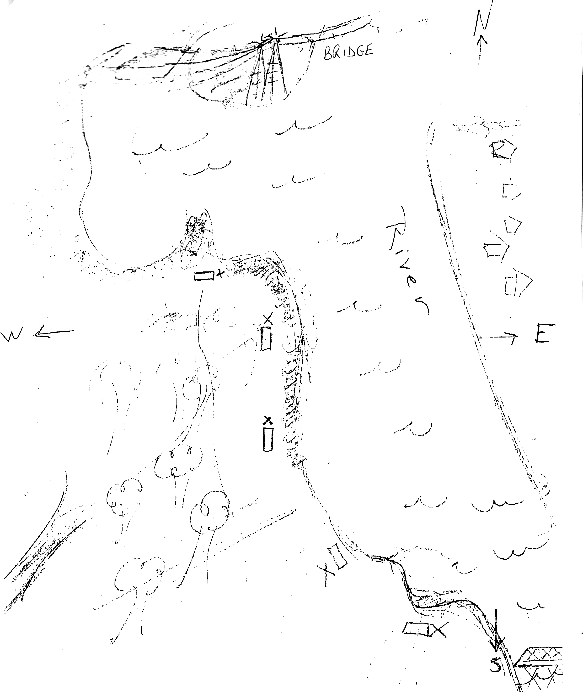
Location: Cohotate preserve – Ice house site –
Area: The ice house is a flat, grassy are on the river with several cotton wood trees. It is situated at the bottom of a forested hill. Large waterfront vegetated. The artificial shoreline of the bulkhead dominates the eastern shore. Shoreline is characterized by tidal mudflats. Area is used recreationally for picnicking, hiking and fishing. Ice house is approximately ½ miles walk from the parking area.
Surrounding Land Use: Forested 90%, Beach 5%; Urban/residential 3%; Industrial Commercial 1%; (average of 3 groups)
Sampling Site: Beach area, Shoreline includes tidal mud flats in the southeast, with a rocky shore further south. To the north of the tidal mud flat there is an old bulkhead, with another tidal flat to the north of the bulkhead, rip rap in sections.
The banks have been altered at the bulkhead (entire ice house area is likely dredge spoil), wood and debris are collected in the southern mudflat, there is lots of vegetation and no pipes entering the water.
Water Depth: We fish at the southern mud flat, which has a muddy bottom and a variable depth, depending on tide.
River Bottom: Muddy, sand in sediments and some rocks, bigger rocks towards shore
Plants in area: In sample site #1 more than half, site #2 less than half, site #3 half

ITEM | Time |  | Reading 1 | Reading 2 | Comments
Physical
Air Temperature | 9:52 AM |  | 15°C | 10:20 AM | 16°C
Wind Speed | AM |  | 3-4 mph | Gusts to 8 mph
 |  |  | 7 mph | Gusts to 17 mph
 |  |  | 3-5 mph | Gusts to 9 mph
Cloud Cover | Partly cloudy |  |  |  | Winds from NW
Weather today | cool – no rain
Weather recently | Windy, mixed clouds and sun, thunderstorms 2 days ago
Water Temperature | 9:45 AM | 15°C  58°F
 | 10:33AM | 16°C  61°F
 | 11:13AM | 16°C  60°F
Water | Slightly choppy
Turbidity

Chlorophyll
Chemical
DO  (drop count kit) | 10:06AM | 11.0 ppm |  | 15°C | 100%
 | 10:45AM | 9 ppm |  | 16°C
 | 11:35AM | 10 ppm |  | 16°C
pH – color match kit | 10:05AM | 8.0
 | 10:42AM | 8.0
 | 11:28AM | 7.5
Salinity | 10:14AM | 28 ppm
 | 10:54AM | 40 ppm
 | 11:44AM | 38 ppm
Fish Catch  60 ft. seine X 30 ft. | Seine 1 | Seine 2 |  | Seine 3 | TOTALS
Killifish | 45 | 12 |  |  | 57
Tesselated Darter | 1 |  |  |  | 1
Shiner |  |  |  | 1 | 1
Blue Crab | 4 | 11 |  | 1 | 16
TOTALS | 50 | 23 |  | 2 | TOTAL - 75
Tides | 9:35 AM
 | 10:15AM | Falling
 | 10:30AM | Falling
 | 10:50AM | Falling
 | 11:05AM | Falling
 | 11:30AM | Falling
 | 11:45AM | Falling
Currents | 9:58AM | Ebb
 | 10:42AM | Ebb
 | 11:12AM | Slack tide
Core Description | Length | Abundant |  | Common | H2S small
Taken @ low tide, no water | 6.5 inches total | Mud and sand |  | Leaves and wood | Yes
1st cove on right from field station | 0.5 inch oxidized top
Other | Small brown bat on ground making noises and biting ground. Then flew away

