Snapshot Day 10/8/09 Data
(Salt Front RM 60.3)
RIVER MILE 133
River Park, Schodack Island, Troy
N 42.482113470199998 W -72.7763160920000002
Dawn Baldwin, Children’s Museum of Science and Technology
Ron West, School Twelve – 6th grade students – 16 students
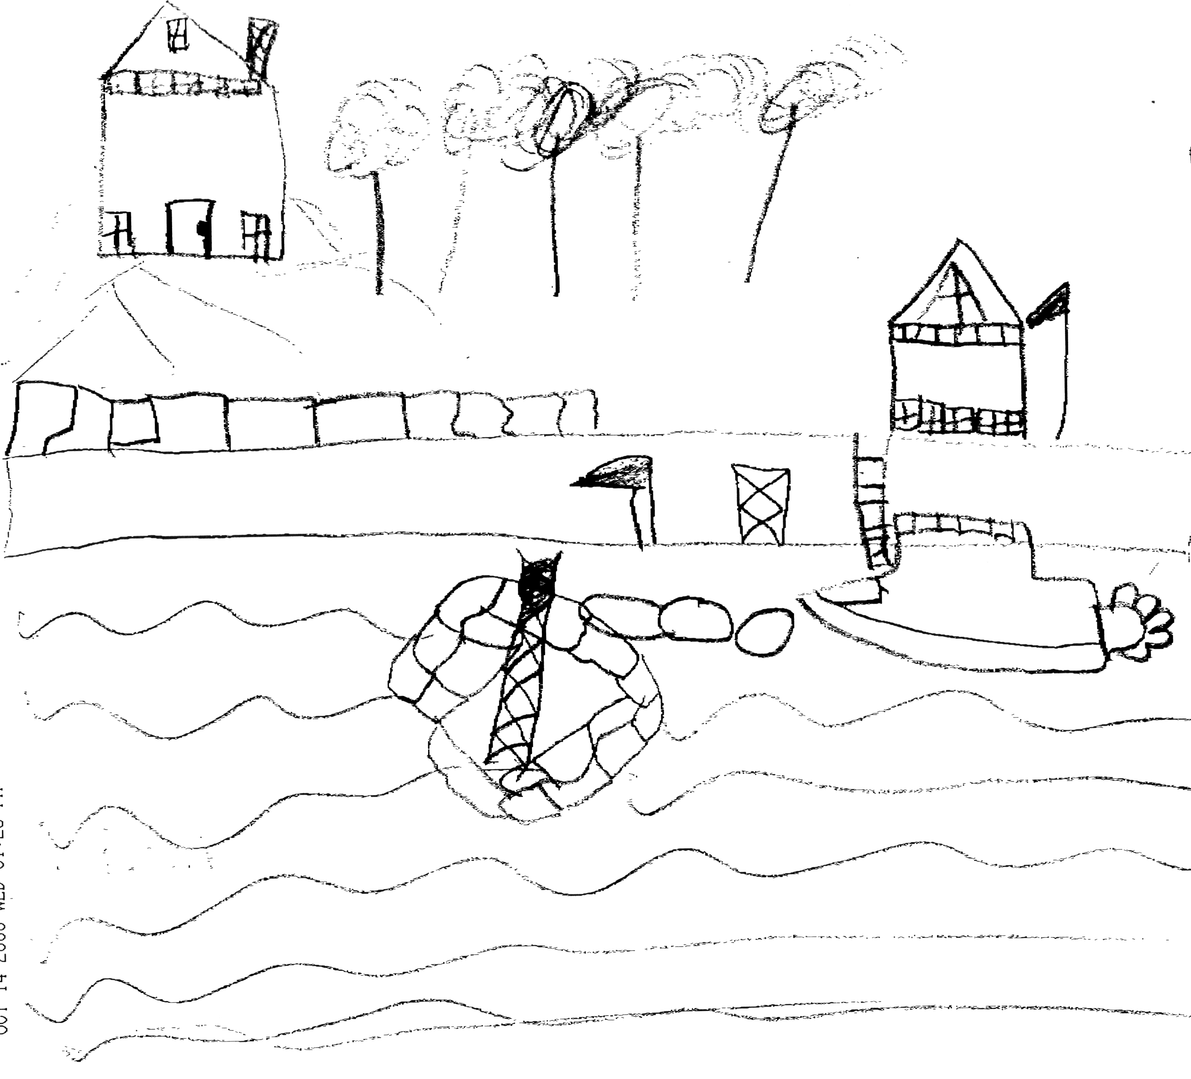
Location: Schodack Island State Park
Area: 1052 acres – park and boat launch area
Surrounding Land Use: Boat launch, playground, parking lot, used for picnics, fishing
Sampling Site: Forested 70%; Urban/residential 5%; Industrial/Commercial 10%; Boat launch & recreational 15% - state park with grass, trees, parking area, picnic area, boat launch – further than 200 ft. downriver a gravel quarry
Shoreline: banks altered, rip rap, bulkhead,
Plants in area: no aquatic plants in this area
Water depth: can’t see the bottom – 2 ft. deep
Observations: People leaving garbage behind, pollution from boats at the launch site, invasive species from boats going into the river, mining and concrete plant across river, so potential for pollution.

ITEM | Time |  | Reading 1 | Reading 2 | Comments
Physical
Air Temperature | 10:40 AM |  | 50 °F  10°C
Wind Speed | Beaufort #6 |  | North
Cloud Cover | Mostly clear
Weather today | Clear but cool
Weather recently | 10/7/09 rain in the AM and then again at night
Water Temperature -  Water depth 2 ft. | 10:40 AM | 60° F  59° F  59.5° F |  | 15.6°C  15 °C  15.3°C | 15.4°C  59.5° F  average
Standing on a very slippery bulkhead. No shade on water, very choppy, no plants | 11:15 AM | 60° F  58° F  59° F |  | 15.6°C  14.4°C  15°C | 15°C  59° F  average
 | 12:30 PM | 60° F  59° F  59.5° F |  | 15.6°C  15 °C  15.3°C | 15.4°C  59.5° F  average
Water calm | Very choppy | Not shaded
Turbidity | Not done
Chlorophyll
Chemical
DO  (Drop count kit | 10:35 AM | 9.1 mg/L |  | 15.27°C | 90%
 | 11:20 AM | 9.1 mg/L |  | 15°C | 91%.
 | 12:30 AM | 9.3 mg/L |  | 15.27°C | 91%
pH  (ind. Sol.) | 11:00 AM | 7.5  7.25  7.75 |  |  | 7.5 avg.
 | 11:30 AM | 8.0  7.5  7.25 |  |  | 7.5 avg.
 | 12:30 PM | 8.0  8.0  8.0 |  |  | 8.0 avg.
Salinity
Fish Catch | Number Caught | Species |  | CPUE | Seine
seine – 8 ft. net, 20 ft. pull - Seining: Kids didn’t think we would catch anything so they were really excited. | 30  1  1 | Spottail Shiners  Banded Killie  Butterfish?? (possible sunfish) |  | 1 inch  2 inch  .75 inch | 32 total
Tides | 10:25 AM | 70 cm
Tidestick set in stones | 11:30 AM | 55 cm |  | Falling
 | 12:40 PM | 35 cm |  | Falling
Currents | 10:30 AM | Ebb
 | 12:30 PM | Ebb
Traffic | No commercial traffic
 | Barge | Empty |  | @ mining facility
 | 10:30-12:00 | Recreational vehicles |  | 1 going north and 1 south
Other Items | The moon was out!
Comments/Observations | Quotes:  I never knew the Hudson was so beautiful  The moon is in the sky – does that have anything to do with the river?  It’s so big!  I hope doing this helps people. I like helping people!  The water is moving fast. We see boats and a house. It is cold.  I want to go to the bus  This is cool  Can we do this again?

