Snapshot Day 10/8/09 Data
(Salt Front RM 60.3)
RIVER MILE 138 – Henry Hudson Park
Dee Strnisa, Five Rivers & New York State DEC
Kari Murad, Mary Cosgrove & students, Mt. St. Rose College
Susan Schiavoni, Delaware Community School – 3rd & 5th
42 elementary students, 2 teachers,
20 St. Rose students, 2 graduate students, 3 faculty
Coordinates: 42.64 N, 73.74 W
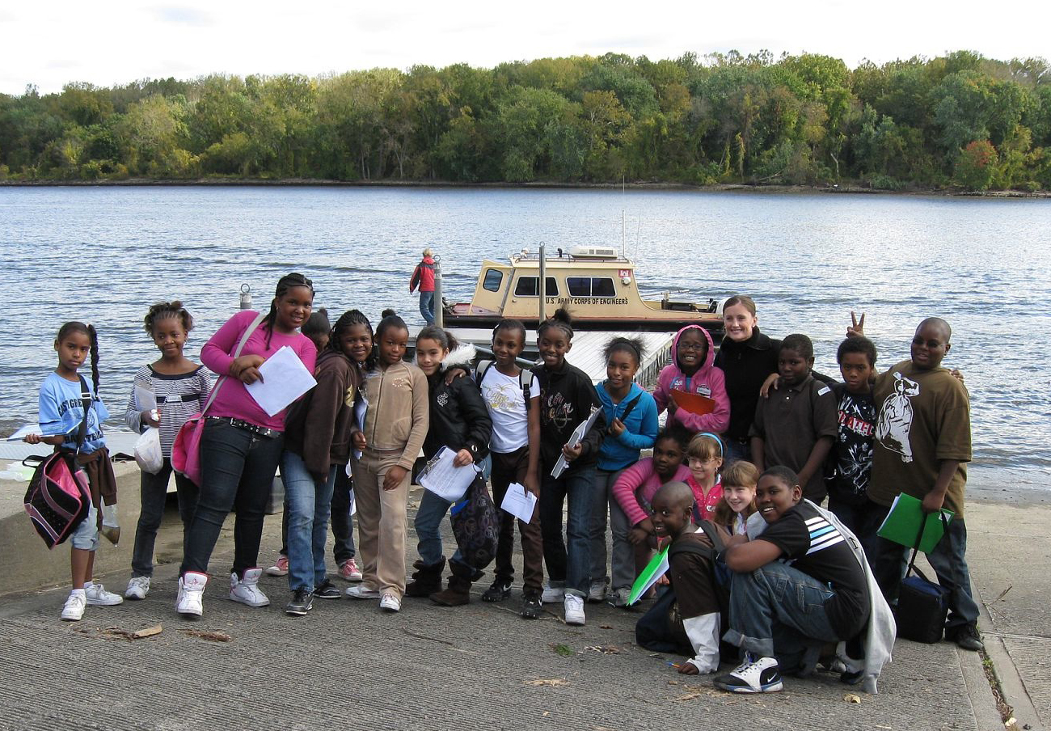
A group of the Delaware Community School students

Note: This is a very special relationship between the College students and the elementary school students. As preparation the College Students completed a 2.5 hour lab at the River completing all the tests and then they met with the Elementary Students and completed a 2 hour lab with them running through all the tests.

Location: Waterfront of Henry Hudson Park
Area: Park/Boat launch,
Surrounding Land Use: 100% parkland with 75% vegetated coverage – grassy, parking lot, used for picnics, boating, fishing
Sampling Site: Banks altered, riprap, bulkheaded - rocky
Plants in area: Smartweed, ragweed, Joe-pye weed, jewelweed, purple loosestrife, grass
Water depth:
River Bottom –
Water - calm
ITEM | Time |  | Reading 1 | Reading 2 | Comments
Physical
Air Temperature | 10:30 am |  | 62 F
 | 11:18 am |  | 63 F,
Wind Speed | Beaufort 2  Later 3
Cloud Cover | few clouds
Weather today | Sunny & bit windy
Weather last 3 days | Windy and rain
Water Temperature | 10:57 AM | 15°C  60 °F |  | 16°C  60 °F | 15.5°C avg.  60 °F
Turbidity  Large site tube | 10:34 AM | 34 cm
 | 10:57 Am | 44.4 cm
 | 11:33 Am | 59.4 cm
 | 11:37 Am | 58 cm
 | 11:38 AM | 64 cm
Chlorophyll | 10:34 AM | 0.3
 | 10:57 Am | 0.4
 | 11:33 AM | 0.1
Chemical
DO  Drop count | 10:34AM | 9.2 mg/L |  | 90% saturations
pH | 10:34 AM | 7.1 |  | 7.3 | Avg. 7.2
Salinity  Test strip | 10:30 AM | 99 ppm Cl
Fish Catch | Number Caught | Species |  | Seines
 | 1 | Freshwater silverside
 | 2-3 | shiners
Tides | 10:23 am | 1.23 m,
 | 11:00 am | 1.16 m |  | falling | ebb
Currents
Other Items
Core Description | Total Length | Top Layer |  | Second Layer | Describe
Commercial Traffic
Other

