Snapshot Day 10/8/09Data
(Salt Front RM 60.3)
RIVER MILE 14
Inwood Hill Park Nature Center, NYC
New York City Park Rangers
Susan Vincent - Young Women’s Leadership School – 12th grade – 24 students
Latitude 40°50’N/ Longitude 73°55 W
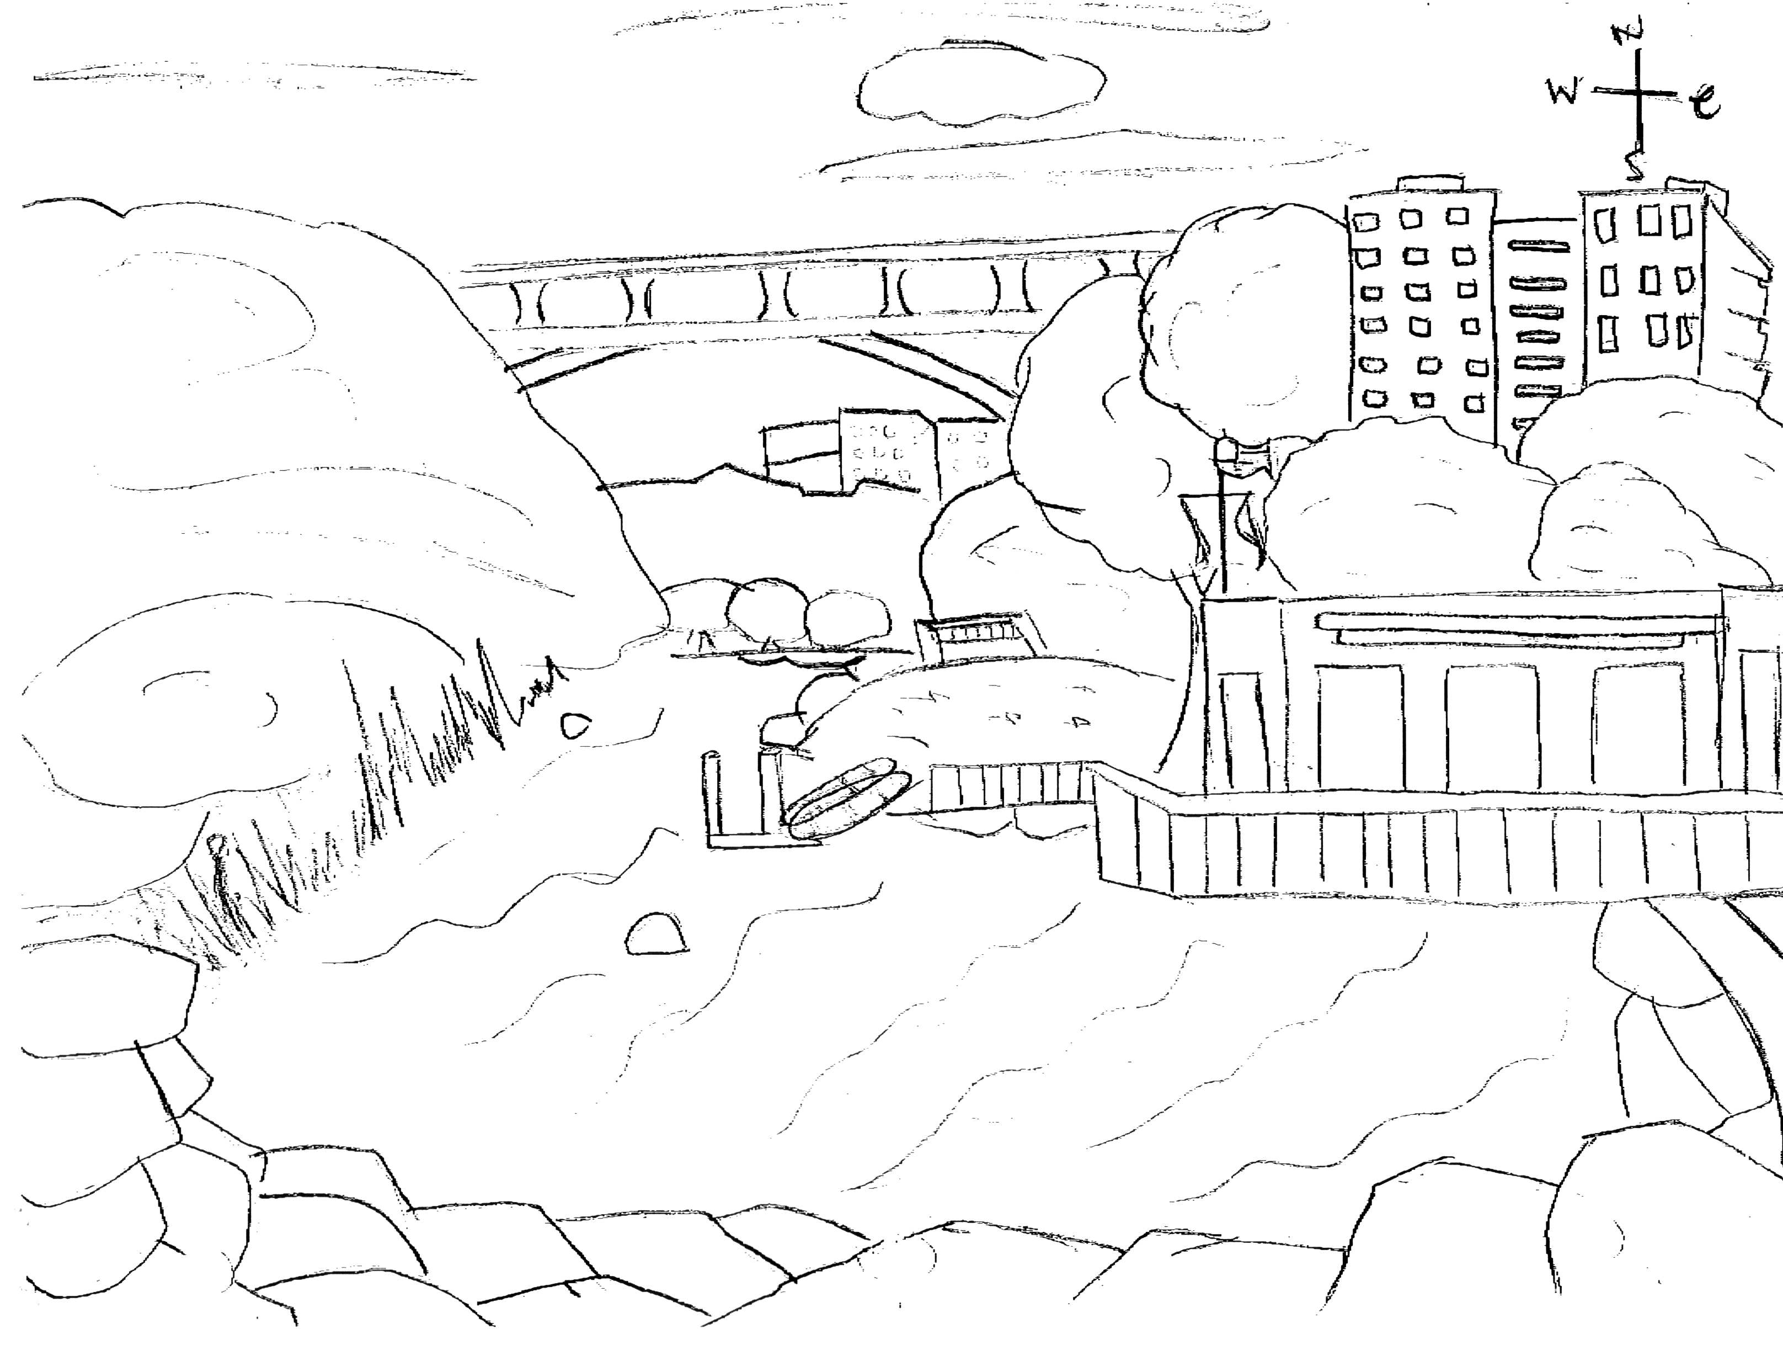
Location: In the cove of Inwood Hill Park
Area: Forested
Surrounding Land Use: Forested 60%; urban residential 10%; Industrial/commercial 10%; 20% paved. Pier, bulk-headed, rip rap shoreline. Forested and used by people for picnics, jogging, sitting on park benches.
Sampling Site: large riprap on shoreline, drainage pipes in area, vegetation
Plants in area: Yes less than half area has plants. 10% of water area has plants.
Water depth: 55 cm @ 10:30 AM; 105 cm @ 12:30 PM
River Bottom – mostly mud with large rocks, some vegetation
ITEM | Time |  | Reading 1 | Reading 2 | Comments
Physical
Air Temperature | 10:58 AM |  | 68 °F  20 °C | 11:30 AM | 68 °F  20 °C
Wind Speed | 2 Beaufort |  | 6-11 kts | 4-6 mph | North
Cloud Cover | Partly cloudy
Weather today | Temperature cooled during day as wind picked up
Weather recently | Windy and some rain
Water Temperature | 11:10 AM | 17.9 °C  17.6 °C  18.3 °C |  | 64.22°F  63.68  64.94 | 17.93°C  64.28 °F
 | 11:40 AM | 18.0 °C  18.4 °C  18.5 °C |  | 64.40°F  65.12  65.13 | 18.3°C  64.94 °F
 | 12:10 AM | 18.7 °C  18.8 °C  18.6°C |  | 65.99°F  65.84  65.98 | 18.7°C  65.66°F
 | 12:23 PM | 18.5 °C  18.4 °C  18.5°C |  | 65.3°F  65.3  65.12 | 18.48°C  65.24 °F
Water surface: | choppy
Turbidity  (long Site tube)_ | 10:50 AM | 41.5 cm  39.75 cm  33.5 cm |  |  | Average 38.25 cm
Chlorophyll | 11:30 PM | 0.1
Chemical
DO  meter | 11:28 AM | 8.46 mg/L |  | Temp.18.4° C | 84.7%
pH | 11:30 AM | 7.7  7.6  7.7 |  | 7.7 avg. | meter.
Salinity | 11:28 AM | 9.2 ppt  8.8 ppt  10.1 ppt |  | 7.7 ppt average | YSI meter
Conductivity | 11:28 AM | 13.18 mS  13.59 mS  14.92 mS |  | 13.9 mS | meter
Fish Catch | Number Caught | Species |  | CPUE | Seine
Used seine 20 ft.  Pull 30 ft. - | 1 | White perch |  | 12 inches | + minnow traps (nothing caught in traps)
Seined – 2 times | 2 | Blue Crab
Tides | 11:15 AM | 90 |  | Rising
 | 11:45 AM | 100 |  | Rising
 | 12:15 PM | 105 |  | Rising
Currents | 11:15 AM | 923 cm/60 secs |  | 815.38cm/sec | 0.30 kts. S/Flood
 | 12:00 PM | 923 cm/60 secs |  | 815.38cm/sec | 0.30 kts. S/Flood
Traffic | 11:20 AM | Circleline |  | Northbound | Loaded - people
Sediment Core description | 7 inch core | 0.9 top |  | 5.7 inch bottom
Other observations

