Snapshot Day 10/8/09 Data
(Salt Front RM 60.3)
RIVER MILE 144
Rensselaer Boat Launch, Forbes Rd., Rensselaer, NY
Alene Onion, Hudson River Estuary Program
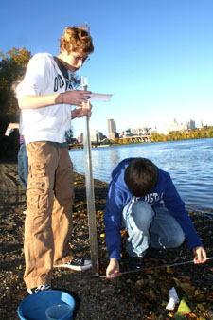
Leah Penniman, Tech Valley High School - 9th grade – 34 students

Location: Rensselaer Boat Launch
Area: Boat launch – beach area
Surrounding Land Use:
Sampling Site: boat launch with surrounding beach area
Plants in area:
Water depth: unknown
River Bottom :
Times: All sampling 8:30-10:00 AM
ITEM | Readings |  | Readings | Average Reading | Comments
Physical
Air Temperature | 10.9°C  15°C  15.6°C |  |  | 13.83 °C
Wind Speed
Cloud Cover
Weather today
Weather recently
Water Temperature | 14°C  13.2°C  13.5°C  13.7°C  13°C | 13.9°C  13.9°C  13°C  12°C |  | 13.4 °C
Turbidity (LaMotte) | 10 JTU  15  5  5 |  |  | 8.1 JTU
Turbidity  Turbidity tube | 50 cm  44  51  14.5  42 | 38.4 cm  40.6  21 |  | 37.7cm
Chlorophyll
Chemical
DO  (chemet color comparator) | 12 mg/L  10  8  8  9 | 8 mg/L  8  8  6 |  | 8.6 mg/L | 82%
pH – pH meter | 7.82  7.96  7.5  7.75  6 | 8.95  7.95  6 |  | 7.49
Phosphate -  Chemet Color comparator | 0.1 mg/L  0.1  0  0  0.5 | 1 mg/L  0.5 |  | 0.31 mg/L
Nitrate –  LaMotte color comparator | 4.4 ppm  1.0  1.0  1.0  2.0 | 8.8 ppm  8.8 |  | 3.86 ppm
Alkalinity (LaMotte) | 55 ppm  40  143  40 |  |  | 69.5 ppm
Salinity*  (reported as ppt – too high a reading for this area) | 0  .75 ppt |  |  | *0.375 ppt | * This salinity result is too high for this area of the river.
Quantab Reading | 24 ppm chloride |  |  | 30 ppm total salinity
Conductivity | 183 uS  187  297  179 | 184  93  121 |  | *177.71 uS
Current/Stream Flow | 0.5 meters per second
Coliform  Petrifilm plate 1 ml water  • stated range is based on a 100 ml sample | 56  170  114  68  59 | 35  4  35 |  | *68 Colonies per ml water | * Acceptable range more than 20% of the samples NOT in excess of 2,400-5,000

