Snapshot Day 10/08/09 Data
(Salt Front RM 60.3)
RIVER MILE 153
River Park, Green Island Park, Green Island NY
Kate Perry, Robert C. Parker School
(18) 2nd & 3rd grade students and (18) 6th and 7th grade students
42.74 N -73.69 W
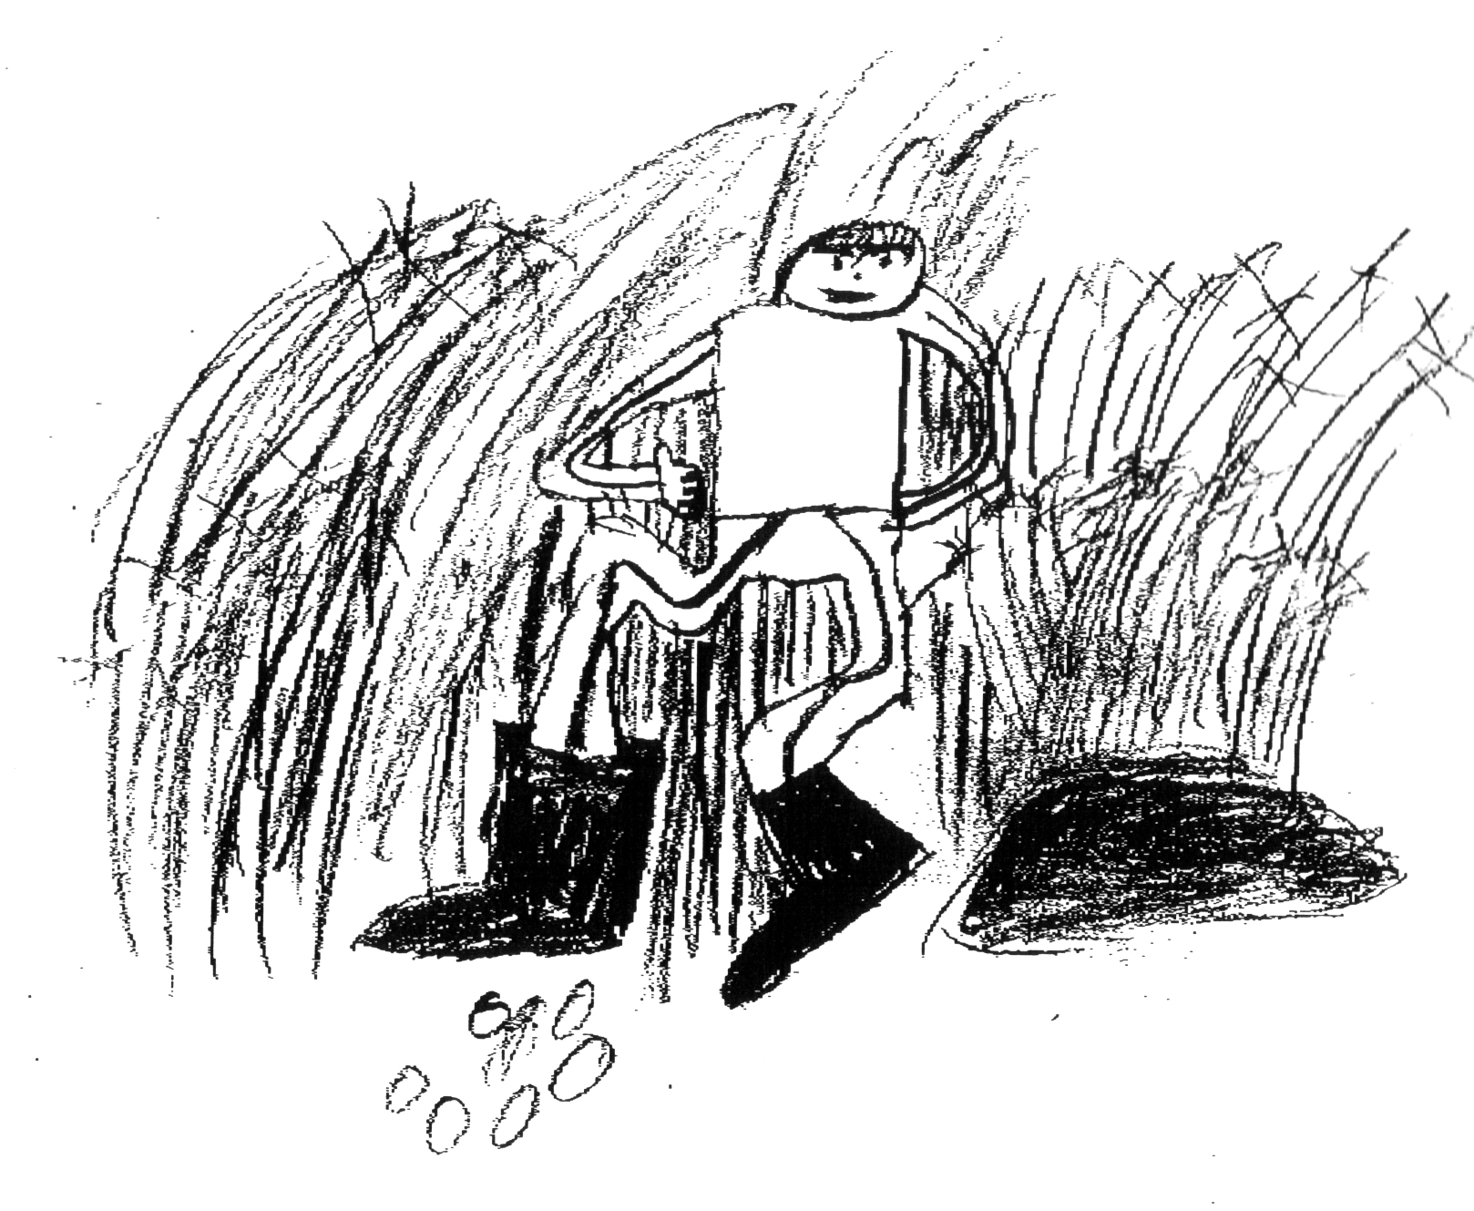
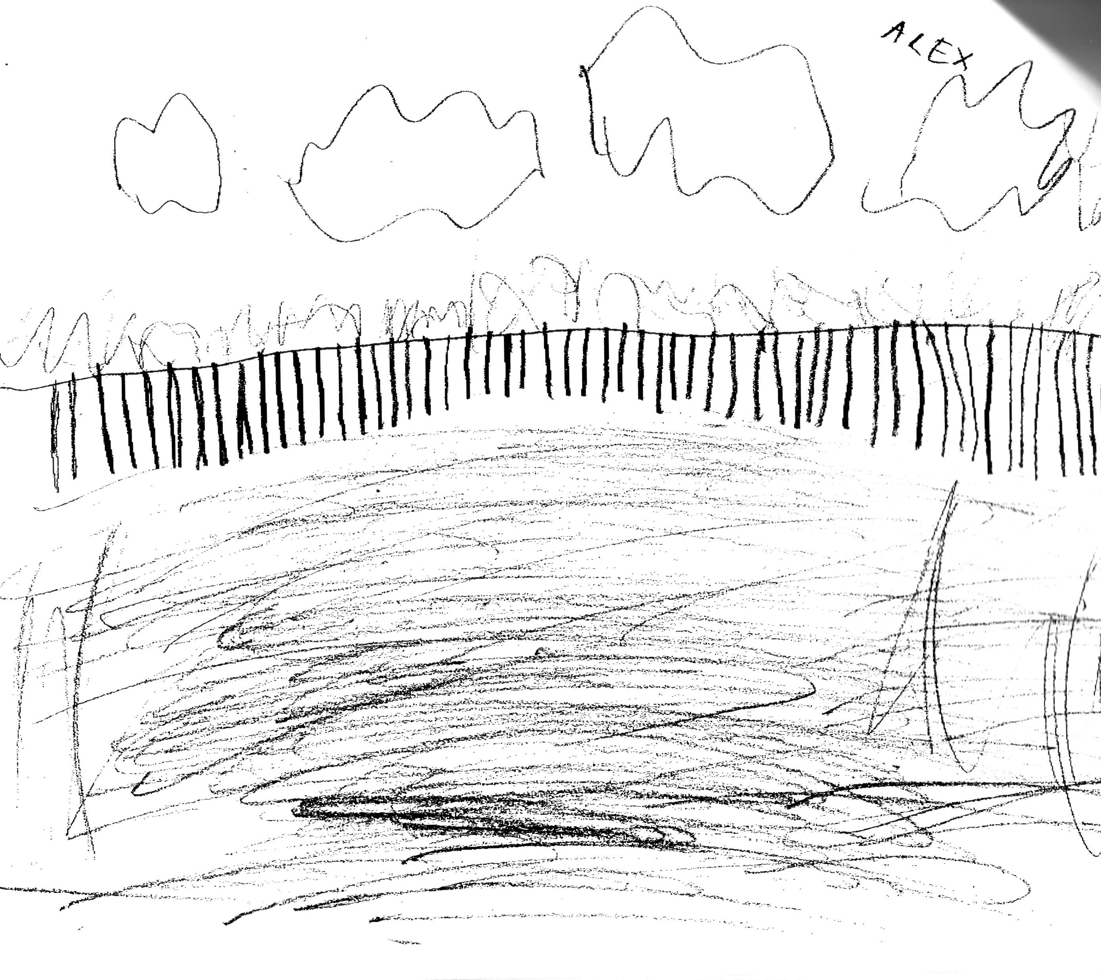
Location: Park @ Green Island, Albany County, NY
Area: park above bluff and then beach below just south of the Troy dam
Surrounding Land Use: Beach, covered with vegetation, shoreline riprap, pipe entering river 100 ft. south of sampling site
Sampling Site: urban/residential, forested, urban industrial, fishing, some plants, beautiful
Plants in area: Spatterdock, purple loosestrife, spotted smart weed, grass, algae, tiny plants, moss, polygonum punctatum
Water depth: 2 ft.
River Bottom: muddy, rocky bottom
Troy Dam picture by student Alex

ITEM | Time |  | Reading 1 | Reading 2 | Comments
Physical
Air Temperature | 10:15 AM |  | 62 °F  14°C
 | 11:24 AM |  | 62 °F  14°C
Wind Speed | 1 Beaufort  2 Beaufort |  | 2 kts.  4 kts | NE
Cloud Cover | Partly cloudy
Weather today | cloudy
Weather recently | Cool and windy and rain last night
Water surface | calm
Water Temperature  (2 ft. water) | 10:17 AM | 14°C  59° F
no plants, direct sun | 10:40 AM | 20°C  62° F
 | 10:52 AM | 15°C  12°C  13.5°C |  | 55° F  53° F  53° F | 13.5°C  53.67° F
 | 11:15 AM | 60° F
 | 11:35 AM | 15°C  57° F
Turbidity | 10:36 AM | 43 cm  55 cm  51 cm  57 cm |  |  | Average 51.5 cm
 | 11:04 AM | 30 cm  37 cm  32.5 cm |  |  | Average 33 cm
 | 11:18 AM | 33 cm  43.7 cm  46 cm |  | • water more turbid in some areas than others | Average –  40.9 cm
 | 11:25 AM | 53.3 cm  54.5 cm  50. cm  60 cm |  |  | 54.45 cm
Chlorophyll | 10:55 AM | 0.5 |  | 11:28 AM | 0.5
 | 11:14 AM | 2.0 |  | 11:33 AM | 5.0
 | 11:15 AM | 0.1
Chemical
DO  (Drop count kit | 10:30 Am | 12 mg/L |  | 14°C | 115%
 | 10:56 AM | 11 mg/L |  | 13°C | 105%
pH | 10:15 AM | 6.5  6  7 |  |  | Average 6.5
 | 10:40 AM | 7.0  6.5  7.0 |  |  | Average 6.83
 | 11:07 AM | 7  6  7 |  |  | Average 6.67
 | 11:20 AM | 5  4  6 |  |  | Average 5
Salinity | 10:16 AM | 39 mg/L Cl |  | 48.75 ppm salinity
 | 10:45 AM | 39 mg/L Cl |  | 48.75 ppm salinity
 | 11:11 AM | 39 mg/L Cl |  | 48.75 ppm salinity
 | 11:28 AM | 39 mg/L Cl |  | 48.75 ppm salinity
Fish Catch | Time | Number Caught |  | Species | Note
30’ long X 3’tall | 10:31 AM | 1 |  | Darter | 6.5 cm
*Its hard to count moving fish |  | 40 |  | Spottail Shiner | 8.5 cm
Tides | 10:09 AM | 27cm
 | 10:15 AM | 26 cm |  | Falling
 | 10:39 AM | 15 cm |  | Falling
 | 11:03 AM | 33 cm |  | Falling
 | 11:20 AM | 27 cm |  | falling
Currents | 10:12 AM | Ebb |  | 4.53 secs./meter
 | 10:39 AM | Ebb |  | 4.3 cm/sec
 | 11:22 AM | Ebb
Traffic | 9:45 Am | Yacht |  | White | Southbound  /full
 | 9:45 Am | The blue bird |  | Brown | Southbound  /empty
Other Items | Seagull | The dam adds pollution
Core Description | Length | Rare |  | Common | Abundant
 | 8.5 inch core | Wood – piece in core about 1/3 way down |  | Sand | mud
Almanac | Life dies when certain areas get cut off by maybe a damin the Hudson. Also it is really dirty,

