Snapshot Day 10/8/09 Data
(Salt Front RM 60.3)
RIVER MILE 18.5W
Alpine Boat Basin
Leslie Day & Gary Lyon, The Elisabeth Morrow School,
Englewood, NJ – 5th /6th grade – 53 students
Rivka Rosenstein & Lisa, Wolfelsperger, Alpine Elementary School
Alpine NJ – 6th grade – 12 students
N 40.94583 – W -73.91833
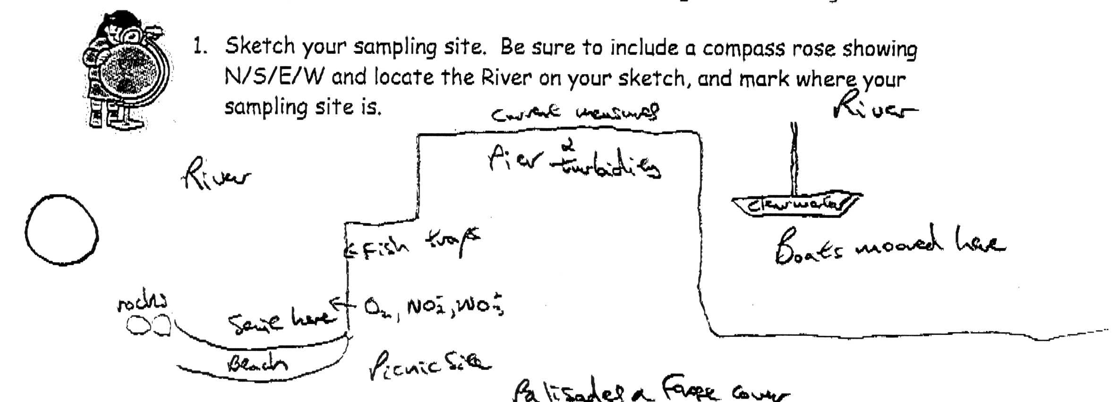
Location: North end of the Alpine Boat Basin, adjacent to a sandy beach area
Area: Used for picnics, boats, seining and education programs
Surrounding Land Use: Forested 20% (at the foot of the Palisades, Man made Sandy Beach 10%, Recreationally developed boat mooring & picnic table 70%
Sampling Site: sandy beach, banks altered, rip rap, bulkhead
Plants in area:
Water depth: 1 – 2 meters
River Bottom – sandy, muddy, rocky
* Note – boating marina and extensive piers could affect turbidity, fish populations, current flow rates and wave action.
ITEM | Time |  | Reading 1 | Reading 2 | Comments
Physical
Air Temperature | 9:30 AM |  | 21.13°C  70°F
Wind Speed | Beaufort #2.5 to 3 |  | 6 knots | Very windy day | SW
Cloud Cover | clear
Weather today | Sunny and dry
Weather recently
Water Temperature | 9:25 AM | 15.5°C  60°F |  | 16.12°C  61°F
(at shoreline 1 foot depth) | 10:00 AM | 16.12°C  61°F |  | 16.12°C  61°F
 | 10:22 AM | 15.5°C  60°F
Turbidity | 10:50 AM | 20 cm |  |  | Long Site tube
 | 10:50 AM | 45 cm |  |  | Secchi Disk
Chlorophyll | 11:48 AM | 1.0
Chemical
DO - | 9:35 AM | 10.0 mg/L |  | 15°C | 98%
 | 10:10 AM | 12.0 mg/L |  | 16°C | 120%
 | 11:40 AM | 12.0 mg/L |  | 16°C | 120%
pH | 9:30 AM | 5.0
 | 11:00 AM | 7.0
 | 11:30 AM | 8.0
Nitrate | < 5 ppm
Salinity | 8:30 AM | 10 ppt |  | hydrometer
 | 9:30 AM | 9 ppt |  | refractometer
 | 9:55 AM | 9 ppt |  | refractometer
 | 10:00 AM | 9 ppt |  | refractometer
Fish Catch | Number Caught | Species |  | Size | Seine
 | 11 | Silversides |  | 10 cm
 | 5 | White Perch |  | 27 cm
Crab caught off pier by fisherman | 1 | Blue Crab |  | 14 cm
Tides | 9:41 AM | 32 cm
 | 10:15 AM | 38cm |  | Rising
 | 10:30 AM | 42cm |  | Rising
 | 11:28 AM | 63 cm |  | rising
Currents- | 9:32 AM | 60 ft./60 sec |  | 1 ft. a sec.
 | 9:36AM | 60 ft./60 sec |  | 1 ft. a sec.
 | 10:18 AM | 23 ft./60 secs |  | .38 ft. a sec.
 | 10:50 AM | 25 ft./60 sec |  | .42 ft. a sec.
Sediment Core | TOTAL Length | Top Layer |  | Bottom Layer | Description
 | 20 cm | 14 cm  lighter sandy color |  | 6 cm  bottom darker color | Larger grain size – sulfur smell in cove
 |  | sand |  | Blackish grey mud
Shipping | 9:30 AM | Clearwater |  | Northbound | full
 | 9:30 AM | Barge |  | Red & black | Stationary
Observations | Osprey flying above | 2 fishermen – caught large bluefish |  | Flock of gulls | Lots of plant debris in the water from seasonal plants

