Snapshot Day 10/8/09 Data
(Salt Front RM 60.3)
RIVER MILE 1 –Harbor @ Statue of Liberty to East River .75 Brooklyn Bridge - Boat Based
South Street Seaport Museum
Maggie Flanagan, Pioneer
Ethical Culture School 3rd graders – 22 students
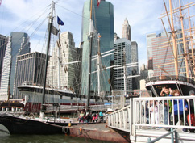

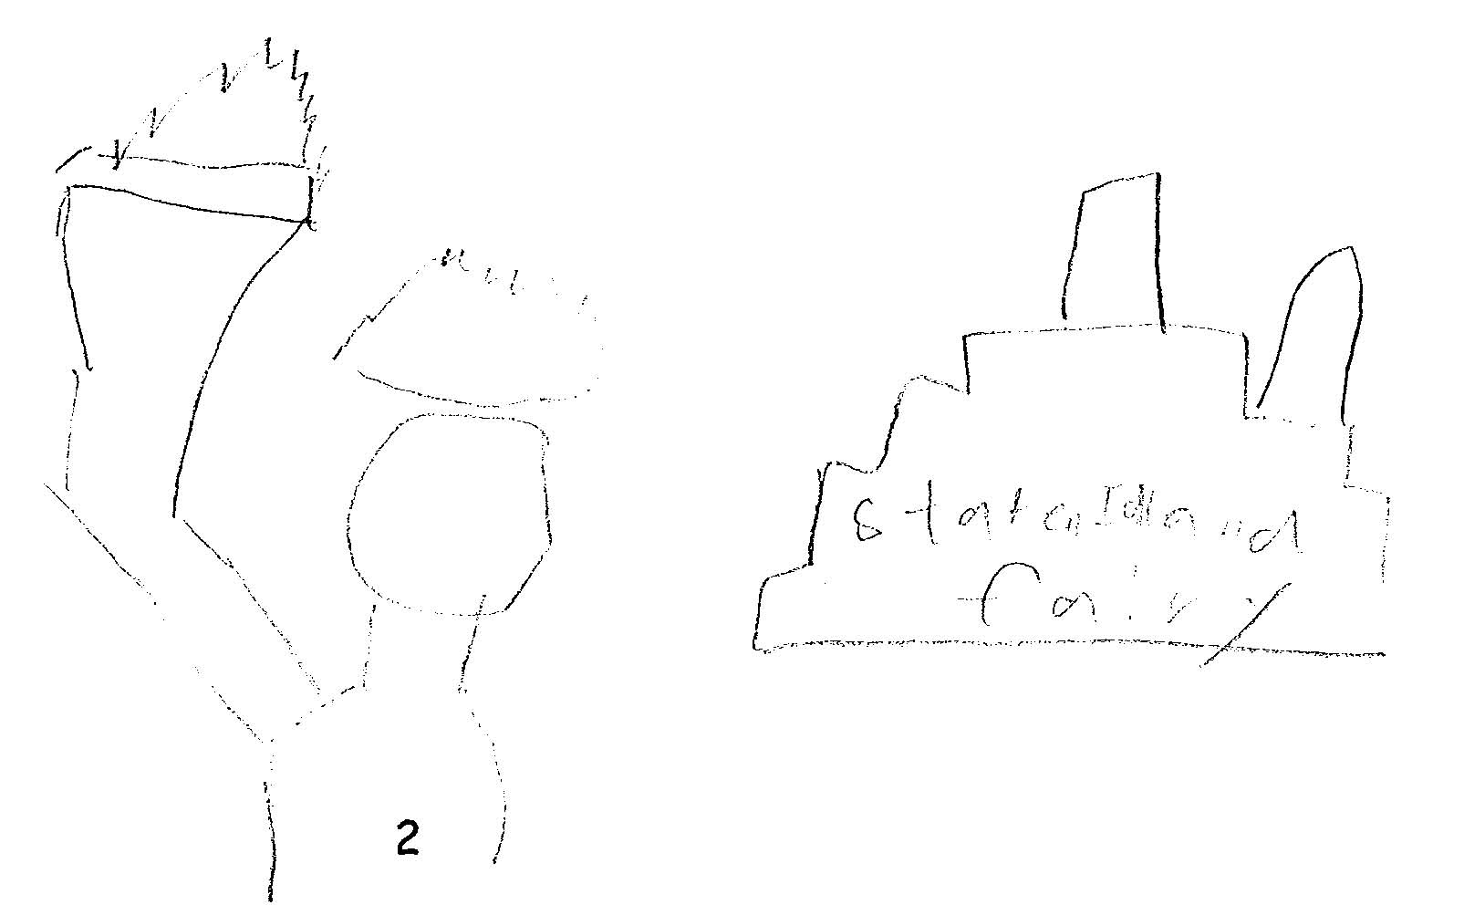  Statue of Liberty & Staten Island ‘Fairy’ | 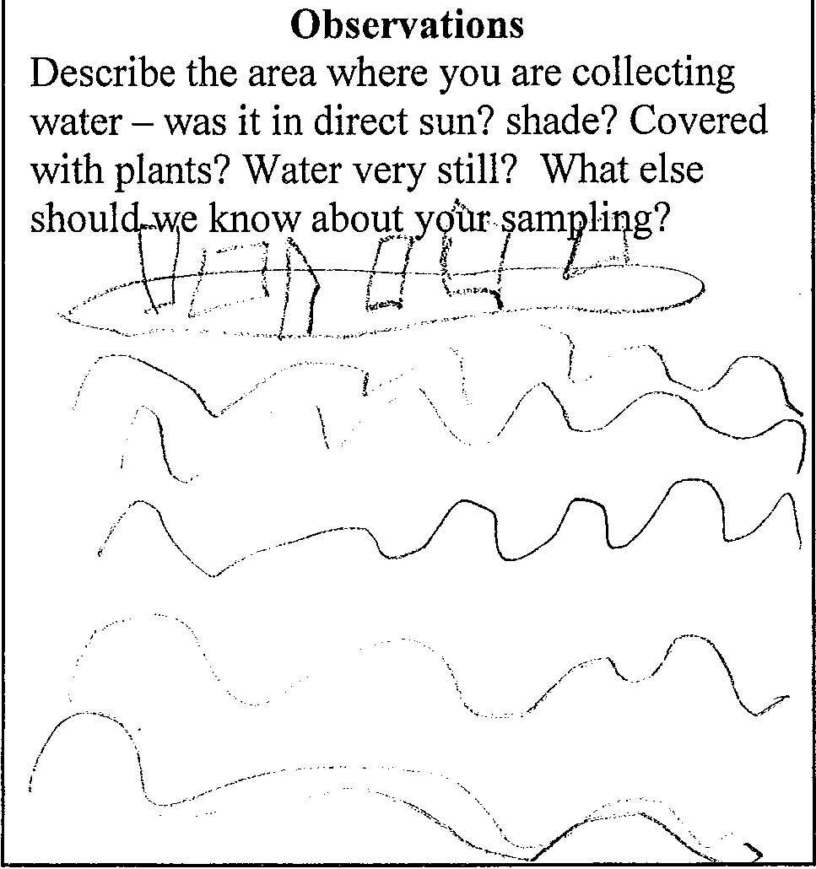  Sampling site with wind causing waves

Location: The Hudson Harbor @ the Statue of Liberty and around to the East River .75 Brooklyn Bridge
Area: The Harbor of the Hudson River
Surrounding Land Use: 95% urban/residential; 5% industrial/commercial
Water depth: 40-60 feet
River Bottom –unable to determine
Water: calm

ITEM | Time |  | Reading 1 | Reading 2 | Comments
Physical
Air Temperature | 10:45 AM |  | 17° C
Wind Speed | 10:45 AM |  | Beaufort 4 | West
Cloud Cover | Some clouds |  | windy
Weather yesterday | Windy, cool |  |  | Water CHOPPY!!!!
Water Temperature | 11:20 AM | 15° C  17° C |  |  | Avr. 16° C.
Turbidity
Chlorophyll | 11:40 AM | 0.3
Chemical
DO  (ampules) | 10:50AM | 6 mg/L |  | Temp 17° C | 63% saturated
pH – indicator solution | 11:10 AM | 8
Salinity | Time | Method |  | Reading
 | 11:25 AM | Refractometer |  | 20 ppt  24 ppt | Avr. 22 ppt
Fish
Tides
Currents | 10:45 -11:30 AM | flood current observed through observations of water movement and buoy leaning, no specific measurements taken
Traffic | 11:34 AM | Paul Andrew tug/with barge |  | Blue | Southbound – with crushed cars
 | 11:30 AM | US Coast Guard |  | White | Southbound
 | 11:21 AM | Delberman (name) |  | Yellow& Black & Red | Northbound empty
Other | Seagulls | Staten Island Ferry

