Snapshot Day 10/8/09 Data
(Salt Front RM 60.3)
RIVER MILE 25W
Piermont Pier
Lamont-Doherty Earth Observatory
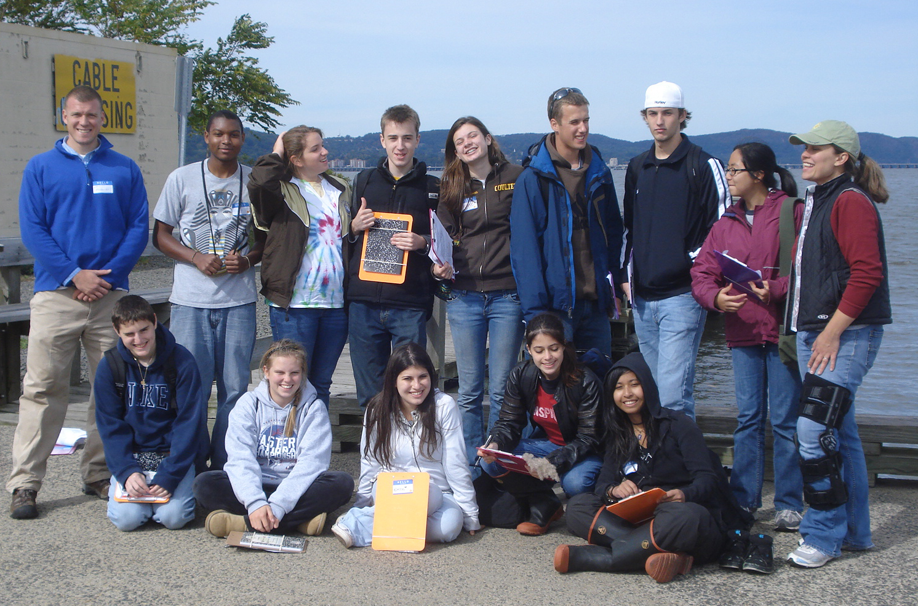 | 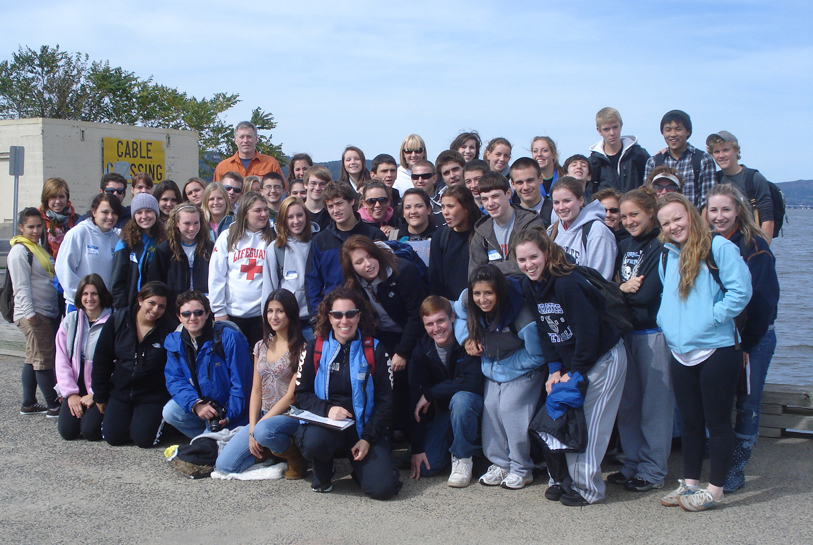
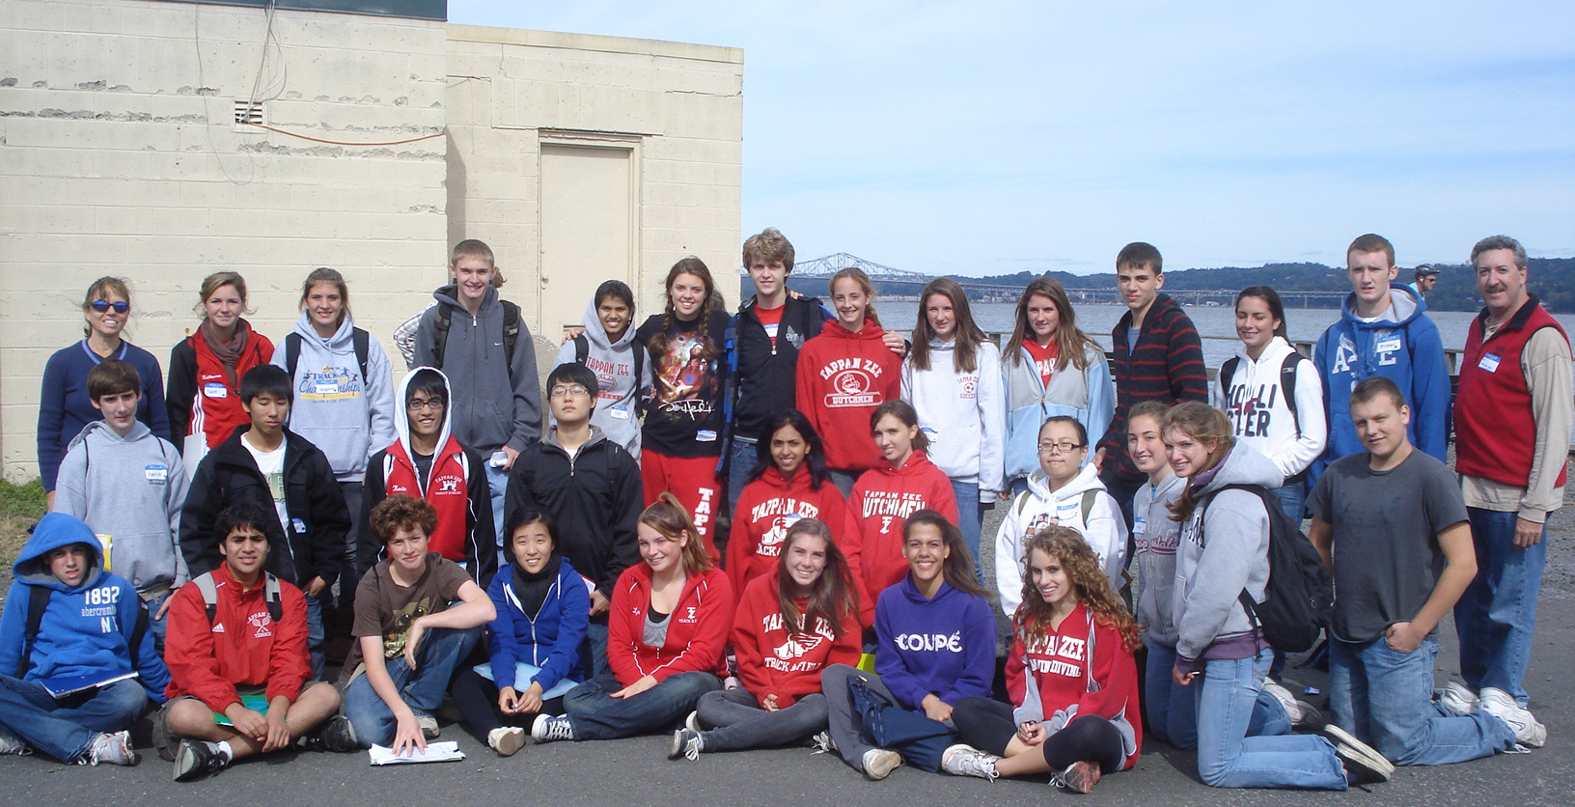
Ellen Pollina, Brian Newburger– Tappan Zee High School AP Bio. – 30 students
Tom Mullane & Sheryl Turk - Pearl River High School APES – 50 students
Jen Mazza, Khris Arvanites– Clarkstown South High School - 12 HS students
Latitude N 41 degrees 02’591” Longitude W 73 degrees 53’792"
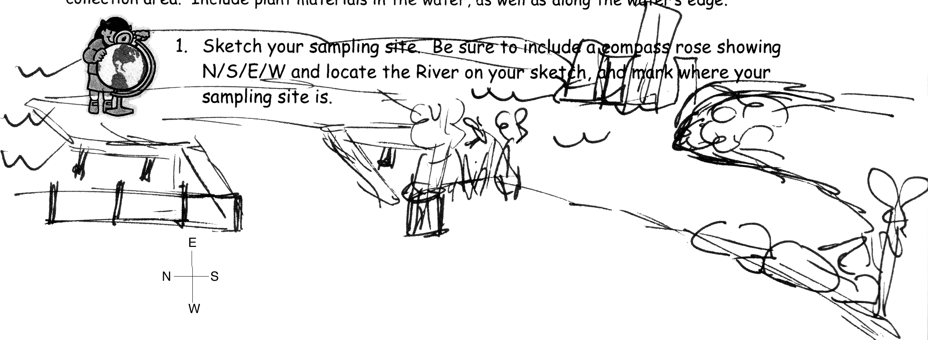
Location: Piermont Pier, Piermont NY
Area: Man made fishing/shipping pier at the east end, long pier with paved roadway and vegetation along both sides
Surrounding Land Use: Urban/residential 80% , Forested 20%
Sampling Site: Pier, roadway in center of whole pier, parking area at end, Plants and trees along side. Shoreline Rip Rap, collected wood in area and piping entering river on the South of sampling site
Plants in area: some plants in the water but lots of plants along pier & lots of water celery washed up on shore
Water depth: Varied by location on the pier and by tide
River Bottom – sandy/rocky bottom with marsh grass growing in or near the water
Plants in area: sumac 30%; marsh plants 70%; reeds & cattails
ITEM | Time |  | Reading 1 |  |  |  | Comments
Physical
Air Temperature | 10:00 AM |  | 17°C
 | 10:32 AM |  | 19 °C
 | 11:25 AM |  | 18°C
 | 11:40 AM |  | 19 °C
 | 12:40 PM |  | 26 °C
 | 1:00 PM |  | 24 °C
 | 1:20 PM |  | 20.5 °C
Wind Speed | Time |  | Beaufort # |  | Anenometer |  | Direction
Very windy | 10:00 AM |  | 3 |  | 7.4 knots |  | North
 | 10:30 AM |  | 1 |  | 3.5 knots |  | NW
 | 11:00 AM |  |  |  | 18.1 km/hr |  | 7.4 kts. NW
 | 11:25 AM |  | 1 |  | 1.6 knots |  | NW
 | 11:40 AM |  | 1 |  | 2.8 knots |  | N/NW
 | 12:40 AM |  | 1 |  | 1.2 knots |  | North
 | 1:00 PM |  | 0 |  | 0.7 knots
 | 1:20 PM |  | 2 |  | 5.0 knots
Cloud Cover | Partly cloudy
Weather today | Very windy on the pier, a bit chilly, northerly wind gusts, mostly calm water with mild waves
Weather recently | Tuesday sunny and warm, Wed. windy and rainy.
Water Temperature |  |  |  |  |  |  | SURFACE  SAMPLE
 | 9:30 AM | 18°C
 | 10:30AM | 16°C
 | 11:30AM | 16°C
 | 12:30PM | 16°C
 | 1:15 PM | 16°C
Water Temperature |  |  |  |  |  |  | BOTTOM SAMPLE
 | 9:30AM | 17°C
 | 10:30AM | 17°C
 | 11:30 AM | 17°C
 | 12:30 PM | 18.5°C
 | 1:15PM | 18.5°C
Turbidity – | 9:30 AM | 16.5 cm |  |  |  |  | Long site tube
Turbidity – | 10:30AM | 17.5 cm
Turbidity – | 10:55AM | 16 cm
Turbidity – | 11:06AM | 12.3 cm
Turbidity – | 11:28AM | 13.4 cm
Turbidity – | 12:40PM | 15 cm
Turbidity – | 1:00 PM | 17.6 cm
Turbidity | 9:30 AM | 40 cm |  |  |  |  | Secchi Disk
 | 10:00 AM | 40 cm
 | 10:30 AM | 40 cm
 | 11:25 AM | 20 cm
 | 11:40 AM | 32.5 cm
 | 12:40 PM | 45 cm
 | 1:10 PM | 45 cm
 | 1:30 PM | 50 cm
Turbidity | 9:30 AM | 40 JTU |  |  |  |  | Small site tube
 | 10:00AM | 27.5 JTU
 | 10:30AM | 27.5 JTU
 | 11:06AM | 25 JTU
 | 11:25AM | 42.5 JTU
 | 12:40PM | 45 JTU
 | 1:00 PM | 35 JTU
Depth | 10:00 AM | 30 cm
 | 10:30 AM | 410 cm
 | 10:40 AM | 420 cm
 | 11:25 AM | 463 cm
 | 12:25 PM | 502 cm |  |  |  | Waves made it hard to read
 | 12:40 PM | 456 cm
 | 1:10 PM | 459 cm
Chlorophyll | 1:00 PM | 1.75
 | 1:20 PM | 1.75
Chemical | SURFACE WATER SAMPLES
DO | 9:30 AM | 22.0 mg/L |  |  |  | 18°C | Too high – students probably introduced O2
Drop count | 10:30AM | 9 mg/L |  |  |  | 16°C | 90%
 | 11:30AM | 5 mg/L |  |  |  | 16°C | 50%
 | 12:30PM | 4 mg/L |  |  |  | 16°C | 40%
 | 1:15 PM | 9 mg/L |  |  |  | 16°C | 90%
pH | 9:30 AM | 7.0
colorimeter | 10:30AM | 7.5
 | 11:30AM | 7.0
 | 12:30PM | 7.25
 | 1:15 PM | 7.5
Phosphate | 9:30 AM | 0.2 mg/L
colorimeter | 10:30AM | 0.54 mg/L
 | 11:30AM | 0.40 mg/L |  |  |  | Seems too high?
 | 12:30PM | 0.44 mg/L |  |  |  | Seems too high?
 | 1:15 PM | 0.1 mg/L
Nitrate | 9:30 AM | 0.88 mg/L
Drop count | 10:30AM | 0 ppm
 | 11:30AM | 0 ppm
 | 12:30PM | 0 ppm
 | 1:15 PM | 0 ppm
Alkalinity | 9:30 AM | 82 ppm
Drop count | 10:30AM | 105 ppm
 | 11:30AM | 90 ppm
 | 12:30PM | 100 ppm
 | 1:15 PM | 75 pm
Salinity | 9:30 AM | 6.6 ppt |  |  |  |  | Hydrometer
 | 10:30AM | 6.6 ppt
 | 11:30AM | 6.6 ppt
 | 12:30PM | 6.6 ppt
 | 1:15 PM | 6.6 ppt
Chemical | BOTTOM WATER SAMPLES
DO | 9:30AM | 8.0 mg/L |  |  |  | 17°C | 80%
 | 10:30AM | 9.0 mg/L |  |  |  | 17°C | 92%
 | 11:30 AM | 9.0 mg/L |  |  |  | 17°C | 95%
 | 12:30 PM | 8.0 mg/L |  |  |  | 18.5°C | 85%
 | 1:15PM | 11.0 mg/L |  |  |  | 18.5°C | 115%
pH | 9:30AM | 8.2
 | 10:30AM | 8.4
 | 11:30 AM | 7.5
 | 12:30 PM | 7.0
 | 1:15PM | 7.5
Phosphate | 9:30AM | 0 mg/L
 | 10:30AM | 0 - 0.5 mg/L
 | 11:30 AM | 0.38 mg/L
 | 12:30 PM | 0.1 mg/L
 | 1:15PM | 0.25 mg/L
Nitrate | 9:30AM | 0 -0.2 ppm
 | 10:30AM | 0 ppm
 | 11:30 AM | 0 ppm
 | 12:30 PM | 0 ppm
 | 1:15PM | 0 ppm
Alkalinity | 9:30AM | 86 ppm
Alkalinity | 10:30AM | 90 ppm
Alkalinity | 11:30 AM | 62 ppm
Alkalinity | 12:30 PM | 100 ppm
Alkalinity | 1:15PM | 95 ppm
Salinity | 9:30AM | 7 ppt |  |  |  |  | refractometer
 | 10:30AM | 7 ppt
 | 11:30 AM | 8 ppt
 | 12:30 PM | 7 ppt
 | 1:15PM | 7 ppt
Tides | Time | Tide Stick
 | 9:38 AM | 12 cm
Setting a tide stick | 10:00 AM | 30 cm |  |  |  | flood
Setting a tide stick | 10:30AM | 41 cm |  |  |  | flood
Setting a tide stick | 11:00 AM | 58 cm |  |  |  | flood
Setting a tide stick | 11:20 AM | 70 cm |  |  |  | flood
Setting a tide stick | 12:25 PM | 85 cm |  |  |  | Flood
Setting a tide stick | 1:10 PM | 90 cm |  |  |  | flood
 | 1:23PM | 72 cm |  |  |  | rising
Currents | Time | Cm/60 secs |  |  |  | Cm per sec | Knots/direction
 | 9:45 AM | Strong current opposite direction to waves |  |  |  | 32.6 cm/sec | flood
 | 10:00 AM |  |  |  |  | 50.2 cm/sec | flood
 | 10:15 AM | 1826.3cm/60 secs |  |  |  | 33.4 cm/sec | flood
 | 10:49 AM |  |  |  |  | 38.2 cm/sec | flood
 | 11:27 AM |  |  |  |  | 15.8 cm/sec | flood
 | 11:45 AM |  |  |  |  | 38.2 cm/ sec | Flood
 | 12:00 PM | 2290cm/60 secs |  |  |  | 46.1 cm/sec
 | 12:30 PM |  |  |  |  | 43.7 cm/sec | Flood
 | 12:40 PM |  |  |  |  | 34.2 cm/sec
 | 1:20 PM |  |  |  |  | 27.6 cm/sec
Fish Catch | Number Caught | Species |  |  |  | Measure of largest | Seine 30 m
Northside of pier | 19 | Atlantic Silverside |  |  |  | 5 cm | 9:30 AM
5 rotations – | 1 | Striped Bass |  |  |  | 12 cm
Each group 1 seine | 5 | Juvenile Blue Crabs |  |  |  | 3 cm
But with 2 nets | 1 | Naked Goby |  |  |  |  | Diversity 5
 | Several | Ctenaphors (comb jelly)
 | 2 | Shore shrimp |  |  |  | 2 cm | 28 + total
 | 9 | Atlantic Silverside |  |  |  | 10 cm | 10:00 AM
 | 1 | White Perch |  |  |  | 19 cm
 | 6 | Blue Crab |  |  |  | 1 | Diversity 4
 | Several | Ctenaphors (comb jelly) |  |  |  |  | 16 + total
 | 22 | Atlantic Silverside |  |  |  | 9 cm | 11:17 AM
 | 1 | Striped Bass
 | 1 | Menhaden |  |  |  | 15 cm | Diversity 5
 | 1 | White Perch |  |  |  | 21 cm
 | 2 | Blue Crab |  |  |  | 9 cm | 27 total
 | 15 | Atlantic Silverside |  |  |  | 9 cm | 12:30 PM
 | 3 | Striped Bass |  |  |  | 12 cm
 | 6 | Blue Crab |  |  |  | 10 cm
 | 3 | White Perch |  |  |  | 22 cm
 | 52 | Comb jellies |  |  |  | 2 cm | Diversity 6
 | 1 | Shore shrimp |  |  |  | 3 cm | 80 total
 | 5 | Atlantic Silverside |  |  |  | 15cm | 1:00 PM
 |  |  |  |  |  |  | Diversity 1
 |  |  |  |  |  |  | 5 total
 | 5 | Atlantic Silverside |  |  |  | 8 cm
 | 1 | Striped Bass |  |  |  |  | Diversity 3
 | 5 | Blue Crabs |  |  |  | 4 cm | 11 total
 |  | Grand Total |  |  |  |  | Diversity 8
 |  |  |  |  |  |  | Count 167
OTHER | 2 | Cumaceas
Cores | Length | Abundant |  | Common |  | Rare | Comments
9:30 AM – water | 18 cm  5 cm top grainy dark -13 cm  bottom lighter clay | Clay |  | Sand  Gravel |  | Mud  wood | Feels like clay, newer sediment is looser and cooler, smells metallic and sulfurish
10:06 AM – water 70 cm deep | 29 cm - 10 cm top sand & gravel  bottom  clay & mud | Clay, mud |  | Sand  Gravel |  | Pebbles & Shells | material in a pocket in the clay down by bottom
10:42 AM – | 19 cm – top 1 cm oxidized | Sand – |  | Clay |  | Gravel Pebbles Leaves
11:25 AM – | 12 cm – 9 cm in the middle are red | Sand |  | Mud  Gravel |  | Pebbles  Clay & some vegetation | Oxidized top
12:00 PM – | 6 cm – top 2.5 cm | Sand, leaves & Living vegetation |  | Clay, leaves (grasses) |  | Mud  Gravel  Pebbles  Wood  Brick | Dark colored, not very oxidized a lot, no sulfur smell, grainy with clay
12:35 PM – water 47 cm | 7 cm - | Clay – fine grain |  | Mud  Sand |  | Gravel | Small bit of H2S odor, some plants in & organisms
1:00 PM – |  | Sand  Leaves |  | Clay  Mud  Gravel |  | Pebbles  Wood
Shipping | 10:25 AM | Recreational boat
 | 10:30 AM | Sailboat |  | White |  |  | Southbound
History | Pier used to load cargo from trains to boats in WWII, people came to pier at nighttime and silently loaded ships with thousand of soldiers. 50,000 soldiers a month were shipped out from pier.

