Snapshot Day 10/8/09 Data
(Salt Front RM 60.3)
RIVER MILE 41
Steamboat Dock Park, Verplanck, Westchester
Beth Rhines, Teatown Lake Reservation
Bob Connick, Sott Rizzo, Trisha Fuller Johnson & Liz Stevens & Mahopac High School - Chem Honors, Regents and APES - 9th - 12th graders – 40 students
Latitude N 41°24’.936” Longitude W 73°93’.479"
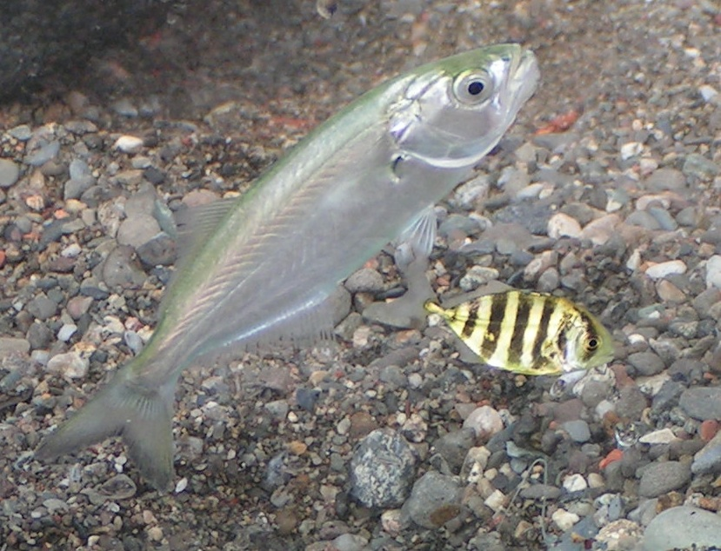
Blue Fish and a Crevalle Jack seined during A Day in the Life
Location: Steamboat Dock Park beach, City of Verplanck in Westchester County
Area: located in a small cove between a point and a bulkhead – sampled approximately 30 ft. from south end of dock/parking lot
Surrounding Land Use: Urban/residential 30% , Forested 10%, beach 40%, Industrial commercial 5%, Other 15%. Some buildings with large parking lots in front to the north. Beach, a street with houses with some trees to the south
Sampling Site: beach, riprap, banks altered, dock, bulkhead
Plants in area: Trees – Oak, Maple, Black Locust
Vines – Wild grape
Other Plants – Burdock
Deadly nightshade
Water depth: 0.7 meters
River Bottom – sandy and rocky
Observations- Bricks on beach – 2 types. 1. Rounded edges, talked with a local who noted they had been in the river awhile. Rejects from the brick factories on the Hudson. 2. Intact – Construction waste dumped in river. Lots of sea glass.
Parking lot – garbage, cans, storm drains, buildings, dock – impacts due to alteration of habitat – both thermal and chemical pollution.

ITEM | Time |  | Reading 1 | Reading 2 | Comments
Physical
Air Temperature | 11:25 AM |  | 18.5°C  51 °F
 | 12:17 PM |  | 19°C
Wind Speed | 1 Beaufort |  | 4.83 km/hr | 3 knots wind from the North
Cloud Cover | none
Weather today | Partly cloudy, no rain
Weather recently | A lot of wind and rain the day before
Water Surface | Calm
Water Temperature | 11:25 AM | 20°C  20°C  20°C |  | 70°F  70°F  70°F | Water depth 2 ft.
 | 11:45 PM | 20°C  20°C  20°C |  | 70°F  70°F  70°F | Water depth 2 ft.
Turbidity - secchi
Meter
Chlorophyll
Chemical
DO  (drop kits) | 11:35 AM | 8 mg/L |  | 18°C | 85 %
 | 12:20 PM | 9 mg/L |  | 20°C | 97%
 | 12:32 PM | 9 mg/L |  | 20°C | 97%
pH  Indicator sol | 11:38 AM | 8.0
 | 12:05 PM | 7.5
 | 12:15 PM | 8.5
Salinity  meter | 11:25 AM | 2.3 ppt
 | 12:15 PM | 2.0 ppt
Conductivity |  | 3594 mS
Fish Catch | Number Caught | Species |  | CPUE | Seine
20 ft net X 4ft– 50 ft. pull | 70 | Silversides |  | 7.5 cm
4X6 mm openings | 1 | Crevalle Jack |  | 4.5 cm
Did a total of 10 seine runs | 1 | Bluefish |  | 10.5 cm
1st seine run =  1 bluefish, 9 silversides and 1 Crevalle Jack | 1 | Striped Bass
Tides | TIME | Water height |  | Rise/Fall
 | 11:10 AM | 67cm
 | 11:25 AM | 68cm |  | rising
 | 11:50 AM | 74 cm |  | rising
 | 12:07 PM | 81 cm |  | rising
 | 12:21 PM | 84 cm |  | Rising
Currents | Time | Cm/60 sec |  | Knots | Direction
 | 11:35 AM | 60 cm/60sec |  | 0.019 knots | N Flood
 | 11:53 AM | 56 cm/60sec |  | 0.018 knots | N Flood
Core –  From 3.5 ft. of water - 40 ft. from shore | Length -12-13.5 cm – dark slatey grey | Top 4 cm oxidized –  reddish grey with red dots – brick or oxidation? |  | 8-13 cm second layer –  fine particles (clay?) | Abundant”  Clay
Traffic | 11:36 AM | Tugboat with barge |  | Brown | Southbound/Full
 | 12:18 PM | Corander Ferry |  | White | Northbound
 | 12:33 | Sheriff |  | White | Northbound
Other Items | Turkey Vultures, 12 Canadian Geese, 2 Black Ducks, 10 Ringed-Bill Gulls

