Snapshot Day 10/8/09 Data
(Salt Front RM 60.3)
RIVER MILE 55
Little Stony Point
Pete Salmansohn & Lisa Mechaley of the Hudson Highlands Land Trust
Mark Patinella, Highland High School
17 students - 12th grade
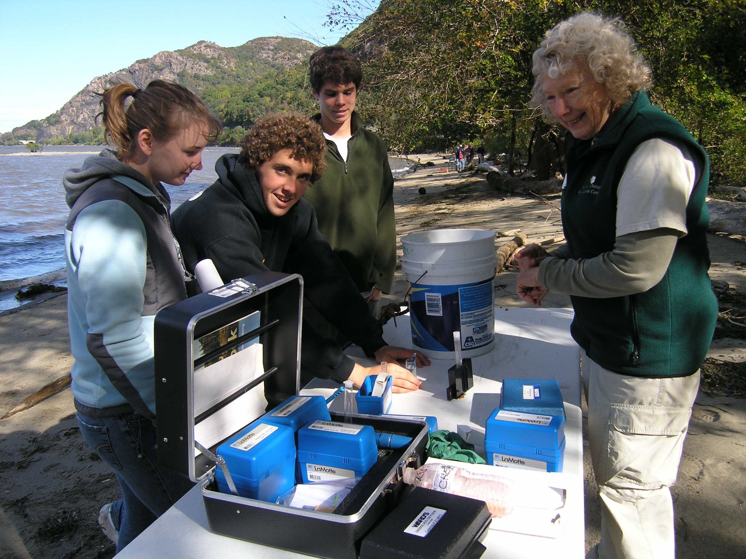
Location: Little Stony Point beach, Cold Spring, Putnam County
Area: On the beach at Little Stony Point, facing Beacon across from Storm King
Surrounding Land Use: 50% forested, 50% beach
Sampling Site: beach area
Plants in area: no plants in water
Water depth: 45 cm
River Bottom –

ITEM | Time |  | Reading 1 |  | Reading 2 |  | Comments
Physical
Air Temperature | 10:37 |  | 15°C  59°F |  | 12:33PM |  | 16°C  61°F
Wind Speed | 8 Beaufort |  | 7.5 kts |  |  |  | North
Cloud Cover | Partly cloudy
Weather today | Overcast, no rain, windy
Weather recently | Rain and significant wind over last 3 days
Water Temperature | 12:50 PM | 17.5°C  63°F
Water | Choppy
Turbidity – drop kit | 11:32 AM | 72 JTU  50 JTU  65 JTU |  |  | 62.3 average JTU
Chlorophyll
Chemical
DO  (ampules) | 12:10 PM | 17°C |  |  | 8 mg/L |  | 70% saturated
pH | 10:48 AM | 7.3
 | 11:23 AM | 7.5
 | 12:10 PM | 7.5
Phosphate
Nitrate | 10:37 AM | 0.5 ppm  1.0 ppm |  |  |  |  | 0.75 ppm Average
Alkalinity
Salinity  Test strips | 10:56 AM | 1.8 quantab unit  1.8  1.8 |  |  | 53 ppm chloride
 | (per Tom Lake) | <1.0 ppt
Fish Catch | Number Caught | Species |  |  | CPUE |  | Seine
Seine net 20 feet , X 4 ft. X 50 yrd pull
Also dip net | 2 | Pumpkinseed
 | 1 | Spottail shiner |  |  | 13.5 cm
 | 1 | White Perch |  |  | 6 inches
 | 2 | Bullhead
 | 1 | Herring
 | 1 | Striped Bass
Tides | 10:20 AM | rising |  |  | 5.1 cm
 | 10:40 AM | Rising |  |  | 12.7 cm |  | .38 cm/min
 | 11:15 AM | Rising |  |  | 22.9 cm |  | .29 cm/min
 | 11:40 AM | Rising |  |  | 35.6 cm |  | .5 cm/min
 | 12:11PM | Rising |  |  | 45.7 cm |  | .34 cm/min
 | 12:28 PM | Rising |  |  | 48.3 cm |  | .15 cm/min
 | 12:47 PM | Rising |  |  | 53.3 cm |  | .25 cm/min
Currents  (no time listed) | Time | Cm/60 sec |  | Cm/sec | knots | N/S | Ebb/Flood/Still
 | 10:37AM | 720 |  | 12 | .24 | N | Flood
 | 11:00AM | 20 |  | .33 | .0066 | S/SW | Flood
 | 11:10AM | 144 |  | 2.4 | .046 | SW | Flood
 | 12:05PM | 136 |  | 21.7 | 0.434 | S | Flood
 | 12:33PM |  |  | 16.3 | .326 | S | Flood
Core Description | Rare | Common |  |  | Abundant
 | Mud | Gravel, pebbles |  |  | Sand
 | 7 inches total length | Nothing living in it |  |  | Not much oxidation occurred

