Snapshot Day 10/8/09 Data
(Salt Front RM 60.3)
RIVER MILE 57
Donahue Memorial Park, Cornwall Landing, Village of Cornwall-On-Hudson, Town of Cornwall, Orange County, NY
Christopher O’Sullivan, NYSOPRHP Trailside Museums & Zoo
Deborah Gilson, Willow Ave. Elementary - 4th grade – 70 plus - students
GPS Latitude 41°26’36”N Longitude 74°0’1”W

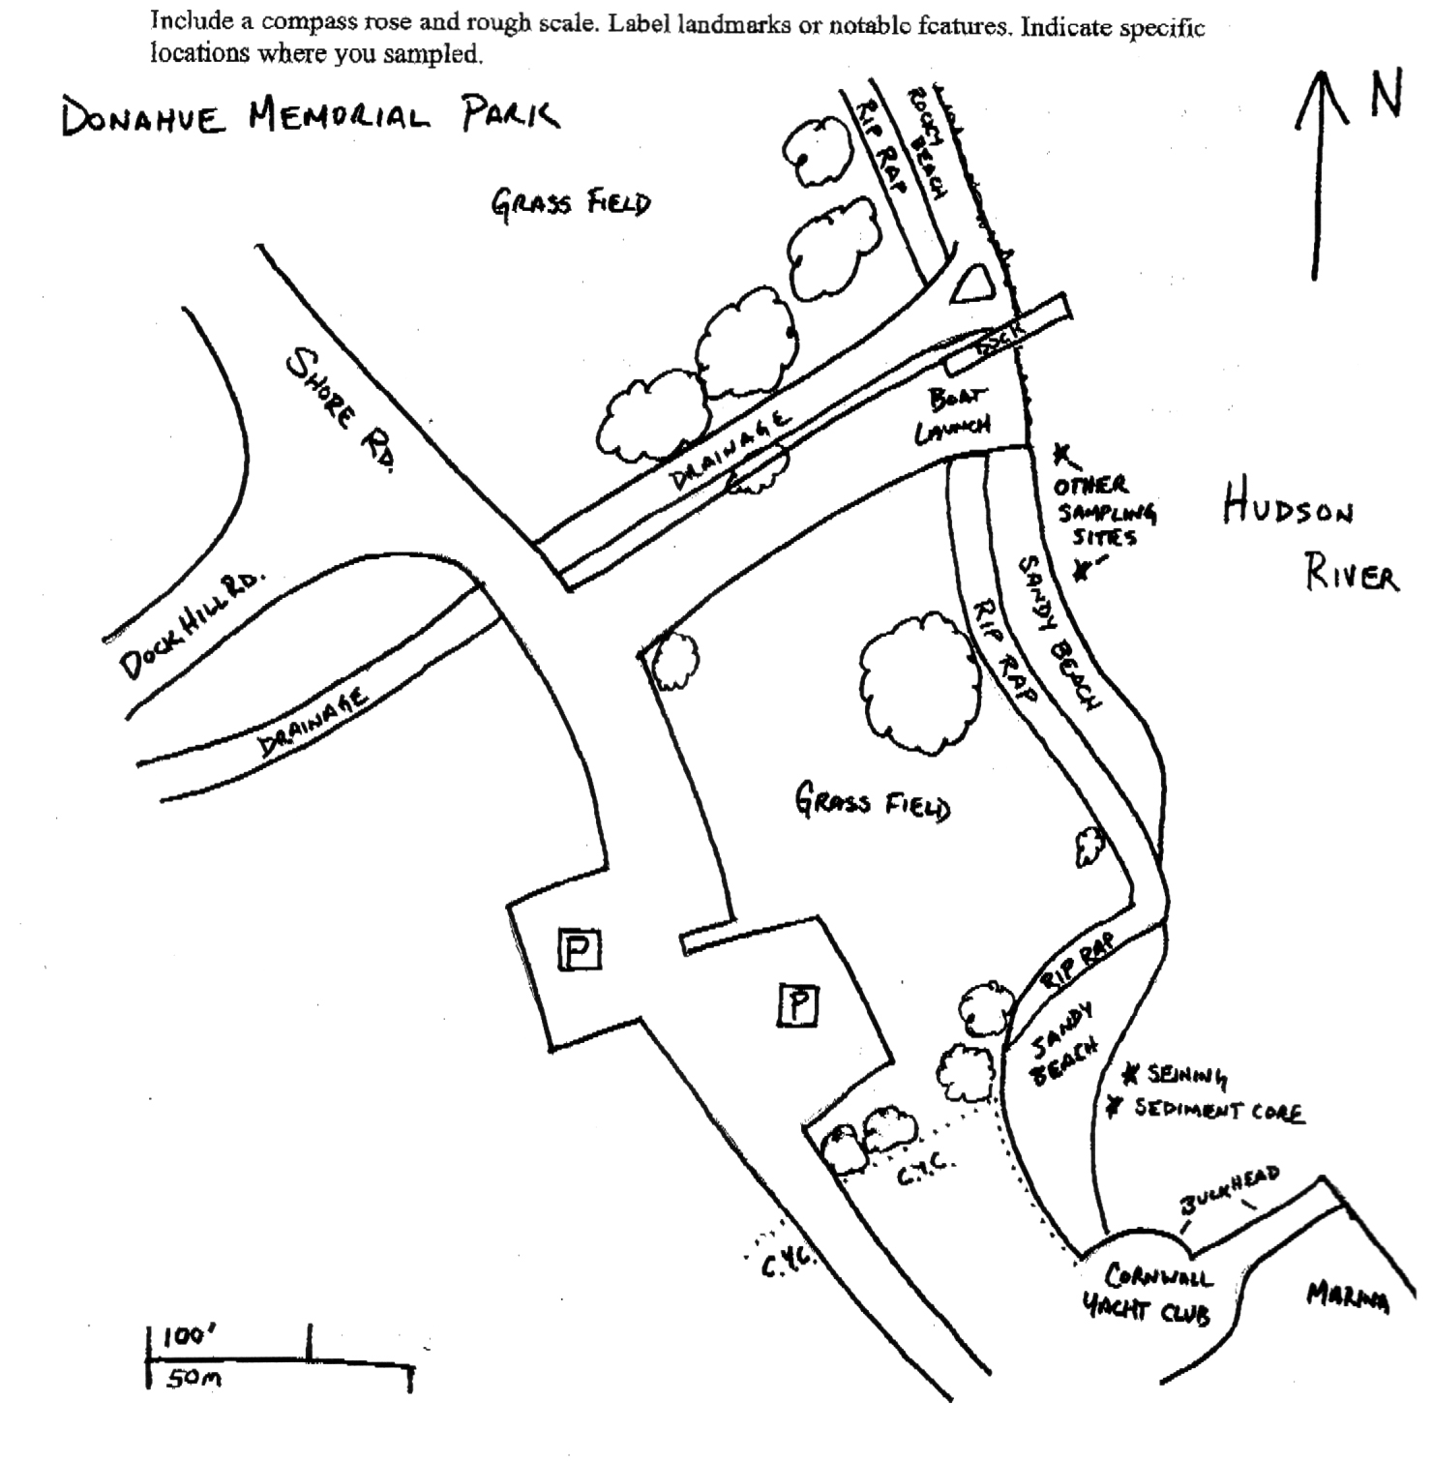
Location: Donahue Memorial Park
Area: Sandy beach used for seining & sediment core, 2nd beach are for other sampling.
Surrounding Land Use: Forested 5%, beach 20%, 75% open and grassy
Sampling Site: sandy beach, altered banks, shoreline riprap, bulkhead, collected wood & debris in area,
Plants in area: water celery covers 10% of sampling area – only plant in area
Water depth:
River Bottom –

ITEM | Time |  | Reading 1 | Reading 2 | Comments
Physical
Air Temperature | 10:59 AM |  | 19°C
 | 1:20 PM |  | 20°C
Wind Speed | BEAUFORT #3 |  | 14 kts. | 16 mph | North
Cloud Cover | partly cloudy
Weather today | The weather got warmer and the sky became clearer as the day  progressed.
Weather recently | There were periods of rain over the last few days.
Water Temperature | 11:08 AM | 20°C
 | 11:25 AM | 20°C
 | 12:37 PM | 20°C
 | 12:57 PM | 20°C
 | 1:25 PM | 20°C
Water Calm
Turbidity  Long sight tube | 12:55 PM | 44 cm  45 cm  34.5 |  |  |  | 41.16 cm
Chlorophyll | 12:55 PM | 0.1
Chemical
DO  Drop count kit | 1:15 PM | 10 mg/L |  | 20°C |  | 110%
pH (indicator sol.) | 11:00 AM | 7.4
Salinity -  Quantabs – low range strips – | 11:00 AM | 42 ppm Cl  49 ppm  42 ppm |  | Avg. 44 ppm Cl |  | 55 ppm total salinity
 | 10:50 AM | 81 ppm
 | Noon | 73 ppm
 | 1:40 PM | 73 ppm
Fish Catch  80 ft. seine X 4 ft. with bag – ¼ inch mesh - | Number Caught | Species |  | CPUE |  | Seine -  1 seine
10:00 AM | 2 | Alewife |  | 4 inch (landlocked) |  | 58 Total
 | 10 | Banded Killifish
 | 4 | Golden Shiner
 | 20 | Pumpkinseed sunfish
 | 20 | Spottail Shiner
 | 1 | Tessellated Darter
 | 1 | White Perch
 | 1 | Largemouth Bass
Tides* | TIME | RISING/  FALLING |  | HEIGHT IN CM |  | RATE OF CHANGE
 | 11:02 am | Rising |  | 10
 | 11:25 am | Rising |  | 15 |  | 0.65
 | 12:00 pm | Rising |  | 35 |  | 0.57
 | 12:30 pm | Unchanged |  | 35 |  | 0
 | 1:00 pm | Rising |  | 40 |  | 0.5
 | 1:30 pm | Unchanged |  | 40 |  | 0
Currents | 11:05 AM | Ebb
 | 11:40 AM | Flood
 | 12:45 PM | Flood
 | 1:10 PM | Still
 | 1:45 PM | Ebb
Core -

Shipping | 12:45 PM | Red Tug Boat |  |  |  | Empty
 | 1:33 PM | Brown Tug Boat |  | Northbound |  | Empty
 | 1:35 PM | Red & White |  | Southbound |  | Empty

