Snapshot Day 10/8/09 Data
(Salt Front RM 60.3)
RIVER MILE 58
Kowawese Unique Area, Plum Point, New Windsor, Orange County, NY
Pam Golben & Judy Onufer, Museum of the Hudson Highlands
Bernadette Kleister, Bishop Dunn Memorial School - 7th grade – 34 students
GPS Latitude 41°27’44”N Longitude 74°00’41”W
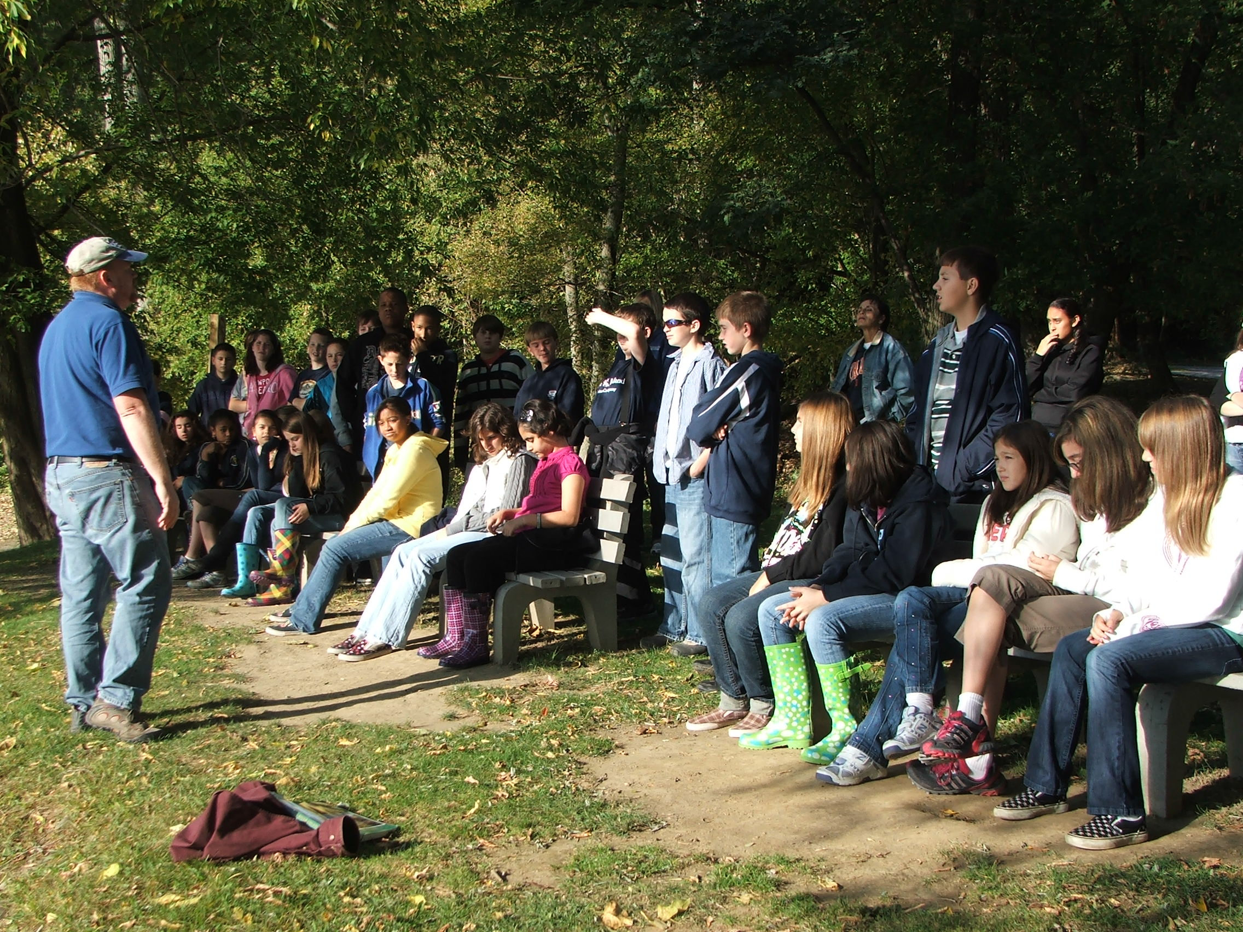 | 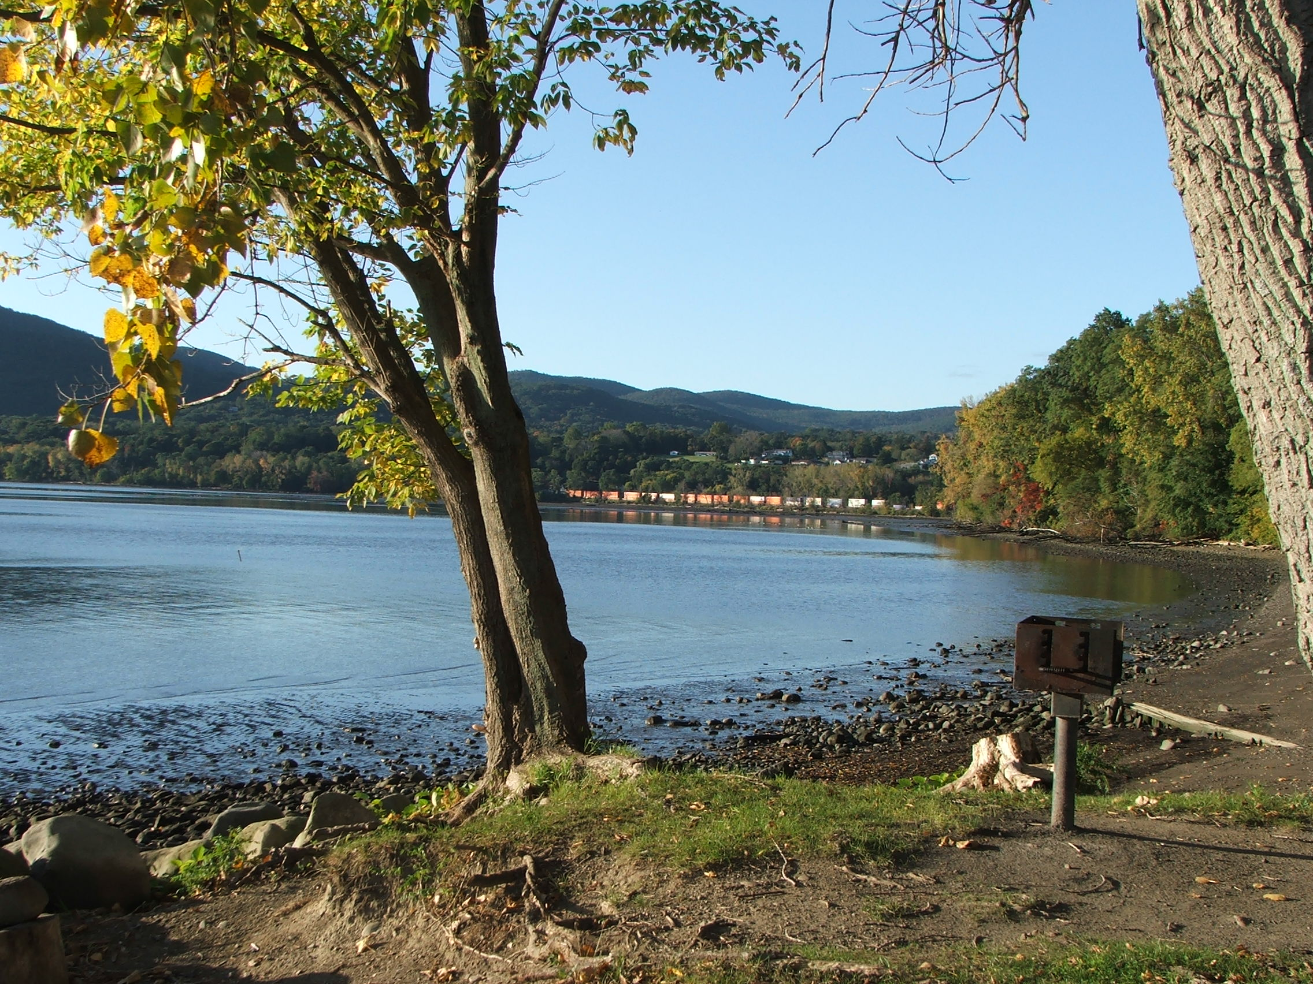
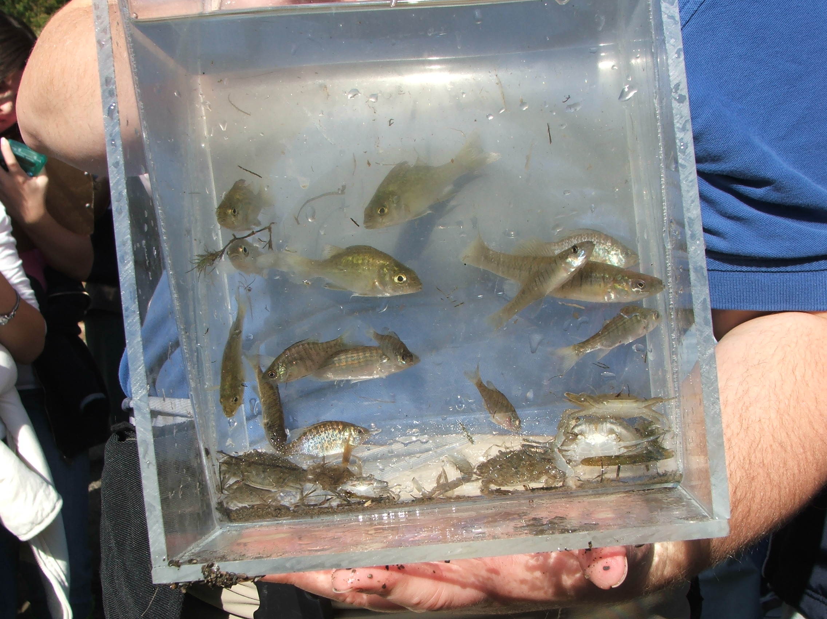
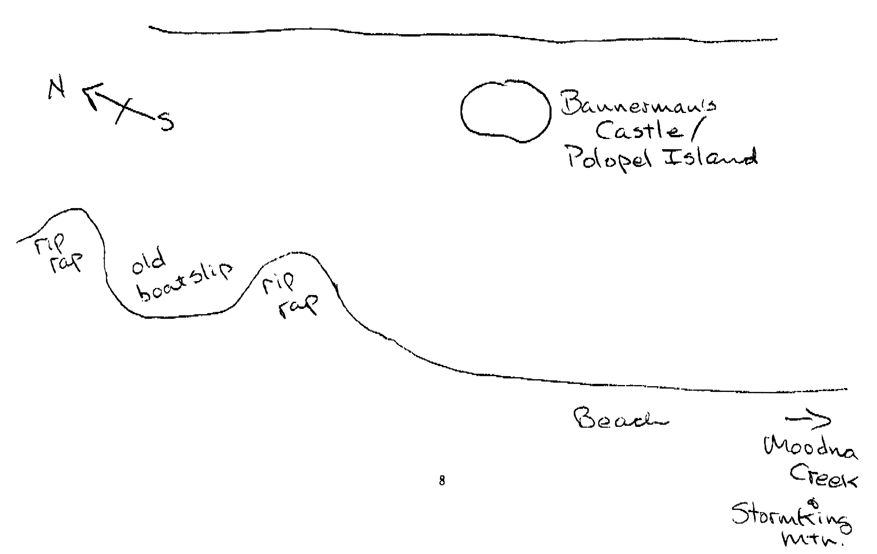
Location: Sandy beach at Kowawese, New Windsor, Orange County, Public Shore, Picnic Area
Area: Sandy beach with scattered tidal debris, forested above beach to South, grass and trees and picnic area to North. Rip Rap, broken wood in boat launch area. Parking above beach area. No swimming. People fish and launch boats here.
Surrounding Land Use: Forested 25%, beach 50%, Urban/residential 25%
Sampling Site: sandy beach (cove), vegetation 500 ft. south of sampling site, Much wood washed up on beach.
Plants in area: < 25% of sampling area – 75% of plants Water celery – sporadic not dense; 25% - other vegetation.
Other trees in area – mostly wooded – oak, tulip, poplar and maple.
Water depth: <1 meter; EXTREMELY LOW TIDE
River Bottom –Mostly mud/sand with a few larger rocks. Due to low tide we were able to walk out to weed beds offshore.

ITEM | Time |  | Reading 1 | Reading 2 | Comments
Physical
Air Temperature | 10:44 AM |  | 20°C  64°F
 | 11:17 AM |  | 19°C  63°F
Wind Speed | 2 knot |  | N
Cloud Cover | Partly cloudy
Weather today | No rain,
Weather recently | rained previous day
Water Surface | calm
Water Temperature | 10:45 AM | 63.7° F  17.6°C
 | 11:15 AM | 61.7° F  16.5°C
 | 12:30 PM | 63.1° F  17.3°C
Water Calm | yes
Turbidity  sight tube | 11:15 AM | 55 JTU
Chlorophyll | 10:30 AM | 0.1
Chemical
DO  (drop kit) | 10:30 AM | 11.0 mg/L |  | 17.6°C |  |  | 112%
pH (litmus paper) | 10:45 AM | 7.0
 | 11:15 AM | 7.0
 | 12:30 PM | 7.0
Salinity  Quantabs – low range strips – | 10:30 AM | 0.009 %  0.010 %  0.010 % |  | Average  61 ppm Cl |  |  | 76.5 ppm salinity
Fish Catch  40 ft. seine X ~200 ft. pull | Number Caught | Species |  | CPUE |  |  | Seine  2 seines
 | 1 | American Eel |  | 7 inch
 | 2 | Banded Killifish |  | 4 inch
 | 15 | Blue crab |  | 1.5-3 inch
 | 7 | 4 spine Stickleback |  | 1-2 inch
 | 5 | Pumpkinseed Sunfish |  | 3 inch
 | 6 | Striped Bass |  | 2-3 inches
 | 4 | White Perch |  | 3 inches
 | 12 | Tesselated Darter |  | 2-3.5 inches
Seine | Time | Total Catch |  | Length Pull |  |  | CPUE
1 | 9:30 AM | 25 |  | 200
2 | 9:45 AM | 25 |  | 200
Tides | Time | Height in cm |  | Rate of change |  |  | Rising/falling
 | 10:35 AM | 17.5 cm |  | 0.55 cm/min |  |  | Rising
 | 10:53 AM | 27.5 cm |  | 0.55 cm/min |  |  | Rising
 | 11:25 AM | 40.0 cm |  | 0.38 cm/min |  |  | Rising
 | 11:47 AM | 55.0 cm |  | 1.47 cm/min |  |  | Rising
 | 12:45 PM | 70.0 cm |  | 0.26 cm/min |  |  | Rising
Currents | 10:41 AM | Flood
 | 11:30 AM | Flood
Core | 7 inches | 5 inch top – sand layer |  | 2 inch lower layer - clay |  |  | Color dark gray, little or no organics, slight metallic smell
Traffic | 9:45 AM | Barge |  | Southbound |  |  | Full
 | 11:15 AM | Speedboat |  | North |  |  | 2 passengers
 | 12:45 PM | Paddleboat |  | South |  |  | Full
 | 12:56 PM | Sailboat |  | South
Other | Saw an adult Bald Eagle come down off the hillside, catch a fish, and then go back to its feeding perch.at low tide between Moodna Creek outlet and Sloop Hill

